Snapshot Day 10/18/11
(Salt Front RM 35.7)
RIVER MILE 84.5
Mills-Norrie Point Environmental Center, Staatsburgh, NY, Dutchess County
Jean McAvoy, Norrie Point Environmental Center
Bryan Woods, Poughkeepsie High School
Barbara Procario, Van Wyck Jr. High
20 AP Bio and 30 - 7th grade honors science
N412° 0248 W73° 924
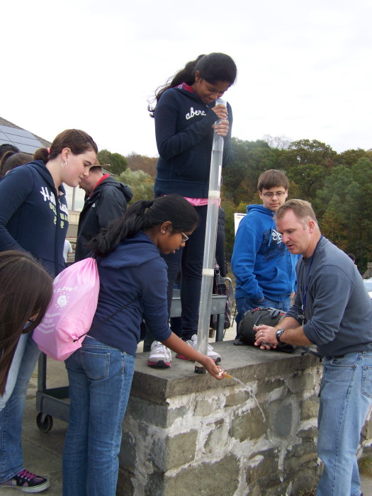
Location: Sampling done Norrie Cove and the SW corner of Norrie Point Env. Center Patio. East side of Hudson far from the main channel in a protected cove
Area: Substantial paved areas nearby, large environmental center building adjacent to the water. Shallow cove, facing south onto the HR, nordered by RR embankment, parking lot & the environmental center.
Surrounding Land Use: 95% Forested; 5% Beach
Sampling Site: Banks altered, Rip Rap
Shoreline: beach area, shore with bulkhead, shoreline rip rap, covered with vegetation (some duckweed on surface, water celery in the bay- mostly uprooted), banks altered for EEC building, riprap along RR tracks, collected wood and debris in shallow cove, piping entering river area
Plants in area:0-5%
River Bottom – weedy, muddy

ITEM | Time | Reading 1 |  |  | Reading 2 | Comments
Physical | Time
Air Temperature | 10:03 AM | 18°C  64.4°F
 | 10:54AM | 15°C  59 °F
 | 12:19 PM | 23.5°C  72.3 °F
 | 1:07 PM | 20°C  68°F |  |  | Cloud cover
Wind Speed | 10:03 AM Beaufort #2 | 10:54 AM-12:19 PM Beaufort #1.5 |  |  | 1:07 PM Beaufort 1.25
Cloud Cover | Mostly cloudy
Weather today
Weather recently
Water calm | Water calm
Water Temperature | 10:15 AM |  | 13°C  56°F | 12:17 PM |  | 16°C  60.8°F
 | 10:55 AM |  | 13 °C  56°F | 12:50 PM |  | 16°C  60.8°F
Turbidity  Long Sight Tube | Time |  | cm
Sight tube | 1:00 PM |  | 10 cm | 8 cm |  | 9 cm average
Chlorophyll | 10:43 AM |  | 0 | 12:19 AM |  | 2
 | 11:35 AM |  | 1 | 1:07 PM |  | 2

Chemical
DO  (drop count) | 10:15 AM | 8 mg/L  10 mg/L | 13°C | 75-96%
 | 10:55 AM | 8.5 mg/L  10 mg/L | 13°C | 80-94%
 | 12:17 PM | 8 gm/L  8 mg/L | 16°C | 85%
 | 12:50 PM | 9 mg/L  9 mg/L | 16°C | 93%
pH | 10:15 AM | 7.5 | 12:17 PM | 7.5
 | 10:55 AM | 7.5 | 12:50 PM | 7.5
Salinity | Not recorded

Fish | # of fish | size of largest | Fish Species
4 seines | 53 |  | Spottail Shiner
 | 18 |  | Sunfish
 | 1 |  | Smallmouth Bass
 | 4 |  | bullhead
 | 40 |  |  | shiner
 | 8 |  |  | darter
 | 1 |  |  | killifish
 | 14 |  |  | White perch
 | 68 |  |  | Herring
 | 2 |  |  | American Eel
Tides | time | cm |  | Rising/Falling | cm
 | 9:10 AM | 120 cm
 | 10:03 AM | 103 cm |  | falling
 | 10:54 AM | 103 cm |  | Still
 | 12:17 PM | 105 cm |  | rising
 | 1:07 PM | 125 cm |  | rising
Currents | 10:03 AM | South |  | ebb
 | 10:54 AM | South |  | ebb
 | 12:19 PM | North |  | flood
 | 1:07 PM | North |  | flood
Shipping | 10:29 AM | McAllister Tug and oil barge |  |  | North Bound
 | 12:41 PM | Independence Tour Boat |  |  | Southbound Loaded with passengers

