Snapshot Day 10/18/11 Data
(Salt Front RM 35.7)
RIVER MILE 92
Kingston Point Park, Kingston, Ulster County
GPS Latitude 41°55.6 N Longitude 73°57.90 W
Steve & Julie Noble, Forsyth Nature Center (Site Hosts)
Laura Conner & Nick Martin, Minnewaska State Park
Sidney Ganon, Hudson River Maritime Museum
Karen Knowlton, and 7 adult chaperones Bailey Middle School – 8th grade, 73 students
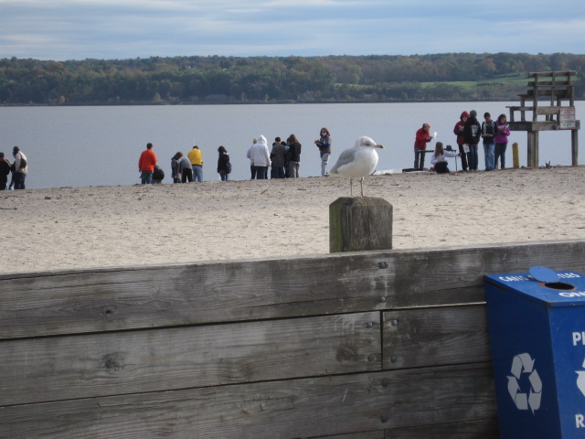
Location: Kingston Point Beach, beach and parking lot
Area: Used for picnics, boating, fishing, swimming
Surrounding Land Use: 5% urban/residential; 70% forested; 10% beach; 15% industrial/commercial
Sampling Site: Beach area - shoreline is sandy with some bricks, banks are altered, collected wood debris in the area, rip rap to north along brickyard shoreline. Sandy shoreline 75 feet from shoreline to parking lot, 200 feet wide with boat launch, large amount of brick debris from prior industry
Plants in area: plants in area were not growing but rather were washed up on the shore. Found water celery, water chestnut, spatterdock, duckweed.
Water depth: gently sloping 0-3 ft.
River Bottom : sandy with bricks

ITEM | Time |  |  | Reading 1 | Reading 2 | Comments
Physical
Air Temperature | 9:43 AM |  |  | 46.4°F  8°C
 | 10:56 AM |  |  | 57.2°F  14°C
Wind Speed | 9:45 AM Beaufort #2 |  |  | 4.5 kts  anenometer
 | 10:56 AM Beaufort #1 |  |  | 1-3 kts. anenometer
 | 12:39 PM  Beaufort #2 |  |  | 4.9 kts. anenometer
Cloud Cover | Overcast 9:15-12:15 |  |  | After 12:15 the clouds broke up and sun came through
Weather today | No precipitation
Weather recently | Sunny, pleasant – except yesterday evening rain and rain early AM today
Water Temperature | Shoreline Thermometer | 3 ft. out Thermometer |  |  | Shoreline Laser | 3 ft. out Laser
9:51 AM | 57.5°F avg  14.17 °C
10:53 AM* | 48°F  8.9 °C | Question mark by reading on sheet
12:30 PM | 64.22°F  17.9 °C | 62.96°F  17.2°C |  |  | 60°F  15.6°C | 62°F average  17°C
12:51 PM | 63.5°F  17.5 °C
Water calm | yes
Turbidity short  Site tube | 9:50 AM | 60 JTU |  |  | 70 JTU | Average  65 JTU
 | 10:55 AM | 100 JTU |  |  | 100 JTU | 100 JTU
 | 12:505PM | 100 JTU |  |  |  | 100 JTU
Chlorophyll | 9:45 AM | 2.0
Chemical
DO  Test tabs | 9:25 AM  10:00 AM  12:30 PM  12:55 PM | 2.0 mg/L  2.0 mg/L  2.0 mg/L  4.0 mg/L |  |  | 14°C  14°C  17.5 °C  17.6 °C | 18%saturated  18%  20 %  40%
pH – pen | 9:50 AM  12:30 PM  12:51 PM | 8.0  7.0  7.0 |  |  | 8.0  7.0 | 8.0 Average  7.0  7.0
Nitrates  Test tabs | 9:51 AM  10:50 AM | 1.0  0.5 |  |  | 1.5  0.0 | 1.25 average  0.25
Phosphate | 9:51 AM  10:55 AM | 1.0 ppm  1.5 ppm |  |  | 1.0  1.0 | - average  1.0
Salinity - Quantab | .0003  .0008 | <29 ppm Cl- |  |  | <52.39 total salinity
Fish Catch  20’seine X 4 ft. –9 seines and dip nets | Number Caught- 7 | Species - 2 |  |  | Largest Size | Macro-invertebrates
9:45 AM | 1 | Striped Bass |  |  | 3 inches
 | 1 | Spottail shiner |  |  | 2 inches
11:00 AM | 1 | Spottail shiner |  |  | 3.25 inches
1:00 PM | 4 | Spottail Shiner |  |  | 3 inches
Macroinvertebrates | 4 | Scud |  |  | 5 mm
 |  | Zebra mussels
Tides | 9:32 AM
 | 9:58 AM |  |  |  | falling
 | 10:30 AM |  |  |  | falling
 | 11:00 AM |  |  |  | falling
 | 11:30 AM |  |  |  | falling
 | 12:15 PM |  |  |  | rising
Currents | Site is out of the channel so no current
Traffic | 11:22 AM | Tug & barge |  |  | Dunker Portland | Northbound – Full - Oil?
Also |  | 2 leisure boats |  |  |  | North
 |  | 2 leisure boats |  |  |  | South
 |  | Coastguard Boat |  |  |  | North
Other Items | Juvenile bald eagle | Took flight over our site for about 10 minutes
 | Mature bald eagle | Played in flight with juvenile and then perched
Almanac entry | While collecting data at our respective stations we noticed a juvenile and a mature bald eagle tumbling in flight overhead. Students jumped to don binoculars as we witnessed the seemingly playful behavior. The adult then perched high in the canopy of a tree near the river’s edge as the juvenile delighted our large group of citizen scientists, soaring, banking, and gliding not 75 feet overhead - Julie Noble
Core – 9:50; 11:50; 12:50 – 6 inch water depth | 4 inch and 9 inch cores Oxidized top - speckled |  | Rare: mud, pebbles, oyster shells |  | Common: Gravel & Brick | Abundant: Sand

