Snapshot Day 10/18/11 Data
(Salt Front RM 35.7)
RIVER MILE 94
Robert Post Park, Town of Ulster, Ulster County
Meg Meisch, Kristen Muller, and Elissa Jury , Rondout Valley High School
80 students 9th-12th graders
GPS Latitude 41°57’50” N Longitude 73°57’31” W
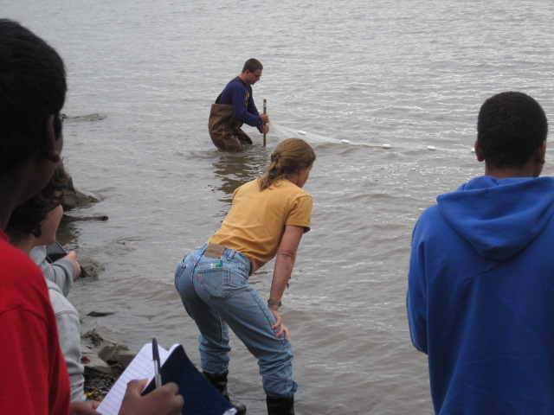
Location: Robert Post Park, Town of Ulster, Ulster, NY
Area: Park space with boat launch and fishing dock
Surrounding Land Use: 30% urban/residential; 10% forested; 10% beach; 50% town park, boat launch, fishing
Sampling Site: Shore is riprapped, broken concrete in the area
Plants in area: no
Water depth:
River Bottom : rocky

ITEM | Time |  |  | Reading 1 | Reading 2 | Comments
Physical
Air Temperature | 9:40 AM |  |  | 63°F  15°C
Wind Speed | 9:40 AM Beaufort #3 |  |  | 7-10 kts | SE
Cloud Cover | Mostly cloudy
Weather today | No precipitation
Weather recently
Water Temperature | Shoreline Thermometer |  | 3 ft. out Thermometer |  | Shoreline Laser | 3 ft. out Laser
9:51 AM
10:53 AM*
12:30 PM
12:51 PM
Water calm
Turbidity short
Site tube
Chlorophyll | 99:34 AM |  | 1.0 |  | 12:50 PM | 2.0
Chemical
DO
Test tabs
pH – pen
Nitrates
Test tabs
Phosphate

Salinity - Quantab
Fish Catch  20’seine X 4 ft. –9 seines and dip nets | Number Caught- |  | Species - |  | Largest Size | Macro-invertebrates
Tides | 9:40 AM |  |  |  | falling
 | 10:27 AM |  |  |  | falling
Currents | 9:54 AM |  | 12.9 cm/60 secs |  | North | Flood
 | 9:57 AM |  | 8.7 cm/60 secs |  | North | Flood
Traffic | 8:46 AM |  | BOAT |  | North | Light
 | 9:37 AM |  | Sheriff or coast guard |  | South
 | ~11:00 AM |  | Large barge |  | North
Other Items | Trains across the river, blue heron, seagulls, Canada geese
Core –

