Snapshot Day 10/18/11Data
(Salt Front RM 35.7)
RIVER MILE -7 Ft. Wadsworth, Staten Island, NY
Geri Kobryn-Blatter, Shalini Gopie, Dan Meharg, Carol Williams, Kathy Garofalo National Parks Service, NPNH Education Center
Mary Lee - St. Clare’s – 7th grade, 35 students
GPS latitude N40.59896° W 074.05443°
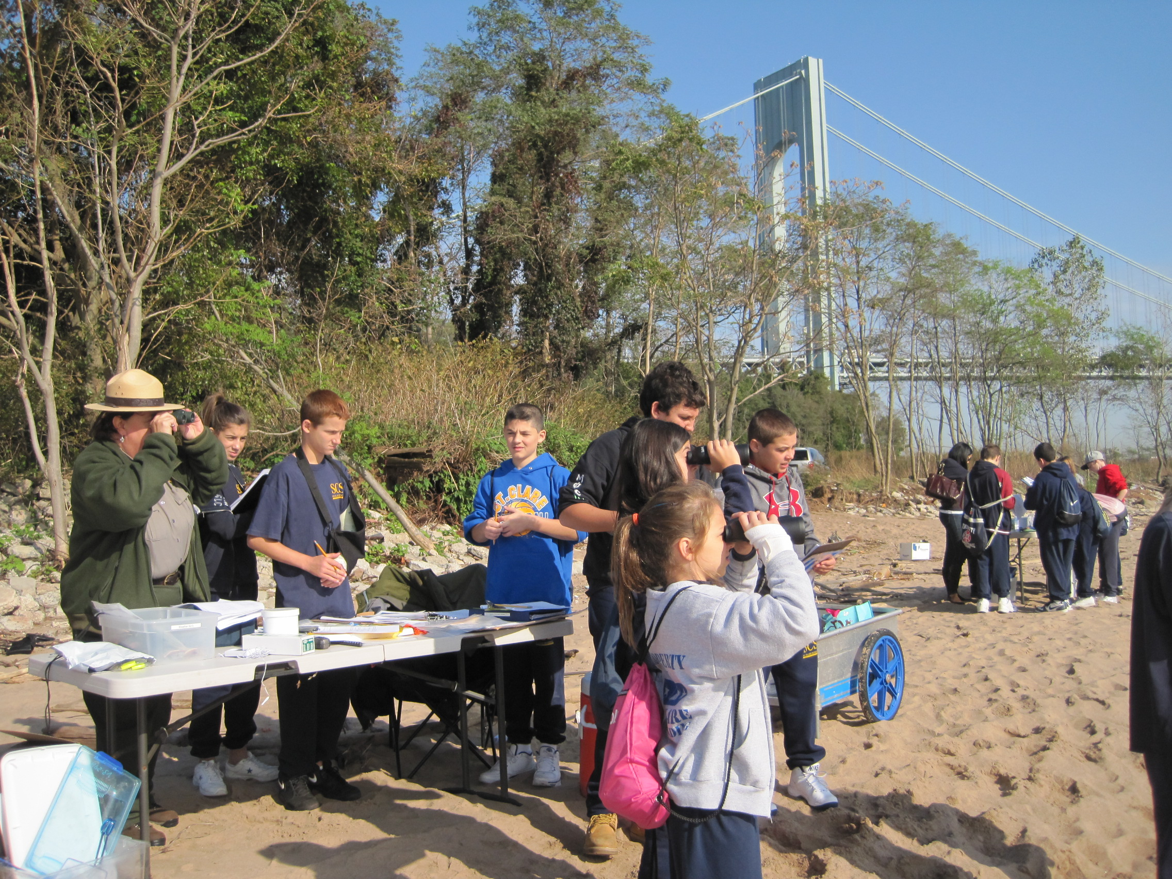 | 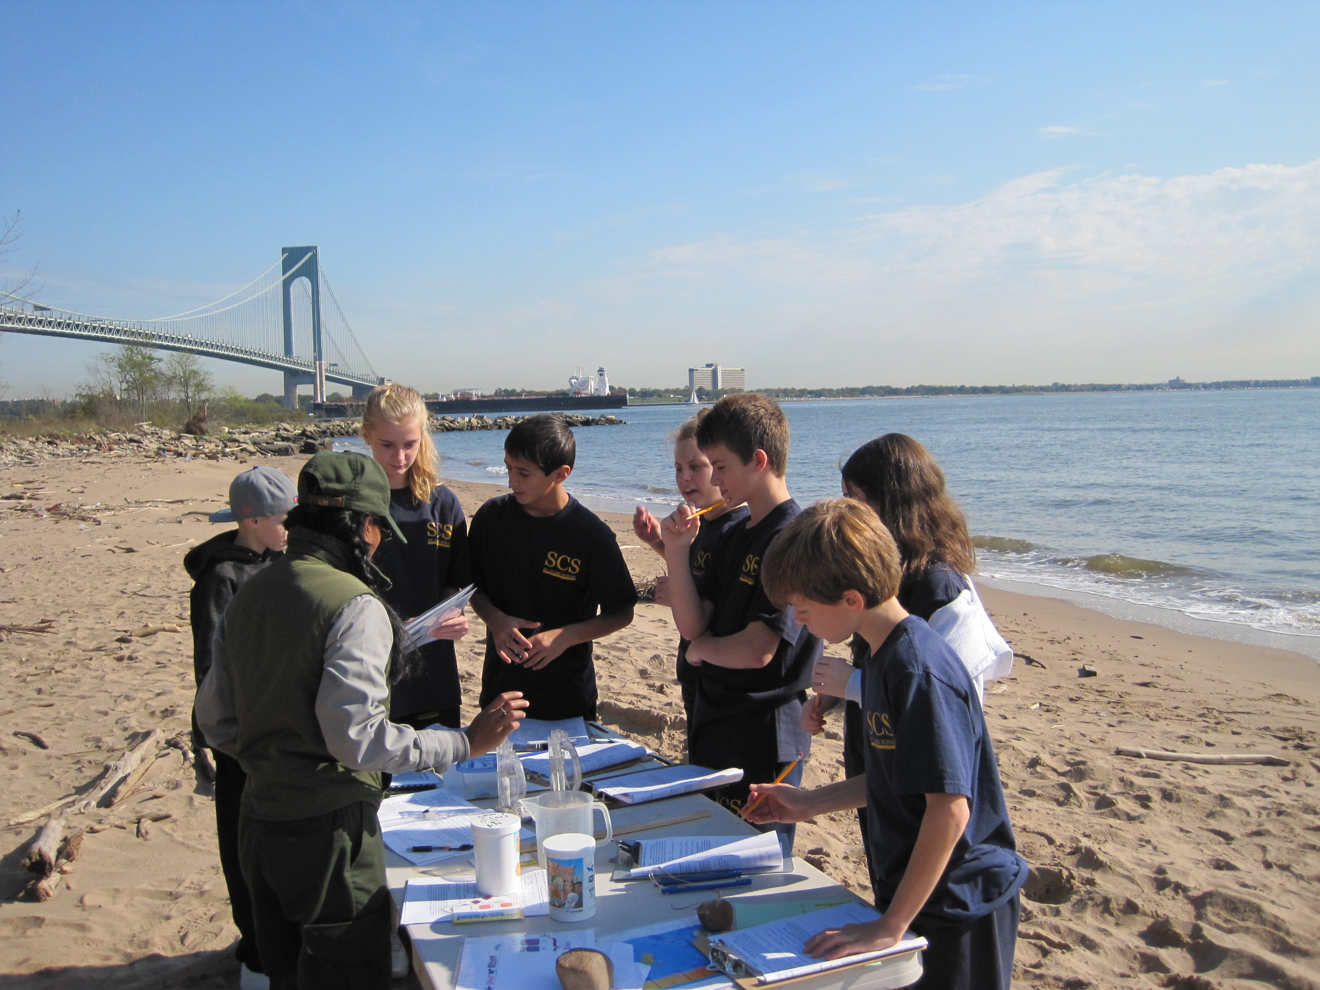
Location: Seabee Fishing Beach, Fort Wadsworth, just south of the Verrazano Bridge, Staten Island
Area: Shoreline is 95 % beach, 50% covered in vegetation, 20% covered in riprap, broken concrete debris in the area
Surrounding Area: 100% fishing beach
River Bottom: sandy, pebbles
Water Depth:
Plants in water: no plants in water
Plants in Area: Ailanthus trees cover 5% of area
ITEM | Time |  | Reading 1 | Reading 2 | Comments
Physical
Air Temperature | 10:10 AM |  | 21° C | 70° F
 | 10:43 AM |  | 22 ° C | 70° F
 | 11:12 AM |  | 24.6 ° C | 73 ° F
Wind Speed | Beaufort 2 |  | 2 mph – 10:00 AM  3 mph – 10:40 AM  4.5 mph – 11 AM
Cloud Cover | 1/3 cloud cover to  2/3 cloud cover |  | Trace amount of rain
Weather | Sunny warmer, temperature rising,
Weather yesterday | Monday sunny, warm
Water Surface | Calm
Water Temperature | 10:20 AM | 20° C  18  18 |  |  | Average  18.67° C
 | 10:30 AM | 18° C  18  18 |  |  | 18° C

 | 10:47 AM | 18 ° C  18  18 |  | 18° C

 | 11:00 AM | 18 ° C  18  18 |  | 18° C
Turbidity | 10:40 AM | 65 cm  60 cm  52cm |  | Average 59 cm
Chlorophyll | 10:27 AM | 0.0
Chemical
DO - tablet | 10:47 AM | 4 ppm | 18° C | 40% saturation
pH - tablet | 10:24 AM | 7  7  8 |  | Average 7.4
Alkalinity
Salinity -  hydrometer | 10:40 AM | 17.4 ppt  17.4 ppt  17.4 ppt |  | 17.4 ppt
Fish Catch | Number Caught | Species | Length
 | 10 | Northern Kingfish | 7 cm
 | 20 | Atlantic Silversides | 11 cm
 | 15 | Striped Bass | 10 cm
Totals | 45 catch | Diversity 3
Macro-invertebrates | 7 | Hermit Crabs
Tides | Time | Height in cm | Rising, Falling
 | 9:55 AM | 50 cm | Rising
 | 10:10 AM | 60 cm | Rising
 | 10:25 AM | 58 cm | Rising
 | 10:40 AM | 60 cm | Rising
 | 10:55 AM | 65 cm | Rising
 | 11:17 AM | 74 cm | Rising
 | 11:35 AM | 76 cm | Rising
Currents | Time | Cm/60 secs | Cm/sec | Ebb/Flood
 | 11:00 AM | 600 cm/60 sec | 10 cm/sec | Still/N
 | 11:05 AM | 2300 cm/60 sec | 38.33cm/sec | Flood/N
 | 11:09 Am | 4700cm/60sec | 78.33 cm/sec | Flood/N
 | 11:35AM | 5000cm/60ec | 83.33 cm/sec | Flood/N
 | 11:57 AM | 1200 cm/60 sec | 7.7cm/sec | Flood/N
 | 11:14 Am | 860 cm/60 sec | 20cm/sec | Ebb
Core | Length | Comment | Abundant | Other
11:10 AM - Cored in 60 cm water | 14 cm – no sections | Pebbles | Sand | Fish bone in core
Boat Traffic | 10:00 AM | Red cargo ship | NE to NY harbor | loaded
 | 10:29 AM | Sea Streak water shuttle | Northbound | loaded
 | 10:29 AM | Australian Blt tanker | Northbound | loaded
 | 10:29 AM | Pilot Boat | Northbound | loaded
 |  | USGS tug
 | 11:28 AM | Fishing Boat | Southbound | Loaded passengers

 | 10:57 AM | Low flying 2 helicopters | NE

 | 10:57 AM | 1 helicopter | SW
 | 11:28 AM | Party fishing boat

Speed boat

 |  | USGS tug boat
Other Items | Black crowned night heron roosting in a tree.
Almanac | The weather began overcast and cool. As experiments were conducted the sky cleared and became warmer and the day progressed.

