Snapshot Day 10/18/11 Data
(Salt Front RM 35.7)
RIVER MILE 11.5 – Fort Washington Park
Dinorah Hudson – Thurgood Marshall Academy
9th – 25 students and 2 adults
Latitude 40.89° N - Longitude 73.94°W

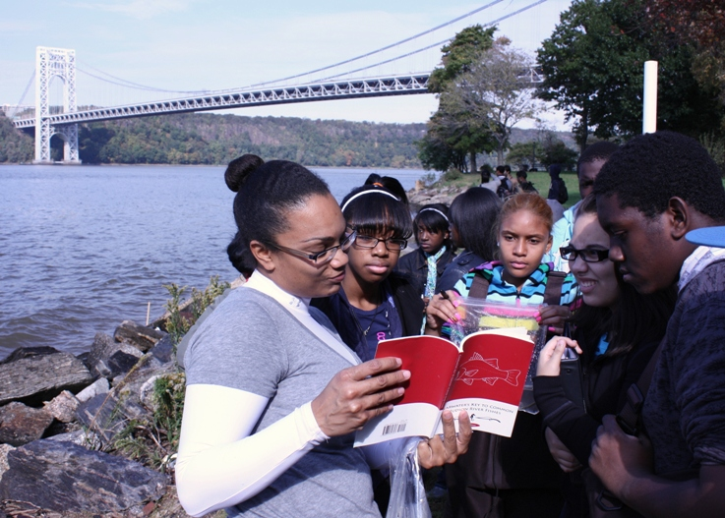
Location: Fort Washington Park just South of the George Washington Bridge
Area: Park/Boat launch, sandy beach area on the point
Surrounding Land Use: 15% forested, 85% park used for recreation & picnics
Sampling Site: Park with a lot of trees, picnic tables, covered with vegetation, riprap shore, collected wood debris.
Plants in water: <10% - a grass of some sort
River Bottom –sandy

ITEM | Time | Reading 1 | Reading 2 | Comments
Physical
Cloud Cover | clear
Weather today | No rain –
Weather last 3 days | windy, little rain overnight
Nitrates
Salinity  Quantab (High Range) | 11:00AM | 5.2 ppt  salinity
Fish Catch | Number Caught | Species
11:15 AM | ~20 | Atlantic Silversides
Commercial Traffic | 11 AM | Bouchard tugboat | Southbound | Light/oil Barge

