Snapshot Day 10/18/11 Data
(Salt Front RM 35.7)
RIVER MILE 127 – Stuyvesant Landing
Chelsea Benson - Columbia County Soil & Water Conservation District
Elizabeth Pagnani, The Alternative Learning Center (TALC) – 4-13 yrs. – 12 students & 13 adults
Latitude 47 N Longitude 73W (topo map)
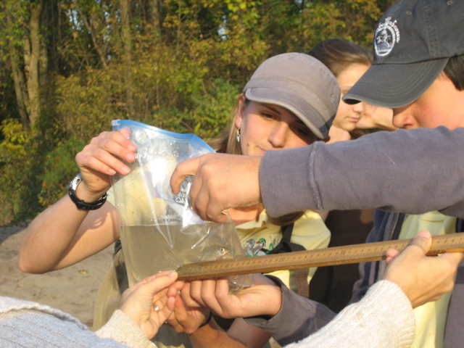

Location: Sandy point of Stuyvesant Landing, Columbia County. The sandy point is just south of the parking lot.
Area: forested area with narrow beach used for swimming, picnics & camping by permit. Park/Boat launch, sandy beach area on the point
Surrounding Land Use: 95% forested, 5% beach – used for picnics, swimming, campfires, sandy beach and dense woods behind
Sampling Site: Beach area
Plants in area: no plants in water
Water depth: waded in approx. 2 ft.
River Bottom –gradual slope, sandy

ITEM | Time |  | Reading 1 | Reading 2 | Comments
Physical
Air Temperature | 3:43PM |  | 68°F  20°C | 4:20 PM | 65.5°F  19°C
Wind Speed | Beaufort 0-1 |  | 1.0-3.0 knots Anemometer | Seems to be from the West
Cloud Cover | clear |  | Partly cloudy
Weather today | Wind picked up slightly |  | Became sunnier
Weather last 3 days | Mild weather - mid 60°F during day – low 50°F night. Windy on 10/16
Water | Calm
Water Temperature | 3:45 PM |  | 65°F  18°C
 | 4:10 PM |  | 64.4°F  18°C
 | 4:20 PM |  | 63°F  16°C
Turbidity – short site tube | 4:15 PM |  | 20 JTU | 4:30 PM | 20 JTU
Chlorophyll | 3:30 PM |  | 2.0
Chemical
DO  Drop count | 4:05 PM |  | 9.8 mg/L | 16 ° C | 100%
pH  meter | 3:30 PM |  | 8.3  8.0  8.3 |  | Average 8.2
Nitrates | 4:10 PM |  | 0.10 ppm
Phosphates | 3:50 PM |  | 0.15 ppm
Alkalinity | 3:50PM |  | 100 ppm  100 ppm |  | Average  100 ppm
Salinity  Quantab Test strip | 3:45 PM  4:24 PM |  | .2*  .8*  readings on wick stick | *Note: salinity was below the level of test detection
Fish Catch –2 pulls - Seine 40 ft. X 3 ft.  Mesh 0.25 inch | Number Caught |  | Species | Size of largest | 2 seines – 10 yds each
4:40 PM | 3 |  | Spottail shiner | 10 cm | 5 minute pulls-
4:50 PM | 2 |  | Spottail Shiner
Tides | 3:45 PM |  |  | 32 cm
 | 4:00 PM |  | Rising | 43 cm | .73 cm/min
 | 4:15 PM |  | Rising | 52 cm | .60 cm/min
 | 4:30 PM |  | Rising | 60 cm | .53 cm/min
Currents | 4:15 PM |  | 150 cm/60 secs | 2.5 cm/sec | .04 knots
Our sampling beach is set back slightly from the direct current. We managed to get the orange out into the current. |  |  |  |  | North/Flood
Other Items
Core Description | Total Length | Top Layer |  | Second Layer | Describe
Shipping | 4:00 PM | Sailboat/Karma |  | Northbound | Sail not up
Observations

