Snapshot Day 10/18/11
(Salt Front RM 35.7)
RIVER MILE 13
Bloomers Beach @ Engelwood Boat Basin
Kirk Weber – Meadowlands Environmental Center
Shabeena Sarker – West New York Middle School – 25 students, 7th & 8th graders
N40.881297 -W73.943948
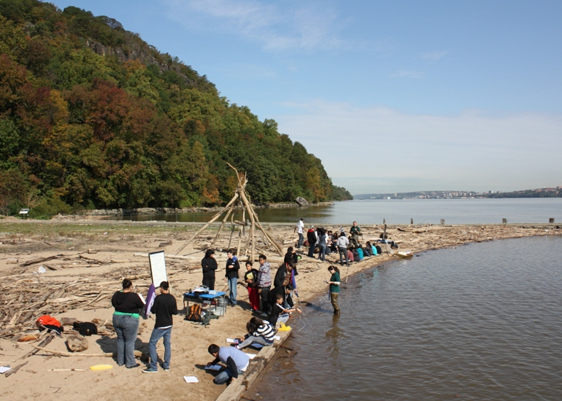
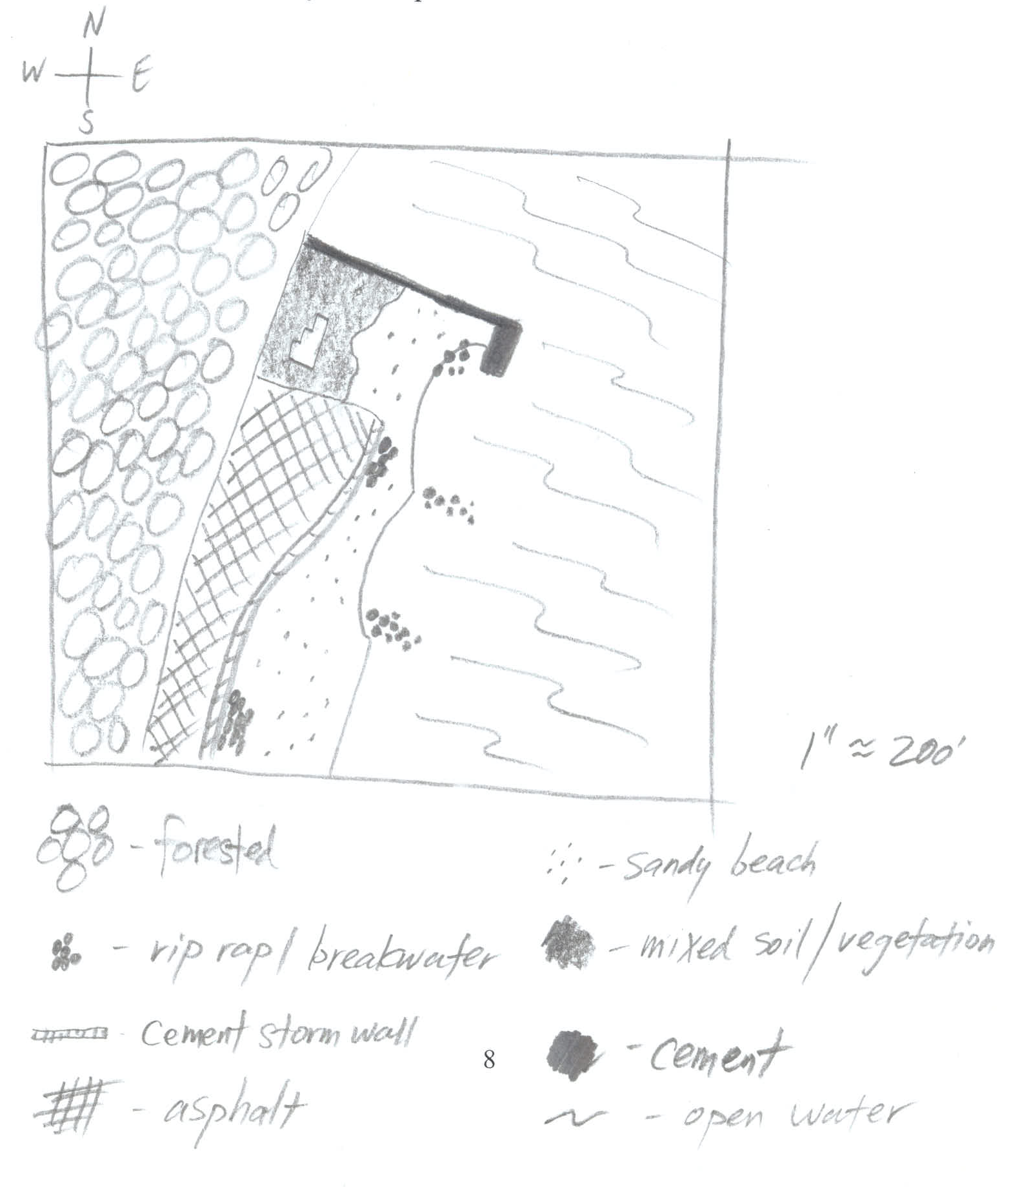 | Location: Bloomers Beach – north end  Area: sandy beach, banks altered, pier with rip rap sections, wood bulkhead, collected wood/debris in area, piping approx. 30” located at sampling site, 2 stone breakwaters as well as on shoreline, + cement storm wall  Surrounding Land Use: 20% urban/residential; 40% forested; 20% beach; 20% Industrial/commercial  Bottom: sandy & muddy  Plants in area: none in the water  Water Depth:115 cm one hour before high tide,

ITEM | Time |  | Reading 1 | Reading 2 | Comments
Physical
Air Temperature | 10:15 AM |  | 65°F  18.3°C
Wind Speed | Beaufort #2 |  |  |  | South
Cloud Cover | Cloud coverage decreased throughout the observation period
Weather today | No precipitation
Weather recently | 10/15 normal (.09 inches rain); 10/16 normal (no rain); 10/17 normal (.01 inches rain)
Water | Choppy
Water Temperature | 10:10 AM | 17.3°C  16.6°C  17.3°C |  | 63.2 °F  62.0°F  63.1°F | 17.07°C  62.7°F
 | 11:00 AM | 17.5°C  17.9°C  18°C |  | 63.6°F  64.3°F  64.5°F | 17.8°C  64.2°F
 | 11:40 AM | 17.8°C  18.1°C  18.4°C |  | 64.1°F  64.6°F  65.1°F | 18.1°C  64.6°F
Turbidity – long site tube | 12.30 AM | 22 cm  25 cm  29 cm |  |  | 25.3 cm
Chemical
Chlorophyll | 11:30 AM | 0.7
DO – ampules | 11:45AM | 6.3 mg/L |  | 17.7° C | 65% saturated
pH – indicator sol. | 12:25 PM | 8.0  7.5  8.0 |  |  | 7.8 avg.
Salinity (hydrometer) | 11:30 PM | 6 ppt  6 ppt  6 ppt |  |  | 6ppt average
Fish Catch | Count | Fish |  | Size of largest | Macros
14 ft. X 3 ft seine – pulled 20 ft. | 50 plus | Atlantic Silverside |  | 9 cm
1/8 inch mesh | 9 | Striped Bass |  | 10 cm
9 seines | 10 | Herring |  | 6 cm
Seine #1 | 10:15 AM | 15 fish |  | 20 ft pull | .18
Seine #2 | 11:15 AM | 18 fish |  | 20 ft pull | .13
Seine #3 | 12:15 PM | 25 fish |  | 20 ft pull | .29
Tides | 8:58 | rising |  | 50 cm
 | 10:50 | rising |  | 95 cm | .40 cm/min
 | 11:35 | rising |  | 105 cm | .22 cm/min
 | 12:15 | rising |  | 115 cm | .25 cm/min
Currents | 10:58 | 7.01 cm/sec |  | North | Flood
Core – | 22 cm total – overall black in color | Top layer 4 cm –pudding like |  | Second layer 18 cm –clayey
Boats

