Snapshot Day 10/18/11 Data
(Salt Front RM 36)
RIVER MILE 25E
Matthiessen Park, Irvington
Joanna Morabito- Irvington High School Marine Science Class
17 students, 11/12th graders
Latitude 41 ͦ 2’ 30” N Longitude 73 ͦ 52’ 32” W

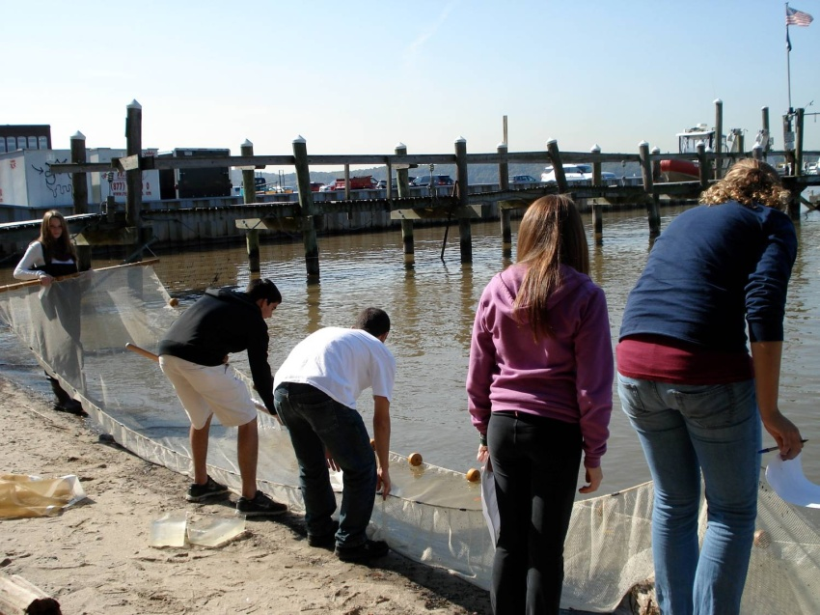

Area: Large, grassy field and small beach with riprap on shore.
Surrounding Land Use: Sampling Site: 90% grassy field; 10% beach
Plants: No water plants; Trees in park, grass
Water Depth: 4 feet
River Bottom: Sand and rock

Weather Conditions: Partly Cloudy, 67 ͦF; Calm wind
Sampling Times: 11:45 AM- 1:45 PM

ITEM | Time |  | Reading 1 | Reading 2 | Comments
Physical
Air Temperature | 12:00 PM |  | 67 °F
Wind Speed | 12:00 PM |  | Calm
Cloud Cover | 12:00 PM |  | Partly Cloudy
Weather today | Light rain early in the morning before arrival; Partly cloudy conditions during sampling time.
Weather recently | Partly cloudy over the last 3 days; Windy over the weekend
Water Surface | Calm
Water Temperature – | 12:00 PM  12:41 PM | 63 °F |  | 63 °F
Turbidity – long-site tube
Chlorophyll
Chemical
DO
(drop kits)
pH | 12:00 PM  1:30 PM | 7.2 |  | 7.2
Salinity -
meter
Alkalinity
Nitrates | 12:12 PM  12:50 PM | < .5 mg/L |  | < .5 mg/L
Phosphate | 12:12 PM  12:50 PM | 2.0 mg/L |  | 1.0 mg/L
Fish Catch- 12:00 PM to 1:25 PM | Number Caught | Species |  | Average Length | Seine
 | 41 | Atlantic Silverside |  | 7 cm
 | 1 | *Rainbow smelt- probably another silverside |  | 9.5 cm | *Students note this was probably mistaken identity
Tides | TIME | Water height |  | Rise/Fall
Currents | Time | Cm/60 sec |  | Cm/sec | Direction
 | 12:00 PM | .15 cm/60 |  | .003 cm/sec | Flood
Core – | TIME | Rare |  | Common | Abundant
Traffic
Other Items

