Snapshot Day 10/18/11 Data
(Salt Front RM 35.7)
RIVER MILE 35 – Bowline Park, Haverstraw Waterfront
Tom Lake, DEC helped with seining
Chuck Barone, Nanuet High School – 12th grade – 20 students
41.° 12’11” N 73.° 57’ 48” W

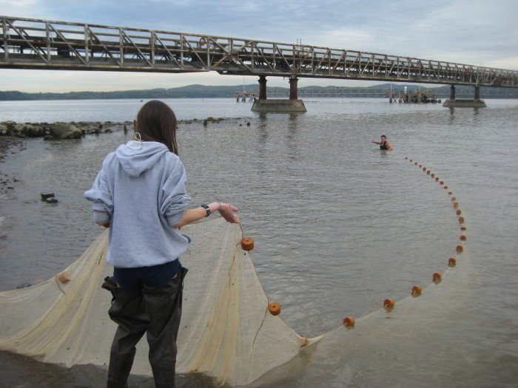
Location: Bowline Park, Haverstraw waterfront, Rockland County NY
Area: Parking lot, recreation, fishing
Surrounding Land Use: 15% beach, 75% Industrial/commercial, 10% other
Sampling Site: shoreline is sandy, muddy, rocky, small beach, bank altered, large rip rap, bulkhead, industrial tress spans the water to the north and east, bricks in the sand
Piping coming into river
Plants in area: water chestnut seed pods (devil-heads) in area 2% (traveled on waterway), uprooted vallisneria (water celery) 2%, trees 2%
Water depth: 1 meter/3 ft.
River Bottom –sandy, muddy, rocky
ITEM | Time | Reading 1 | Reading 2 | Comments
Physical
Air Temperature | 8:45 am | 53°F  11.8°C | Per Tom Lake
 | 10:05 am | 59.2°F  15.1°C
 | 10:50 AM | 68°F  20°C
 | 11:56 AM | 66°F  18°C
Wind Speed | Beaufort #2 | 4-7 miles/hr | 4-6 knots | NW shifting to S in the last rotations
Cloud Cover | Partly cloudy | Sunny and windy
Weather today | No rain
Weather last 3 days | No rain last few days | Overcast in AMs | Sunny during day
Water Temperature – depth 63 cm average | 8:45 AM | 17.0°C | 63°F
 | 10:15 AM | 17.5°C  19  18.5 | 65.25°F  66.5  67.5 | Average  18.25°C  66.5°F
Depth 80 cm | 11:17 AM | 20°C | 68°F
 | 12:25 PM | 20°C | 68°F
Turbidity – secchi AND turbidity meter | 10:02 AM | 22.2 cm  22.3  23.0 | Student comment – relatively turbid | Average 22.5
 | 11:06 AM | 20 cm | 75.6 NTU
 | 11:50 | 19.5 cm | 99.5 NTU
Chlorophyll | 10:20 AM | 0.9
 | 10:56 | 0.7
 | 12:07 | 0.7
Chemical
DO  Drop count | 11:30 am | 20 C | 9.6 PPM | 105 % sat
 | 12:27 pm | 20 C | 4.6 PPM | 50 % sat
pH  pH pen | 10:14 AM rotation | 7.9  8.2  8.1  8.1 |  | Average 8.1
 | 11:14 AM | 7  6.9 |  | 6.95
 | 12:23 PM | 7  7.1 |  | 7.05
Salinity  Titrator strips –& meter | Quantab | Chloride reading | Total Salinity conversion | Meter reading
10:14 AM | Quantab strip 4.4 | 188 mg/L chloride | 339.63 ppm | 200 ppm
11:14 AM | 1.4 | 35 mg/L | 63.29 ppm | 200 ppm
12:25 PM |  |  |  | 200 ppm
Fish Catch | Time | Number Caught | Species | Length of largest
Seine 12 ft. X 6ft.  Mesh 0.25 inch | 8:45 - 10AM w/ Tom Lake | 40 | Blueback herring | 60-65 mm; yoy
 |  | 12 | American Shad | 85-90 mm; yoy
 |  | 4 | Gizzard Shad | 80-85 mm; yoy
 |  | 6 | Striped Bass | 70-75 mm; yoy
 | 9:56 AM | 2 | Blueback herring | 75 mm
 |  | 1 | American shad | 90 mm
 | 11:05 AM | 1 | Striped bass | 14.3 cm
 |  | 3 | Blueback herring | 8.0 cm
 | 11:45 AM | 1 | Herring
Tides | 9:56 am | 72.3 cm
 | 10:26 am | 85 cm | rising
 | 10:50 am | 100 cm | rising
 | 12:15 PM | 140 cm | rising
Currents | CM/60 secs | Cm/Sec | North/South Ebb/Flood/Still | Knots
10:00 AM | 1040/60 sec | 17.3 cm/sec | Ebb* (recorded ebb but expect it should be flood) | 0.34 Knots
10:50 AM | 802/60 sec | 13.4 cm/sec | Flood | 0.26Knots
12:05 PM | 700/60 sec | 11.6 cm/sec | Ebb* (recorded ebb but expect it should be flood) | 0.23 Knots
Core – 3 cores | Length | Rare | Common | Abundant
10:25 AM – water depth 1.0 m | 7.9 cms –  oxidized top 2.4 cm  bottom 5.5 cm | Pebbles. | Clay  Sand  Gravel  brick
10:59 AM – water depth 1 ft. | *13 cm - no layers  *one line says 13 cm and another says 6 cm | Mud  Leaves  wood |  | Clay  Sand  Gravel  Pebbles  brick
12:10 PM | 11 cm – no layers – all rocks | Clay  Mud  brick | Gravel | pebbles
Shipping | 12:20 PM | Sailboat | White | southbound
 | 12:21 | Speedboat | White/black | Northbound
Observations | Giant industrial tresses for Bowline power plant. Plastic and glass along the shores and many bricks were along the beach showing how there were old brick factories in the area.  Few birds flying over water – seagulls.

