Snapshot Day 10/18/11 Data
(Salt Front RM 35.7)
RIVER MILE 4
Pier 84
N 40.76544 W-73.99765
Lauren Donnelly and staff, Hudson River Park Trust
Lisbeth Uribe and 5 teachers from The School at Columbia, 55 fourth graders
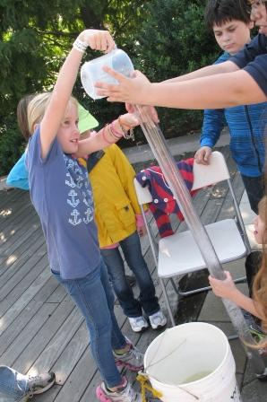 | 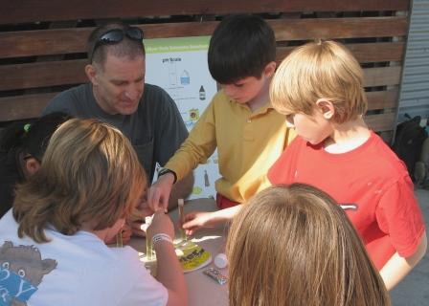

Location: Pier 84, is an educational pier used for picnics, boating, fishing take place at our sample site.
Area: Pier – bulkhead – mainly concrete & wood
Surrounding Land Use: 100% urban/residential
Sampling Site: Recreational pier – rocks near the edge, banks altered
Depth:
Plants in area: No plants

ITEM | Time |  | Reading 1 | Reading 2 | Comments
Physical
Air Temperature | 12:10 PM |  | 23°C  76 °F
Wind Speed | Beaufort 2.5-3 |  | 3 mph anemometer | South | Water choppy
Cloud Cover | clear
Weather today | Clear sky, very little wind |  |  | Water is calm
Weather recently | Some rain and wind
Water Temperature | 12:18 PM surface sample ~ 2 ft depth | 20°C  18°C  19°C |  | 68°F  64.4 °F  66.2°F | Avg.  19°C  66.2°F
Water still – sunny but some shade form the pier | 12:38 PM surface sample ~ 2 ft depth | 18°C  18°C  18°C |  | 64.4 °F  64.4 °F  64.4 °F | 18°C  64.4 °F
Turbidity  Turbidity tube | 12:20 PM | 33.4 cm  43  44 |  | 40 cm average | Water is tan colored
Chlorophyll | 12:27 PM | 1.0
Chemical
DO  (drop count kit) | 12:15 PM  12:30 PM | 6.0 ppm  8 ppm |  | 20° C  18° C | 61%  85% saturated
pH  indicator solution | 12:15 PM  12:35 PM  1:00 PM  1:15 PM | 8  7  7  8 |  | 8  7.5  8  8 | 8  7.5  8  8
Salinity (hydrometer) | 12:20 PM | 2-3 ppt |  |  | Hydrometer range was 0-6 and was ~ half wayy
Fish Catch | AM | 2 |  | White Perch | By park staff
 |  | 1 |  | Striped Bass
Tides (from dock) | 12:12 PM | 289 cm
 | 12:44 PM | 276 cm |  | falling
 | 12:58 PM | 300 cm |  | rising
 | 1:10 PM | 300 cm |  | unchanged
Currents | Cm/60 secs | Cm/sec  North/South |  | Knots | Ebb/Flood/  Still
12:30 PM | 150 cm |  |  | 0.05 kts | Flood
12:45 PM | 0 |  |  | 0 kts | Still
1:00 PM | 1880 cm |  |  | 0.6 kts | Flood
1:10 PM | 1575 cm |  |  | 0.5 kts | Flood
Boats | 12:35 PM | Circle line |  | White | southbound
 |  | Water ferry |  | Yellow | southbound
 | 1:05 PM | Water taxi |  | Yellow
Other Observations | Man just caught a big fish from the pier!!!

