Snapshot Day 10/18/11 Data
(Salt Front RM 35.7)
RIVER MILE 87
Eli Schloss & Esopus Meadows Environmental Center, Ulster Park, Ulster County
Donna Nageli, Anna Devine Elementary School – 4th grade – 29 students
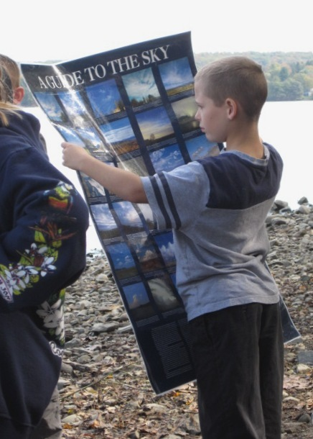

Location: Esopus Meadows Preserve Town of Esopus. Ulster County
Area: A path along the beach with rising forested hills and yard with house and driveway
Surrounding Land Use: Forested 85%, Beach 10%, 5% other
Sampling Site: Rocky shallow, sloping beach area covered with vegetation
Water depth: 2 ft.
River Bottom –rocky & muddy
Plants in area: Plants in 30% of the sample area - 100% are water chestnut

ITEM | Time |  | Reading 1 | Reading 2 | Comments
Physical
Air Temperature | 10:00 AM |  | 60°F  15°C
 | 11:00 AM |  | 61°F  16°C
Wind Speed | 1 Beaufort |  | 1-3 mph | SE
Cloud Cover | Mostly cloudy |  |  | Water Calm
Weather today | 80% cloud cover until sun came out at 1215
Weather recently | Fair weather
Water Temperature | 10:00 AM | 15°C  60 °F
 | 10:30 AM | 16°C  61 °F
 | 11:00 AM | 16°C  61°F
Water calm | yes
Turbidity -  Long Turbidity tube | 10:00 AM | 31  35  32 |  | Average 33 cm
Chlorophyll | 1:30 PM | 2.0
Chemical
DO  (drop count kit) | 10:00 AM | 9.0 mg/L |  | 60°F  15.55°C | 90%
pH  Indicator sol. | 10:00 AM | 7.5  7.5  7.5 |  |  | 7.5 average
Salinity
Fish Catch  25 ft.X 4 ft. X ¼ inch mesh - | Number Caught | Species – total count 110 |  | CPUE | Seine
30 ft pull  6 seines run | 1 | Eel |  | 17 cm
 | 22 | Spottail Shiner |  | 7 cm
 | 16 | White Perch |  | 14 cm
 | 3 | Yellow Perch |  | 30 cm | #2 – 6 Species  25 count
 | 28 | Sunfish |  | 18 cm
 | 1 | Stickleback |  | 2cm
 | 3 | Striped Bass |  | 8 cm
 | 34 | Herring |  | 6 cm | #3 – 4 Species  47 count
 | 1 | Smallmouth Bass |  | 7 cm
 | 1 | Bullhead |  | 6 cm
Tides | 10:00 am | Falling
 | 10:30 am | Falling
 | 11:00 am | Falling
 | 11:30 AM | Falling
 | 12:00 PM | Falling
 | 12:30 PM | Falling

 | 12:50 PM | Rising

 | 1:00 PM | Rising
Currents | Time | North/South | Ebb/Flood
Traffic | 11:30 AM | American Cruise Line | SB | Loaded/people
 | 12:35 PM | Tug & Barge | NB | Loaded/oil

