Snapshot Day 10/18/11 Data
(Salt Front RM 35.7)
RIVER MILE 41
Steamboat Dock Park, Verplanck, Westchester
Bob Connick, Sott Rizzo, Jack Mozel, Taylor Block, Mahopac High School
Environmental Research and APES - 9th - 12th graders – 45 students
Latitude N 41°14.962 Longitude W 73°57.888
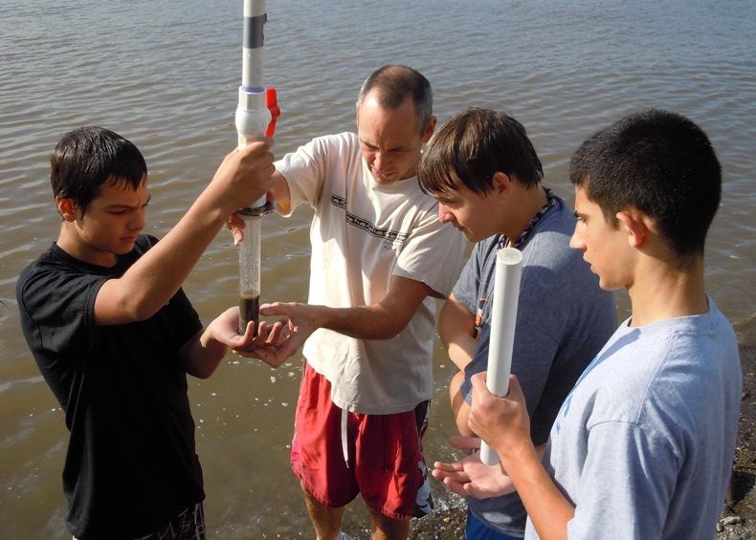

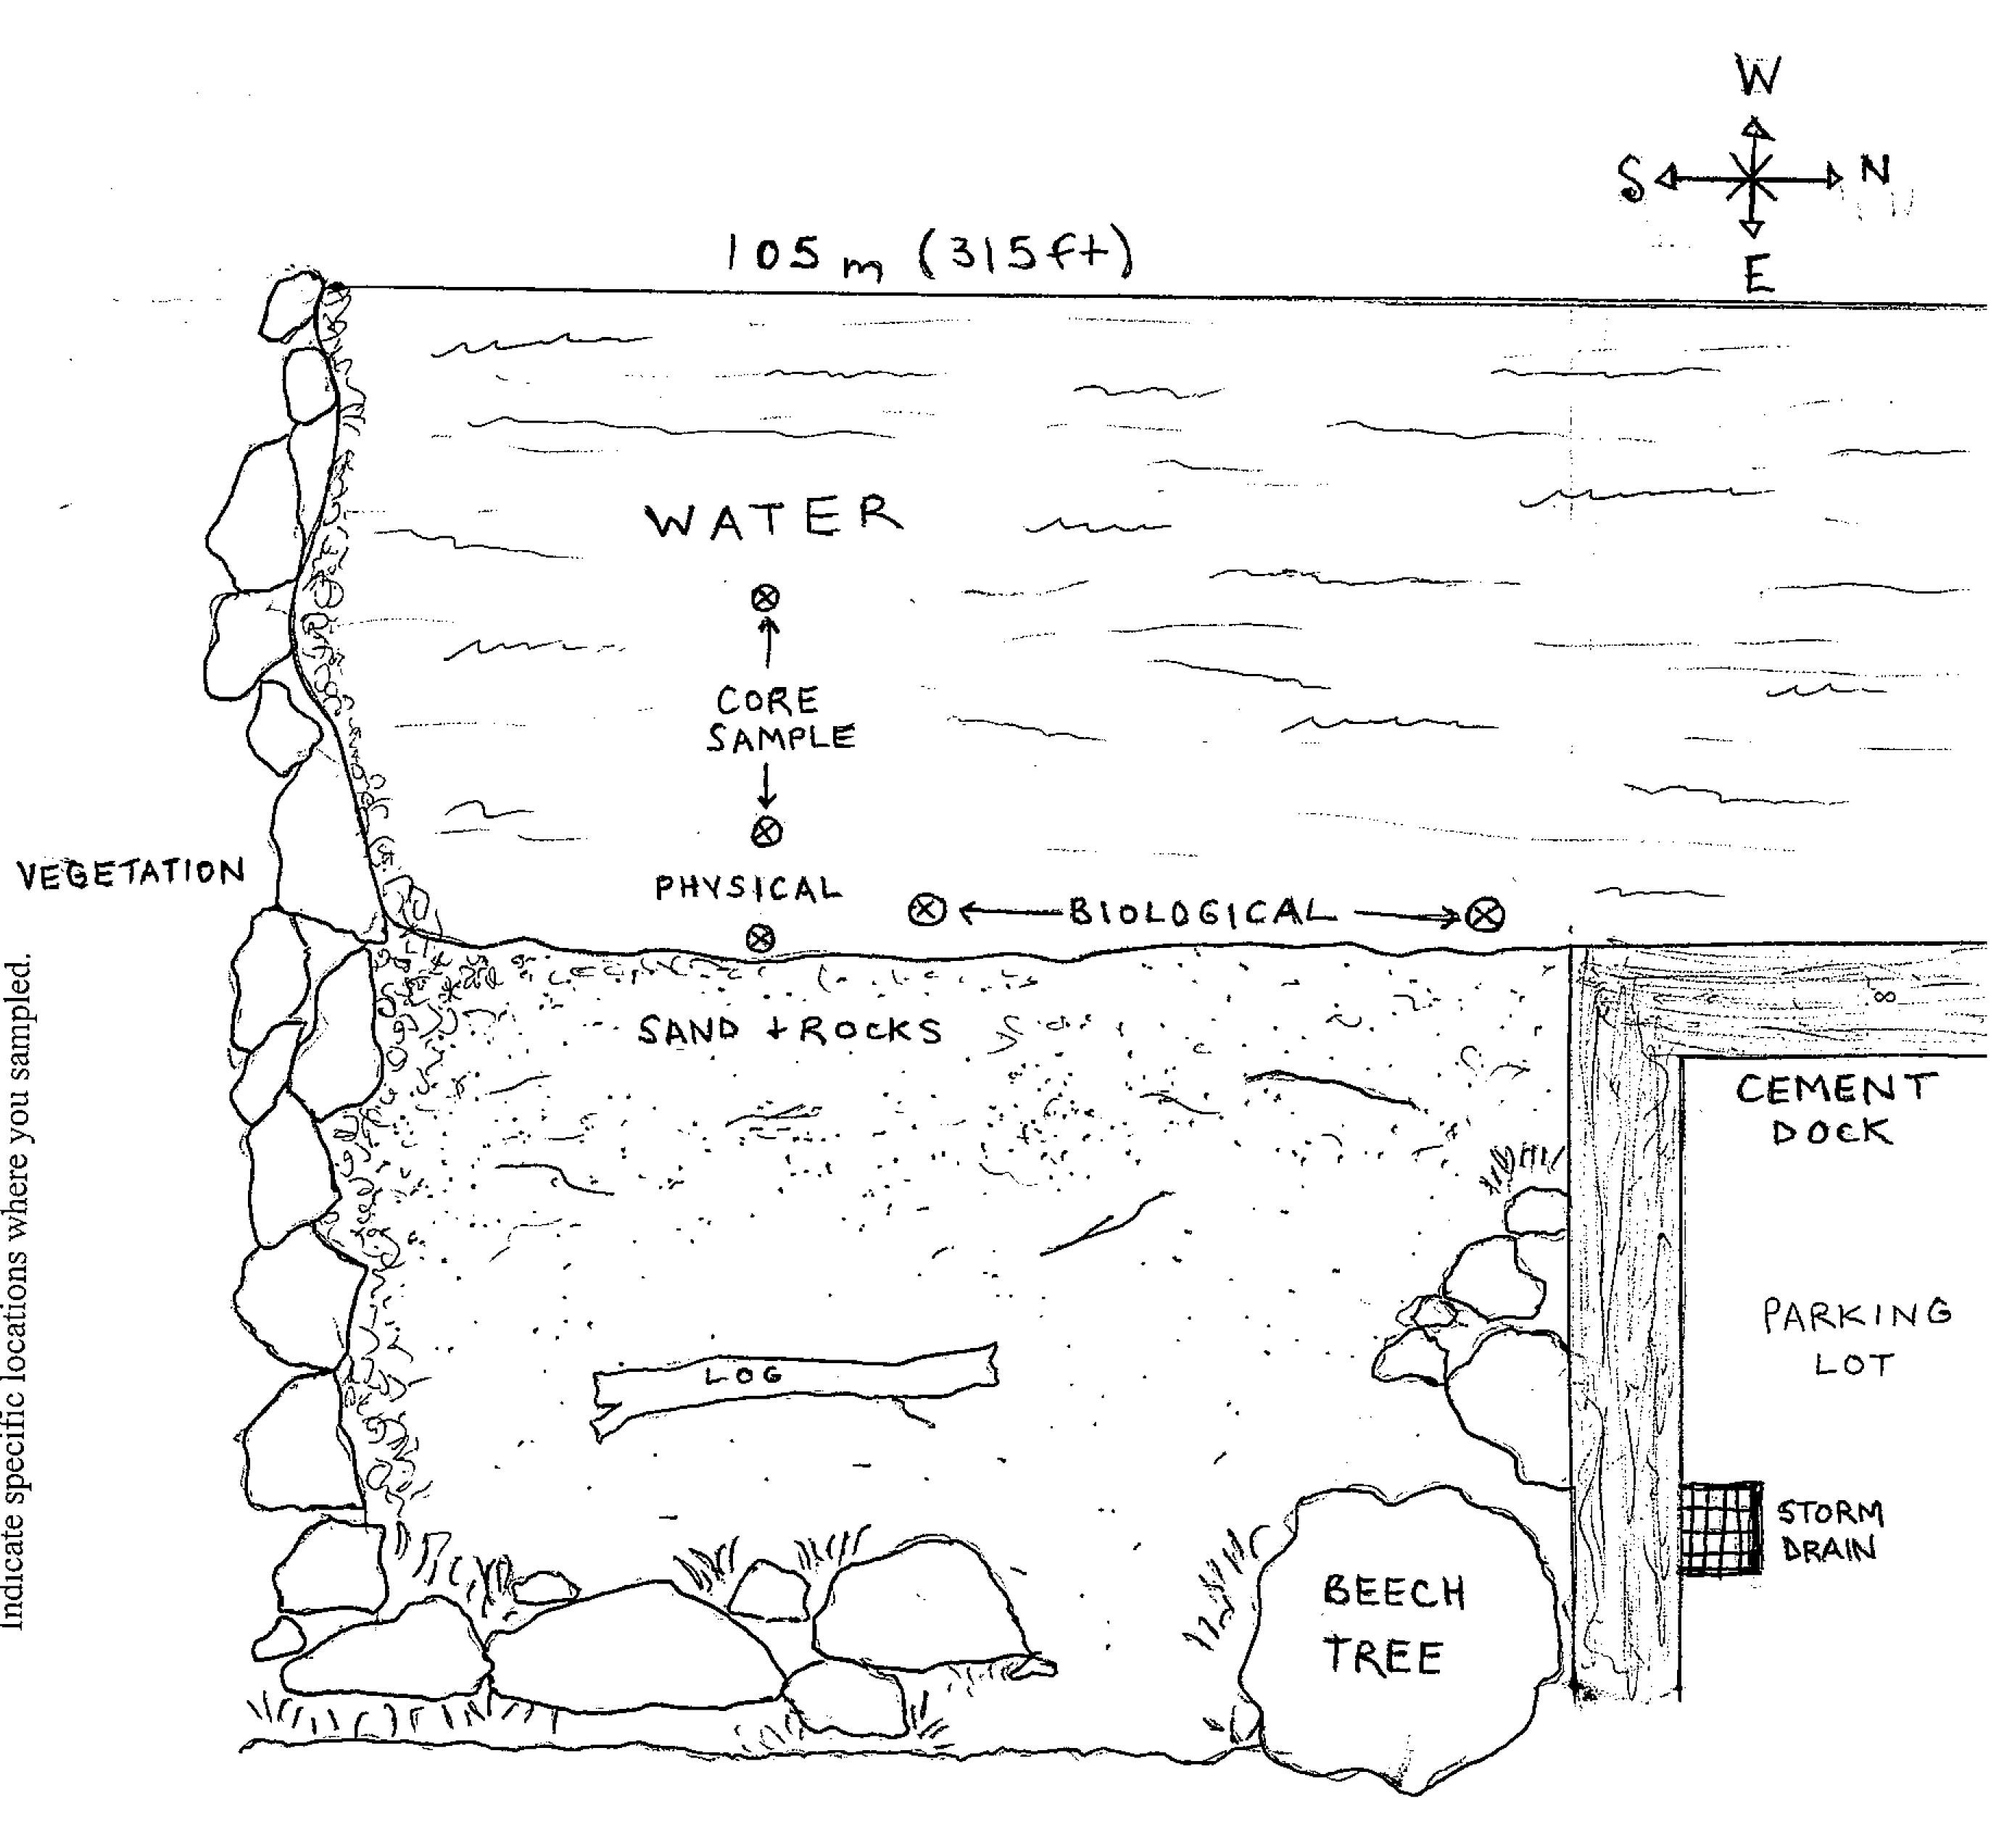
Location: Steamboat Dock Park beach, City of Verplanck in Westchester County
Area: located in a small cove between a point and a bulkhead – sampled approximately 30 ft. from south end of dock/parking lot
Surrounding Land Use: Industrial/Commercial 25% , beach 70%, Forested 5%. Some buildings with large parking lots in front to the north. Beach, a street with houses with some trees to the south
Sampling Site: beach, riprap, banks altered, dock, bulkhead, pipe south of the sampling site 10-15 meters.
Plants in area: none
Water depth: 109 cm
River Bottom – sandy
Observations- 2% bur-reed in area
.
ITEM | Time |  | Reading 1 | Reading 2 | Comments
Physical
Air Temperature | 10:58 AM |  | 15 °C  60°F
Wind Speed | Beaufort #2 |  | 4-6 knots | 6-11 kph | West
Cloud Cover | Partly cloudy
Weather today | No rain
Weather recently | Clear, cool, light showers
Water Surface | Calm
Water Temperature –
Turbidity – |  | 40 cm  40 |  | secchi | 40 cm
 |  | 20.8 cm  23.1 |  | Long site tube | 22 cm
 |  | 27.6  28.4 |  | Turbidimeter | 28 NTU
Chlorophyll | 10:30 AM | 0.7
Chemical
DO  (drop kits) | 10:17 AM | 7 mg/L
pH  Indicator sol | 10:35AM | 7.6
 | 10:38 AM | 7.5
 | 11:10 AM | 7.5
Salinity  meter | 10:30 AM | - ppt  100 ppm |  | 12:40 PM | 0.1 ppt  100 ppm
Conductivity (ppm is = 0.64 conductivity) | 12:30 PM | 216 μS ~ =  138 ppm |  | 12:40 PM - 218 μS ~= 139.52 ppm | microsiemen/cm
Alkalinity | 10:30 Am | 110 mg/L  110 |  |  | Average 110 mg/L
Nitrates | 10:30 AM | 4.8 ppm |  |  | Seems very high
Phosphate | 10:30 AM | 0.59 ppm
Fish Catch- 10:30 AM | Number Caught | Species |  | CPUE | Seine
50 ft net X 4ft– 50 ft. pull | 31 | Herring |  | 12.4 cm | 3 Seines/55 total fish caught
 | 7 | Herring-shad |  |  | Seine #1 - 35 fish
 | 15 | Striped Bass |  |  | Seine #2 - 20 fish
 | 2 | Shiners
Total Catch | 55 | Total Diversity |  | 4
Tides | TIME | Water height |  | Rise/Fall
 | 10:18AM | 49 cm
 | 10:24 AM | 47.5 cm |  | Falling | 1.5 cm/min
 | 10:30 AM | 45.3 cm |  | Falling | 2.3 cm/min
 | 10:36 AM | 42.3 cm |  | Falling | 3.0 cm/min
 | 10:42 AM | 40 cm |  | Falling | 2.3 cm/min
Currents | Time | Cm/60 sec |  | Knots | Direction
Core – | TIME | Rare |  | Common | Abundant
Traffic
Other Items

