Day in the Life of the Hudson River 10/4/12 Data
Canarsie Pier, Jamaica Bay, Brooklyn, NY
 | 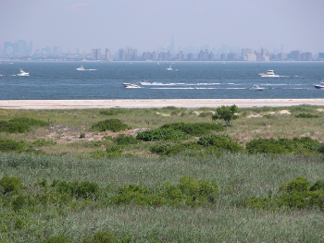
Adam Lammers, International High School at Prospect Heights
9th-10th graders – 170students
3 NYSDEC SCA member assistants
GPS Latitude N 40.37’49.0” - W-73.53’00.98”
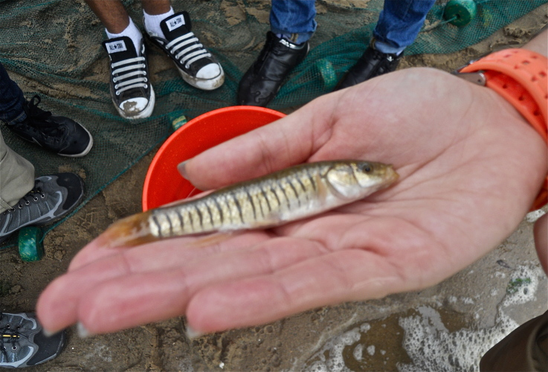  Salt loving Male Striped Killifish with characteristic dark vertical bars, and larger body size than the banded killifish. |  | 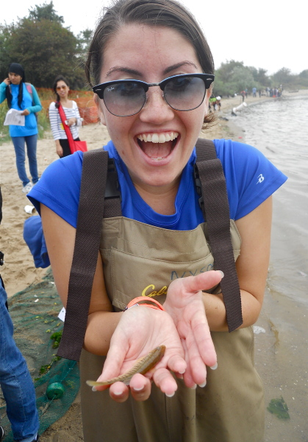
Location: Beach at Canarsie Pier, Jamaica Bay
Area: beach area along the bay
Surrounding Land Use: Beach – 50%; Urban/residential 50%
Sampling Site: beach
Shoreline: beach and pier
Plants in area: No plants in water
Water depth:
River Bottom : sandy

ITEM | Time |  | Reading 1 | Reading 2 |  | Comments
Physical
Air Temperature | 12:00 PM |  | 70 F
Wind Speed | Beaufort Force |  | 1
Cloud Cover | Partly cloudy
Weather today
Weather recently
Water Temperature | 12:00 PM | 71 F
Water calm | yes
Turbidity – long sight tube | 11:30 AM | 28 cm  27.1 cm  54.63 cm |  |  |  | Average 36.58 cm
pH –Litmus Test | 1:00 AM | 6  5.6  6 |  |  |  | Average 5.87
Salinity – hydrometer | 12:30 AM | 23 ppt |  |  | Total Salinity
Fish Catch  93 inch. seine net |  | Species |  |  | Number Caught
11:30 AM |  | Comb Jelly |  |  | 20 | Diversity 7
 |  | Striped Killifish |  |  | 19 | Total Catch 190
 |  | Atlantic Silverside |  |  | 71
 |  | Crab |  |  | 16
 |  | Winter Flounder |  |  | 1
 |  | Glass Shrimp |  |  | 3
 |  | Hermit Crab |  |  | 60
Other Items
Core

