Day in the Life of the Hudson River 10/4/12 Data
Canarsie Pier, Jamaica Bay, Brooklyn NY
Ragini Singhal – Robert Van Wyck MS 217
NYSDEC SCA Members - 2
30 students, 10-13 yr. olds. MS, 3 adults
N 40.37’49.0” - W-73.53’00.98”
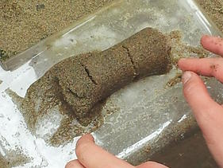 | 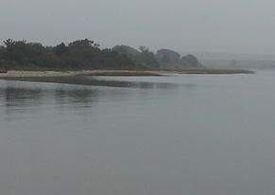 | 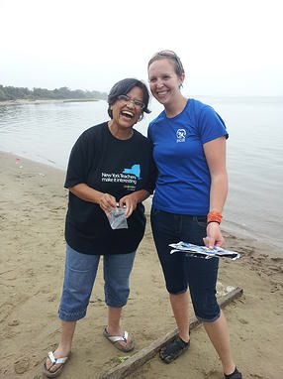

Location: Jamaica Bay, Canarsie Pier,
Area: Beach, large piping entering river
Surrounding Land Use: 50% forested; 40% beach; 10% constructed pier
Sampling Site: Beach, covered with vegetation, concrete pier, some fabric & other debris in rocks, man placed boulders along part of the shoreline near the pier
Recreational pier – rocks near the edge, banks altered
Bottom: sandy bottom
Plants in area:

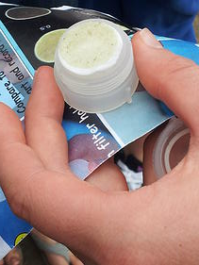 | 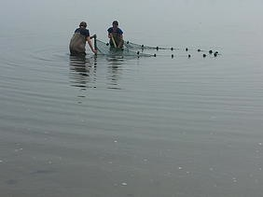 | 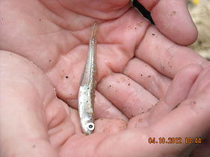

ITEM | Time |  | Reading 1 | Reading 2 | Comments
Physical
Air Temperature | 11:21 AM |  | 25°C  78°F
Wind Speed | Beaufort #0
Cloud Cover | cloudy
Weather today | Overcast |  | Humid and threat of rain
Weather recently | Rainy and warm
Water | calm
Water Temperature | 11:26 AM | 22°C  72°F |  | 20°C  70°F | Average 21°C and 71°F
Turbidity- secchi
Chlorphyll | 11:30 AM | 0.5
Chemical
DO
(drop count kit)
pH meter
Salinity
Fish Catch | Total | Fish |  |  | 1 seine
 | 24 | Atlantic SIlversides
 | 1 | hogchoker |  | small
 | 1 | Mud crab |  | female
 | lots | Sea snails
 | lots | Hermit Crabs
 | lots | Moon jellies
Tides
Currents  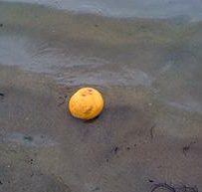 | Still to flooding | Tossed in an orange but it didn't move much, and then came back to shore |  | Tried again with same results – went a bit north, then east then back to shore | Note this area is in a bay – so n orange coming back into shore would have been flooding
Core – 11:10 AM | 15 cms long | Sand - Core was tightly packed with sand – rough texture |  | Some small shell pieces, very small flecks of brick | Small rock, & small black flecks in it we thought might have been shell pieces or fish eggs but couldn’t really tell

