Day in the Life of the Hudson River 10/4/12
East River, Gantry Plaza at Newtown Creek
Cristina Ragusano, Rebecca Raddock, PS 78Q - 5th grade, 40 students
Uzma Shah, Baruch College Campus High School
12th grade, 19 students
Kim Estes-Fradis, New York City Department of Environmental Protection
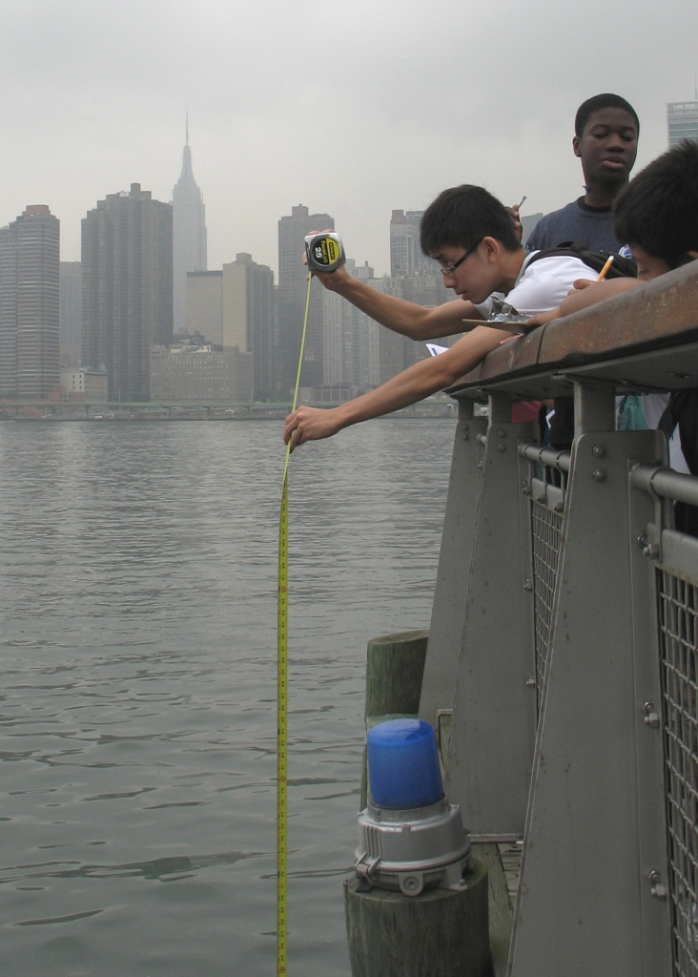 | 
Location: East River, Gantry Plaza State Park, Long Island City, Queens
Surrounding Land Use: Urban 80%; Grassy 15%; Rocky Shoreline 5%
Sampling Site: Shoreline is rocky with some plants and has piers.
Plants in area: A few trees and tall grasses.
Water depth: unknown
River Bottom: unknown

ITEM | Time |  | Reading 1 | Reading 2 | Comments
Physical
Air Temperature | 10:30 AM  10:56 AM  11:17 AM  11:31 AM |  | 22°C  22°C  22°C  22°C
Wind Speed | 10:30 AM  10:56 AM  11:17 AM  11:31 AM |  | Beaufort 1  Beaufort 2  Beaufort 2  Beaufort 2
Cloud Cover | 10:30 AM  10:56 AM  11:17 AM  11:31 AM |  | Mostly Cloudy | Rain during mid morning
Weather last 3 days | Rainy and humid
Water Temperature | 10:52 AM  11:17 AM  11:39 AM | 21°C  25 C  24.5
Turbidity  Secchi Disk | 10:30 AM  10:56 AM  11:30 AM  12:05 PM | 3.6 feet  3.75 feet  3.8 feet  3.75 feet |  | 110 cm  114 cm  116 cm  114 cm
Chlorophyll | 10:30 AM  10:56 AM  11:52 AM  12:26 PM | 0.3  2.0*  0.0 -0.1  0.1 |  | From the chart | *rainy during this reading
Chemical
DO  (CHEMetrics ampules) | 10:52 AM  11:17 AM  11:39 AM  12:20 PM | 21°C  25 °C  24.5 °C  not read |  | 5 ppm  6 ppm  5.5 ppm  6 ppm | 55%  70 %  64%  not calculated
pH (test strips) | 10:30 AM  10:56 AM  11:52 AM  12:26 PM | 7  7  6  7
Salinity  (Hydrometer) | 10:30 AM  10:56 AM  11:52 AM  12:26 PM | 24 ppt  24 ppt  22 ppt  26 ppt
Tides | 10:30 AM  10:56 AM  11:17 AM  11:31 AM | Falling  Falling  Falling  Staying the same
Currents | 10:30 AM  10:56 AM  11:17 AM  11:31 AM | 3 inches/sec  0.88 inches/sec  0.97 inches/sec  1.04 inches/sec |  | 7.64 cm/sec  2.24 cm/sec  2.46 cm/sec  2.64 cm/sec

