Day in the Life of the Hudson River 10/4/12 Data
RIVER MILE -1
Governor’s Island, Upper NY Bay/Buttermilk Channel
Roy Arezzo - New York Harbor School
20 AP Environmental Science students
Latitude N 40°41’30.15” - Longitude W074°46.14’
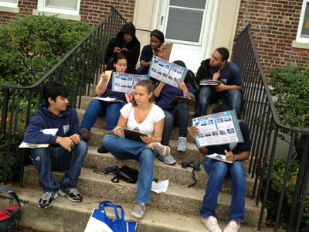 | 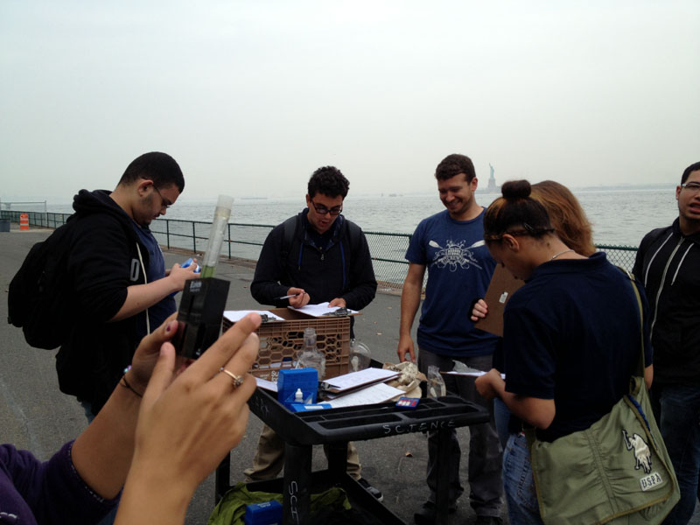
Location: Pier 101, NE Governor’s Island – Upper NY Bay
Area: Pier along waterfront of the island
Surrounding Land Use: 100% converted to public access programs (education, boating, recreation)
Sampling Site: Pier, shoreline is bulkheaded
Plants in area: None
Water depth: surface samples
River Bottom –

ITEM | Time |  | Reading 1 | Reading 2 | Comments
Physical
Air Temperature | 11:29 AM |  | 72°F  24.6°C
Wind Speed | Beaufort 1 |  | 2.1 mph
Cloud Cover | Cloudy |  | Alto Stratus
Weather today | Humid, foggy, wild
Weather recently
Water surface
Water Temperature | 11:30 AM | 21 °C  69 °F
Turbidity – turbidity tube | 11:30 AM | 63 cm
Chlorophyll | 0.5
Chemical
DO  (chemmet kit) | 11:30 AM | 27 °C |  | 6 mg/L | 70% saturation
pH – Lamotte colormetric | 11:30 AM | 7
Salinity  (Hydrometer) | 11:30 AM | 23 ppt
Tides | High Tide | 11:30 AM |  | Low Tide | 6:06 AM
Currents | 11:30AM. | 1-2 kts |  | North | Flood

