Day in the Life of the Hudson River 10/4/012 Data
Gerritsen Creek, Jamaica Bay, NY
Ranger Howard Kreft, Salt Marsh Nature Center
Sydra Mallery, Brooklyn School of Inquiry
59 students, 2nd graders and 20 adult helpers
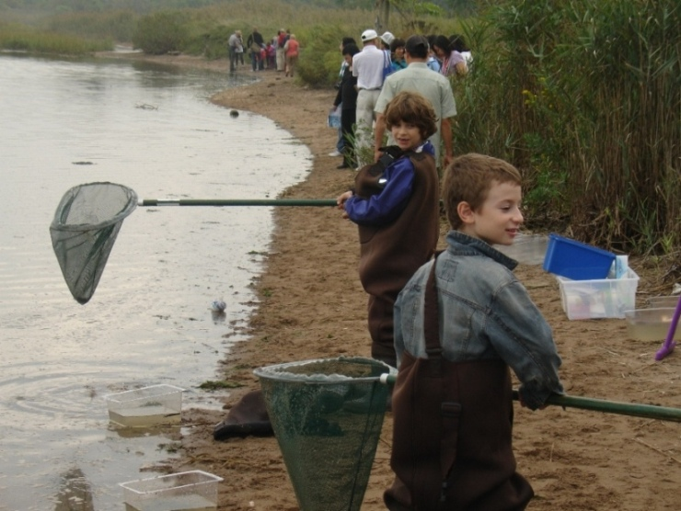

Location: Gerritsen Creek Salt Marsh, Jamaica Bay, Brooklyn, NY
Area: Marsh area
Surrounding Land Use:
Sampling Site: Beach,
Depth:
Plants in area:

ITEM | Time |  | Reading 1 | Reading 2 | Comments
Physical
Air Temperature
Wind Speed
Cloud Cover | Cloudy/drizzly
Weather today | rain |  | humid and wet
Water Condition | Calm at noon
Water Temperature 0.5 ft. depth | 10:20 AM  10:34 AM  11:20 AM  11:52 AM | 19°C  20°C  20°C  20°C
Turbidity  Long site tube | 10:20 AM  10:34 AM  11:20 AM  11:52 AM | 73 cm  66 cm  52 cm  47 cm |  |  | Average 59.5 cm
Chlorphyll
Chemical
DO | 10:20 AM  10:45 AM  11:25 AM  11:40 AM | 8 mg/L  8 mg/L  6 mg/L  7 mg/L |  | 19°C  20°C  20°C  20°C | 95% sat.  90% sat.  67% sat.  80% sat.
pH | 10:20 AM  10:45 AM  11:25 AM  11:40 AM | 7.5  7  7  7.5
Salinity - hydrometer | 10:20 AM  10:45 AM  11:25 AM  11:40 AM | 23 ppt  22 ppt  25 ppt  23 ppt
Fish Catch | Total | Fish |  |  | 4 seines
10:17 Am | 16 | Atlantic Silverside |  |  | Diversity 4  Totals 33
 | 2 | Striped Killifish
 | 12 | Comb Jellies
 | 3 | Ghost Shrimp

10:50 AM | 53 | Atlantic Silverside |  | Diversity 4  Totals 73
 | 13 | Striped Killifish
 | 2 | Green Crabs
 | 5 | Ghost Shrimp

11:20 AM | 45 | Atlantic Silversides |  | Diversity 2  Totals 53
 | 8 | Ghost Shrimp

11:35 AM | 4 | Atlantic Silverside | 10 cm | Diversity 2  Totals 4
 | 4 | Comb Jellies

Grand Totals | 166 |  |  | Diversity 5
Tides
Currents

Core – | Length | Abundant | Common | Rare

