Day in the Life of the Hudson River 10/4/12
HARLEM RIVER MILE 10
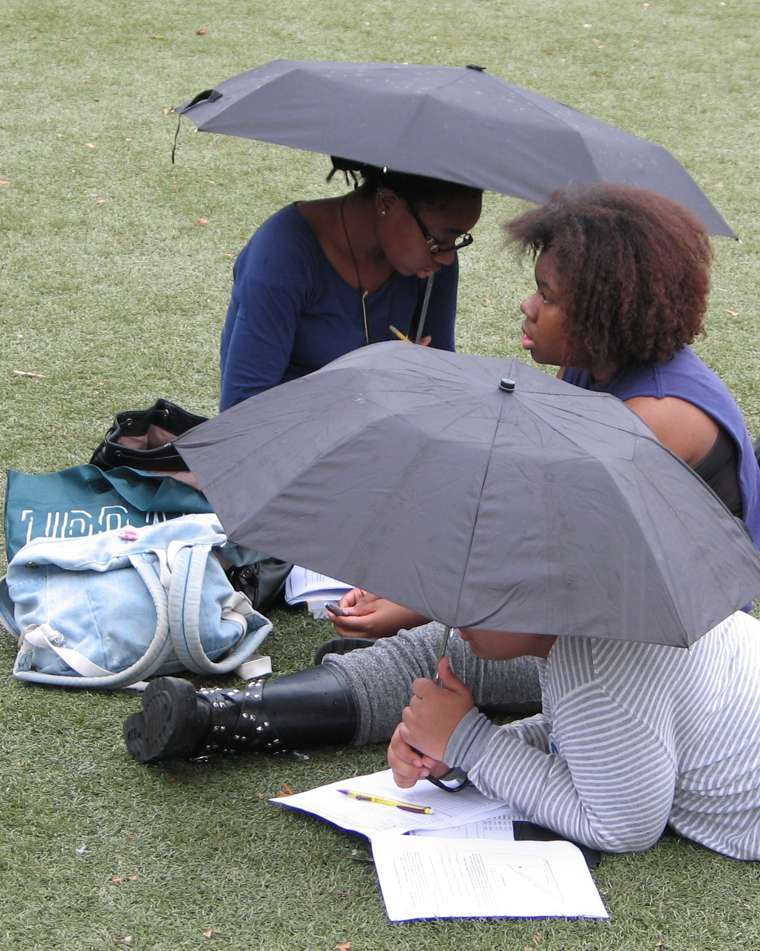
Ward’s Island on the Harlem River
Andrew Mittga, The Young Women’s Leadership School of East Harlem
Cathleen Doherty, Lamont-Doherty Earth Observatory
42 - 9th and 12th graders
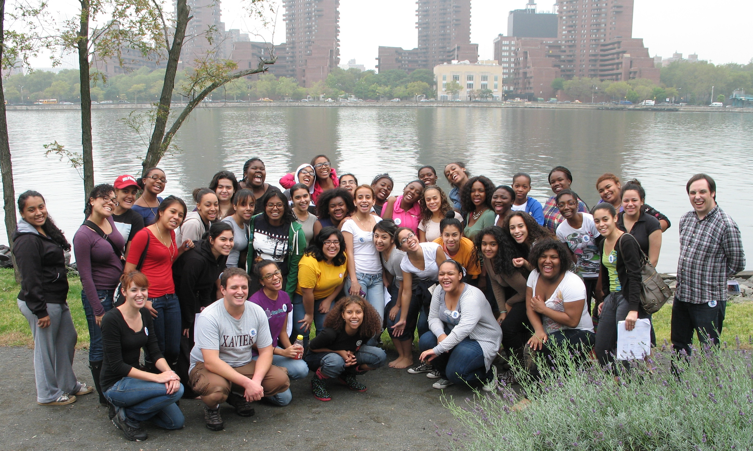
ITEM | Time | Reading 1 | Reading 2 | Comments
Fish Catch – | Number caught | Species | Length of largest
 | 2 | Striped Bass
 | 2 | Atlantic Silverside
 | 1 | Winter Flounder | Young of year | 5
 | Total Fish 5 | Total Diversity 3
 | some | Blue Crab
 | some | Hermit crab

