Day in the Life of the Hudson River 10/4/12
HARLEM RIVER MILE 13
Swindler’s Cove Park on the Harlem River
Mya Jenkins, Jasmine Santana, Ifeoma Nwoke, Dennis, New York Restoration Project
Queila Cordera, Amistad Dual Language School -5th grade PS/MS311 (53 students), 7 adults
PS 5 Ellen Lurie School–4th grade (50 students), 2 adults
(103 students total)
GPS Latitude 40° 51’36”N – Longitude 73°55’12”W
(40° 86 N -73° 92 W)
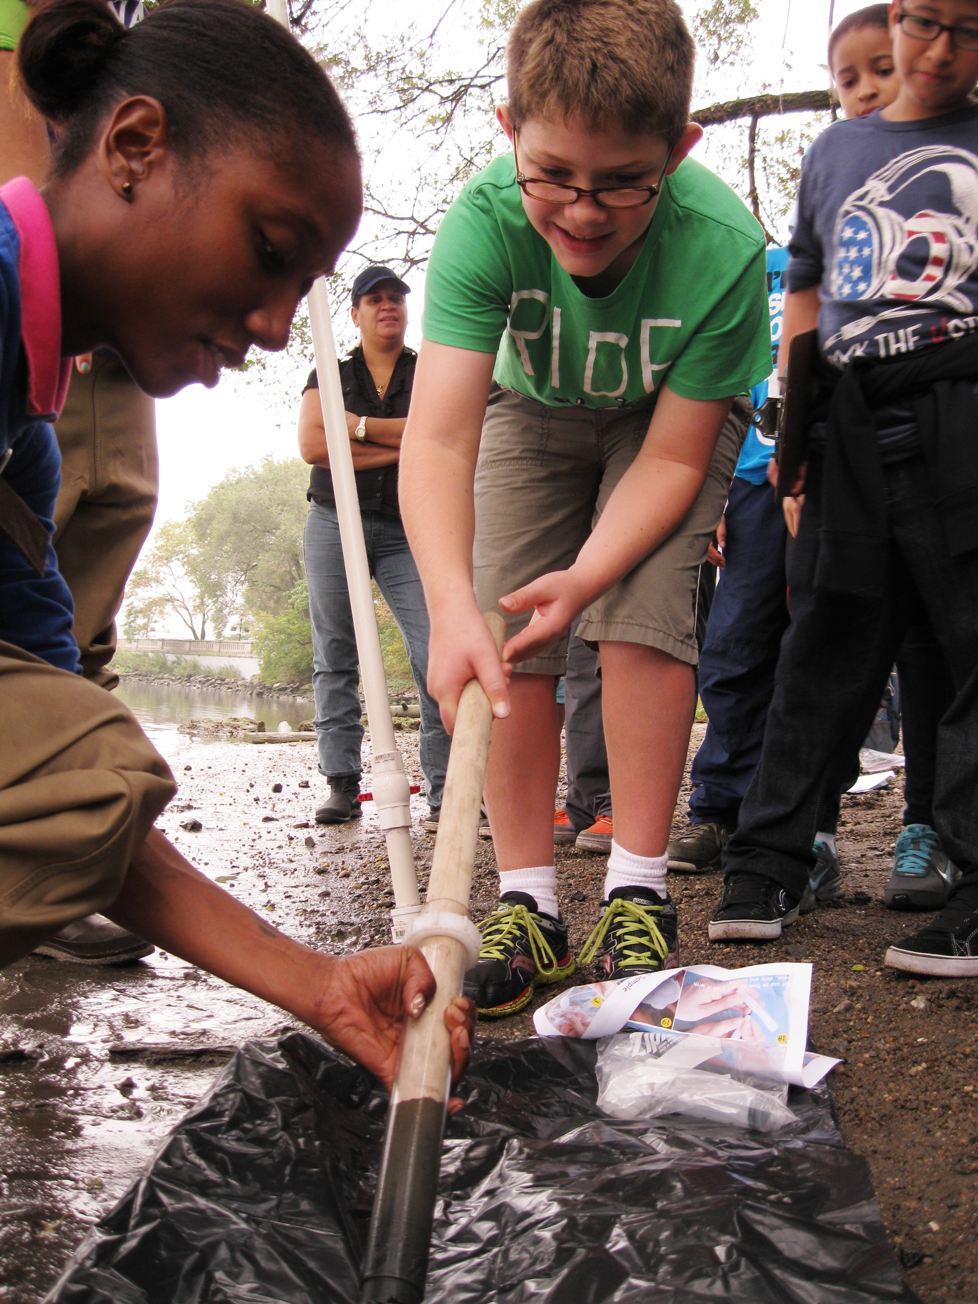 | 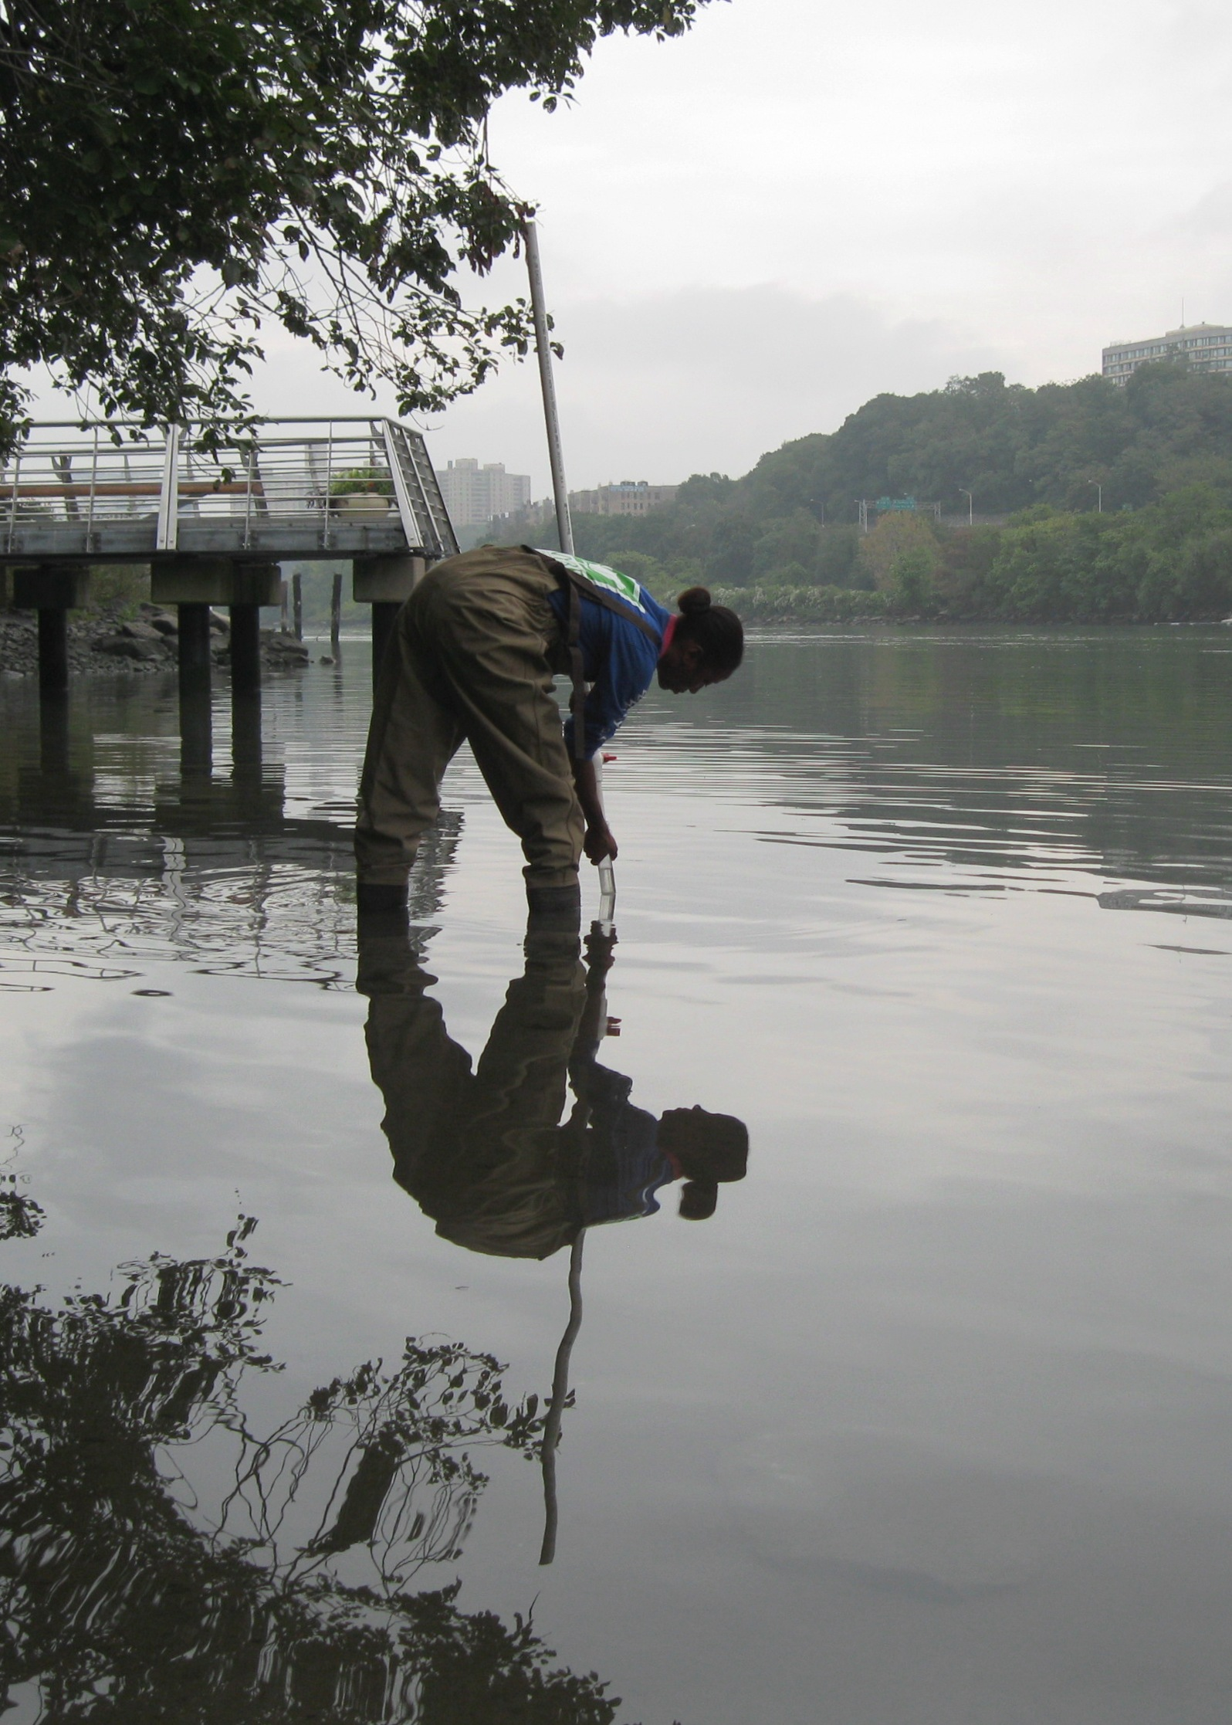
Location: Beach at Swindler Cove Park, next to the north end of Harlem River Drive, Manhattan
Area: There is a pier, beach, floating boathouse with a dock. Area used for boating, rowing, biking, walking, school groups
Surrounding Land Use: 50% Urban/residential, 10% forested, 5% beach, 35% Industrial/Commercial
Sampling Site: Sandy, muddy beach area, covered with vegetation, riprap banks
Plants in area: grass, sycamore trees
Water depth:
River Bottom: sandy, muddy & rocky bottom
ITEM | Time | Reading 1 | Reading 2 | Comments
Physical | Sampling occurred between 10:00 AM to 2:00 PM
Air Temperature | 9:45 AM  10:00 AM | 24.2°C  24.8  23.6  24.4 | 75.6 °F  76.7  74.4  76
Wind Speed | 10:30 AM | Beaufort Force #0
Cloud Cover | Mostly cloudy | Overcast stratus/nimbostratus at 10:30 AM
Weather today | drizzly
Weather recently | Rainy and humid
Water | calm
Water Temperature | 9:15 AM  11:15 AM  1:15 PM | 20°C  21  20.5 | 68°F  69  68.5
Turbidity – long site tube | AM  Noon  PM | 42.5cm  44 cm  47 cm
Chlorophyll | 9:10 AM | 2.5
Chemical | TIME | DO | Temp
DO | 9:30 AM | 6 ppm | 20°C | 65% saturation
 | 10:30 AM | 8 ppm | 21°C | 90 % saturation
 | 1:30 PM | 9 ppm | 20.5°C | 93% saturation
pH – | 9:20 AM | 7
 | 11:20 AM | 7.5
 | 1:20 PM | 7.5
Salinity | AM | 14 ppt
 | Noon | 14 ppt
 | PM | 15 ppt
Fish Catch – more than 30 seine attempts made during day | Number caught | Species | Length of largest | Diversity & Total catch
10 groups of 4 students seined hourly from noon to 2PM | 1 | White Perch | 9.5 inches | Div=4  Totals=9 plus jellies
 | 4 | Atlantic Silverside | 3 inches
 | 4 | Blue Crab | 1 adult, 3 juvenile
 | ~50 | Moon Jellies
Tides | Time | Water height in cm | Rising or Falling
 | 9:30 AM | 397 cm | Falling
 | 10:05 AM | 393 cm | Falling
 | 11:08 AM | 345 cm | Falling
 | 12:50 PM | 400 cm | Rising
 | 1:10 PM | 390 cm | Rising
 | 1:35 PM | 390 cm | Unchanging
Currents |  | 15 cm/sec | ebb
 |  | 25 cm/sec | ebb
 |  | 19 cm/sec | ebb
 |  | 27.5 cm/sec | ebb
Core Sample Sediments | Length | Common | Present | Description
1st core | 11cm – totl  5 cm oxidized top | Clay  Sand | Oil
2nd core | 8 cm – 3 cm oxidized top | Clay  Sand | Oil  Wood bits (rare)
Traffic – recreational (No commercial traffic noted) | 9:55 AM | Speedboat | DaddyO | White - southbound
 | 10:30 AM | Jet skis |  | Northbound
 | 1:35 PM | US Coastguard |  | Northbound

