Day in the Life of the Hudson River 10/4/12 Data
HARLEM RIVER MILE 13b
Sherman Cove Park saltmarsh flats, Harlem River
Obed Fulcar, Friends of Sherman Creek
MS319 Middle School/Children’s Aid Society Afterschool program 6th/7th
8 students, 1 adult – afterschool sampling start time 3:30 PM
GPS Latitude 657452.5 E (aprox)_Longitude 766785.8 N__(aprox)___
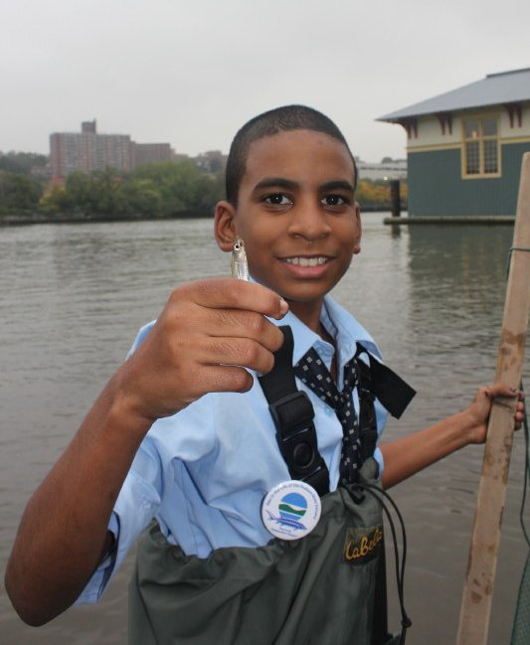 | 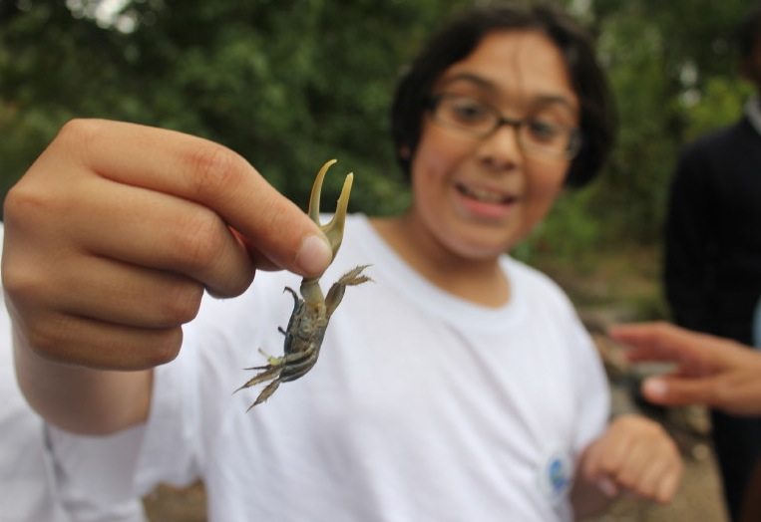 | 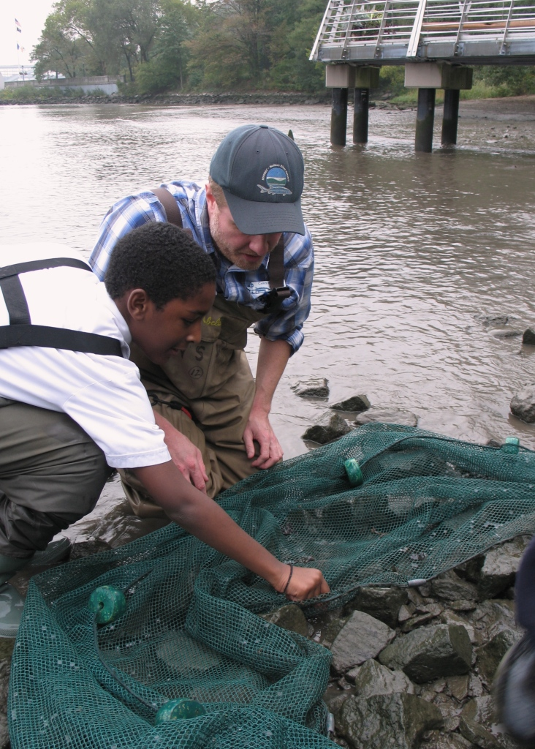

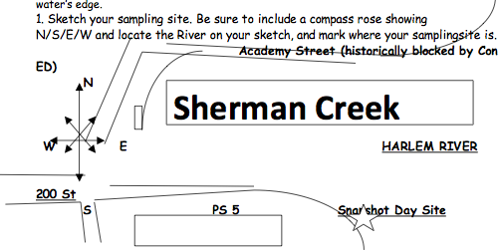
Location: Saltmarsh/mudflats at Sherman Cove Park next to a side road/school building, adjacent to Swindler Cove next to the north end of Harlem River Drive, Manhattan – a forever wild area.
Surrounding Land Use: Parking lot - 50% urban/residential, 20% forested, 5% beach, 5% Industrial/commercial, 5% other
Sampling Site: Beach area, covered with vegetation - Sampled in salt marsh covered with phragmites on one side and a mudflat with gravel on the shore
Plants in area: 50% of site is invasive Phragmites, 5% native spartina, 10% native milkweed, 35% other, and some oak trees
River Bottom: muddy bottom
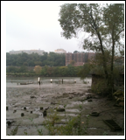 | 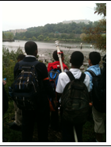 | 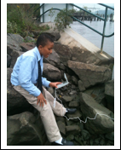
Rocky shore , sand mixed with lumps of coal, mudflats. Shore covered with rocks on one side and mud on the other. Expect rain increased turbidity, and affected DO and salinity.
ITEM | Time | Reading 1 | Reading 2 | Comments
Physical
Air Temperature
Wind Speed
Cloud Cover | overcast
Weather today | Clouds | Rain by end
Weather recently | Rain last few days
Water
Water Temperature | 5:50 PM | 20.9°C | 12 inch water depth
Turbidity – Short site tube | 5:50 PM | 100 JTUs |  | Water was very turbid from rain and upcoming high tide
Chlorophyll
Chemical
DO – LaMotte greenforce kit – (note:this is a low resolution sample kit) | 5:55 PM | 0mg/L | Temp. 20.9°C | 0% sat.
pH – | 5:50 PM | 6
Salinity | Not read
Phosphate |  | 2.0 ppm
Nitrate |  | 0.5 ppm
Ammonia |  | 0 ppm
Fish Catch *see journaling below | Number Caught | Species |  | Size
 | 6 | Silversides | 3 inches
 | 1 | Winter Flounder | 3 inches | juvenile
 | 4-5 | Jellyfish
 | 1 | Blue Crab | 2 inch | Juvenile
 | 1 | Fiddler Crab
 | Few | Shrimp
Total Catch | 14 | Diversity | 6
Tides | 3:45 PM | Tide was low exposing large areas of mudflat (see above photo)
Currents | Not read
Core Sample Sediments | Unable to collect due to weather & tide
Commercial Traffic | 5:00 PM | Circle Line | White/Red | Northbound – fully loaded
 | 5:10 PM | Coast guard | Orange/White | Southbound/ light
 | 5:20 PM | Tugboat/barge | Black | Southbound/ empty
Recreational Traffic | 4:50 PM | Jet Skis | White | Northbound
 | 5:30 PM | Rowing shell | White | Southbound
Other Items  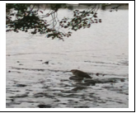 | We observed upon arriving a juvenile crown night heron foraging for fish or small crustaceans in the tide pools left on the mudflats by low tide (photo)
E-Coli Bacteria Test: | We tested the water quality of the site by using the LaMotte Greenforce tablet reagents. We followed the protocol by pouring the sample to 10mm in the glass vial containing the tablet, and mixing it until the tablet dissolved. We stored the sample upright, covered from any light source for 24 hours, and when we compared the color (yellow with foam in the top layer) to the ID card the sample showed positive for the presence of E-coli. Friends of Sherman Creek have tested the site for the past 4 years, and the last 5 tests have come out positive. Several NYCDEP (NYC Dept of Environmental Protection) CSOs (Combined Sewer Overflow) that drains and discharge raw sewage into the Sherman Creek and the Harlem River seriously impact the Harlem River with this level of pollution.
Journaling | 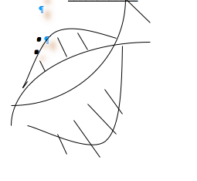  Dots in sketch show seine site. We were able to cast our seine nets and conduct the Fish & Macro invertebrate activity. About 4 of the boys donned their waders with assistance from Chris, Steve and Laura. They had a blast, and it was going on 6pm and they wanted to keep going, even as the rain started to fall. I call this a successful Snapshot Day 2012!

