Day in the Life of the Hudson River 10/4/12 Data
RIVER MILE -7 Ft. Wadsworth, Staten Island, NY
Geri Kobryn-Blatter, Shalini Gopie, Dan Meharg, Carol Williams, Kathy Garofalo National Parks Service, NPNH Education Center
Mary Lee - St. Clare’s – 7th grade, 59 students, 8 adults
GPS latitude N40.35.56.8° W 074.031.15.1°
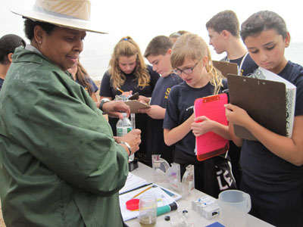 | 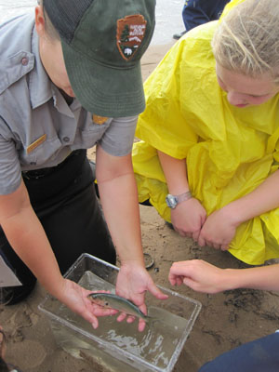 | 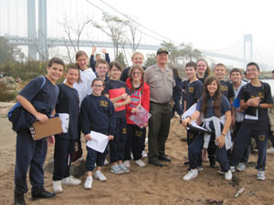
Location: Seabee Fishing Beach, Fort Wadsworth, just south of the Verrazano Bridge, Staten Island
Area: Shoreline is 50 % beach, 50% forested,
Surrounding Area: 100% fishing beach – beach and riprap
River Bottom: sandy, pebbles
Water Depth:
Plants in water: no plants in water
Plants in Area:
ITEM | Time |  | Reading 1 | Reading 2 | Comments
Physical
Air Temperature | 10:10 AM |  | 25° C | 77°F
 | 11:30 AM |  | 25 °C | 77° F
Wind Speed
Cloud Cover | overcast |  | Trace amount of rain
Weather | Overcast, drizzly,
Weather yesterday | Some rain, warm
Water Surface | Calm
Water Temperature | 9:55 AM | 20° C
 | 10:20 AM | 21 °C
 | 10:55 AM | 21 °C
 | 11:15 AM | 21 °C
 | 11:00 AM | 18 ° C  18  18 |  |  | 18° C

Turbidity | 10:22 AM | 70.9 cm  70.8 cm  50.2 cm |  | Average 66.9 cm
Chlorophyll | 10:35 AM | 0.1
Chemical
DO - tablet | 10:04 AM | 4 ppm | 20° C | 40% saturation
pH - tablet | 10: 00AM  10:23AM 10:45AM 11:09 AM  11:34 AM | 7  7  7  7  7
Alkalinity
Salinity -  hydrometer | 9:55 AM  10:05 AM  10:28 AM  10:50 AM  11:12 AM  11:36 AM | 39 ppt  35 ppt  21 ppt  24 ppt  23 ppt  28 ppt
Fish Catch | Number Caught | Species | Length
 | 112 | Atlantic Silversides | 5 cm
 | 1 | Snapper Bluefish (young) | 10 cm
 | 1 | Needlefish | 15 cm
 | 3 | Jellyfish | 6 cm
Totals | 117 catch | Diversity 4
Tides | Time | Height in cm | Rising, Falling
 | 9:49 AM | 65 cm
 | 9:54 AM | 68 cm | Rising
 | 9:59 AM | 70 cm | Rising
 | 10:26 AM | 70 cm | Unchanged
 | 10:47 AM | 70 cm | Unchanged
 | 10:57 AM | 71 cm
 | 11:05 AM | 72 cm
 | 11:24 AM | 70 cm
Currents | Time | Cm/60 secs | Cm/sec | Ebb/Flood
 | 9:54 AM | 770 cm/60 sec | 12.8 cm/sec | East/F
 | 10:04 AM | 500 cm/60 sec | 8.3 cm/sec | East/F
 | 10:21 Am | 1000cm/60sec | 16.7 cm/sec
 | 10:26 AM | 2210cm/60ec | 36.8 cm/sec
 | 10:57 AM | 865 cm/60 sec | 14.42 cm/sec
Core | Length | Comment | Abundant | Other
Boat Traffic | 9:50 AM | CUA CGM Blue | North | loaded
 | 9:59 AM | Oil Tanker orange | North | loaded
 | 10:07 AM | Tug white | North | Light
 | 10:50 AM | Oil Tanker red and black | North | loaded
 | 10:53 AM | Oil Tanker Damico B&Red | North | Loaded
 | 11:33AM | Cargo red | East | Loaded
 | 11:42 AM | Bulk Carrier white & blue | North
 | 11:42 AM | Seastreak blue and white

