Day in the Life of the Hudson River 10/4/12 Data
RIVER MILE 0.5 –Harbor @ Bay Ridge Flats south of Governor’s Island
Boat Based South Street Seaport Museum
Maggie Flanagan, Pioneer
Chris Bowser, NYSDEC HREP
Andries Hudde Junior HS/IS 240 – 8th graders –31 students, 7 adults
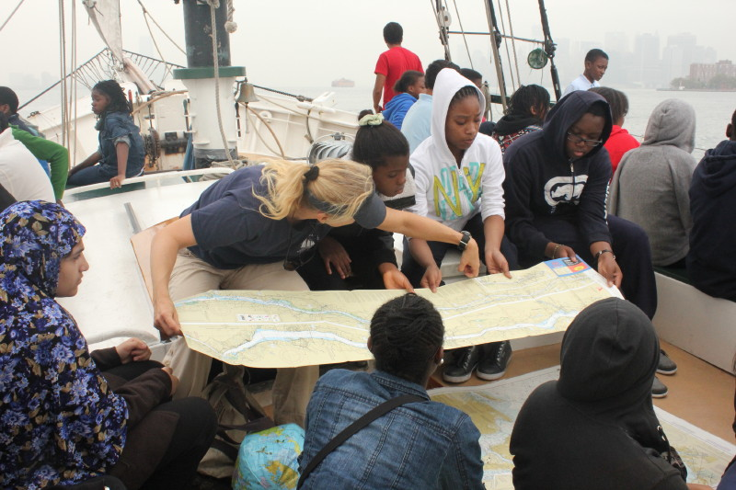

Location: The Hudson Harbor Bay Ridge Flats, south of Governor’s Island
Area: The Harbor of the Hudson River
Surrounding Land Use: 95% urban/residential; 5% industrial/commercial
Water depth: 40-60 feet
River Bottom –unable to determine
Water: calm
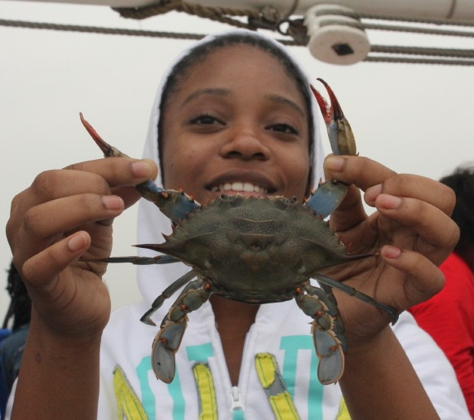 | 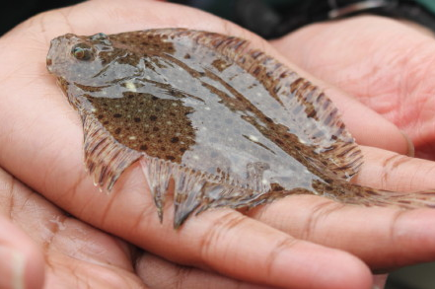 | 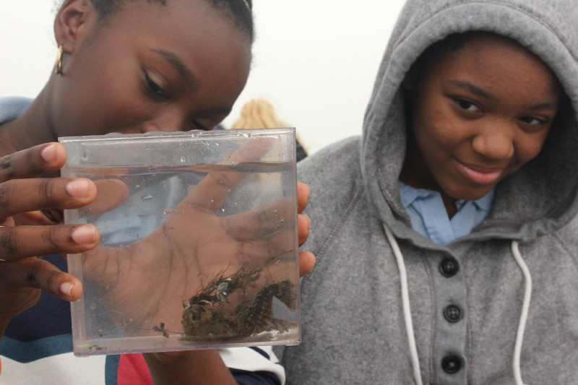

Sampling 10:30-1:30 PM
ITEM | Time |  | Reading 1 | Reading 2 |  | Comments
Physical
Air Temperature
Wind Speed
Cloud Cover | overcast
Weather yesterday | Rainy,
Water Temperature | 11:20 AM | 20.1° C  69° F
Fish - trawl | AM Time | Catch |  | Number
 |  | Scup (Porgy) |  | 2
 |  | Lined Seahorse |  | 1
 |  | Windowpane Flounder |  | 1
 |  | Blue Crabs |  | 3 |  | Adult female
 |  | Blue Crabs |  | Several |  | Juvenile (nickel sized)
 |  | Mud crab |  | Many
 |  | Red beard sponge |  | Several
Almanac entry | At the fish station students closed their eyes and I placed a small red beard sponge or bryozoans in each hand. The immediate recoil when they opened their eyes was followed by incredulity that these were actual animals, not clumps of debris. The catch also included two porgies, several female blue crabs, a dozen button-sized mud crabs, a palm-sized windowpane flounder, and…drumroll please...an exquisite three-inch lined seahorse, a first for Day in the Life! It was astounding to see this little fish curl its tail around a piece of sponge as we coasted along the Brooklyn waterfront.

