Day in the Life of the Hudson River 10/4/12 Data
RIVER MILE 115
Cohotate Preserve, Athens, Greene Co.
Liz LoGuidice, Cornell Cooperative Extension of Greene County
Tony Loughran, Coxsackie Athens High School, AP Bio - 20 students, 11-12th
Donna Trunzo & Sue Boyle, Cairo Durham HS/MS – 20 students, 9th
(adults – 3 teachers, 3 chaperones, 4 instructors)
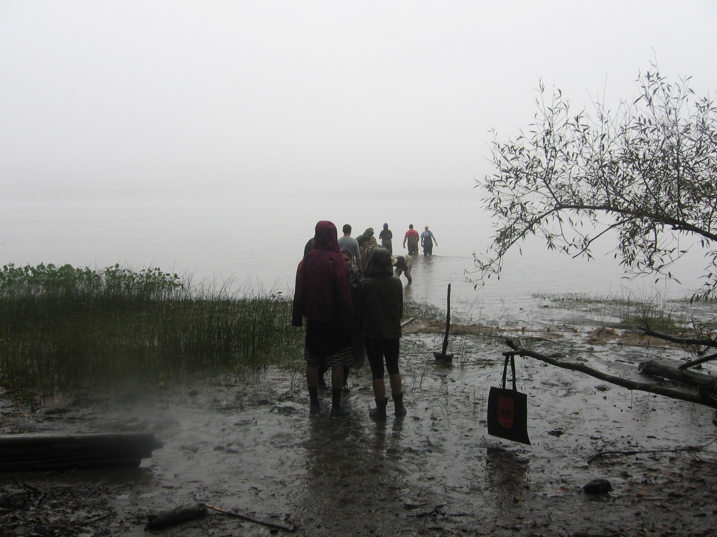
Location: Cohotate preserve – Ice house site –
Area: The ice house is a flat, grassy are onthe river with several cotton wood trees. It is situated at the bottom of a forested hill. Large waterfront vegetated. The artificial shoreline of the bulkhead dominates the eastern shore. Shoreline is characterized by tidal mudflats. Area is used recreationally for picnicking, hiking and fishing. Ice house is approximately ½ miles walk from the parking area.
Surrounding Land Use: Forested 70%, Beach 5%; Urban/residential 15%; Industrial Commercial 5%; wetland 5%
Sampling Site: Beach area, Shoreline includes tidal mud flats in the southeast, with a rocky shore further south. To the north of the tidal mud flat there is an old bulkhead, with another tidal flat to the north of the bulkhead, rip rap in sections.
The banks have been altered at the bulkhead (entire ice house area is likely dredge spoil), wood and debris are collected in the southern mudflat, there is lots of vegetation and no pipes entering the water. Brick pieces on shoreline
Water Depth: We fish at the southern mud flat, which has a muddy bottom and a variable depth, depending on tide.
River Bottom: Muddy, rocky, weedy
Plants in area: 25% of water covered in plants – Arrow Arum, Arrowhead, Bur-reed, Pickerelweed, Spatterdock, Yellow Flag, Jewelweed,
ITEM | Time |  | Reading 1 | Reading 2 | Comments
Physical
Air Temperature | AM |  | 20 °C | 68°F
 | AM |  | °C | 66°F
Wind Speed | none
Cloud Cover | Foggy, cloudy
Weather today | Fog, drizzle, precip.
Weather recently | lovely
Water Temperature | 9:10 AM | 66.5°F  66.3  66.5 |  |  | Average 66.4°F
Water | calm
Turbidity  Long site tube | 10:00 AM | 110  123  123 |  |  | 119 cm
Chlorophyll
Chemical
DO  (drop count kit) | AM | 7 ppm |  | °C
pH – color match kit | AM | 7
Salinity -  Test strips | AM | 44-45 ppm Chloride |  |  | 79 Total Salinity
Fish Catch  40 ft. X 30 ft. | Total # | Species – |  | Macros | Totals
2 pulls | 5 | Striped Bass |  | Scuds | hundreds
FISH | 5 | Pumpkinseed |  | Damselfly nymph
Diversity 9 | 2 | White Perch |  | Leeches
Total Catch 136 | 18 | Blue Gill |  | snails
 | 19 | Banded Killi |  | Zebra Mussels
 | 52 | Herring
 | 12 | Spottail Shiner
 | 3 | Mummichog
 | 8 | Tesselated Darter
 | 12 | Blue Crab
Currents | Cm/60 sec | Cm/sec |  | Kts | flow
9-noon sampling | 96 cm | 1.6/sec |  | 0.0313 | South/ebb
 | 130 cm | 2.17 |  | 0.04 | South/ebb
 | 400 cm | 6.67 |  | 0.14 | South/ebb
 | 160 cm | 2.67 |  |  | South/ebb
 | 95 cm | 1.53 |  | 0.031 | South/ebb
Shipping | 9:40 AM | Motorboat |  |  | South
 | 10:17AM | Motorboat |  |  | North
 | 11:57AM | Motorboat |  |  | South
October 4, Cohotate Preserve – The fog was so thick that we could not differentiate between the water and the sky when the students arrived at 8:45 am. Our spirits were not dampened by the drizzly rain that fell upon us as we gazed out into the gray abyss of the river. The fog gradually cleared as the morning progressed and the students were able to describe the physical characteristics of the shoreline that had been hidden from view. A brilliant, fall landscape was revealed by the end of the day.

