Day in the Life of the Hudson River 10/4/12 Data
RIVER MILE 116 – Athens Riverside Park
Elisa Futia, Edward J. Arthur Elementary School
14 second grade students
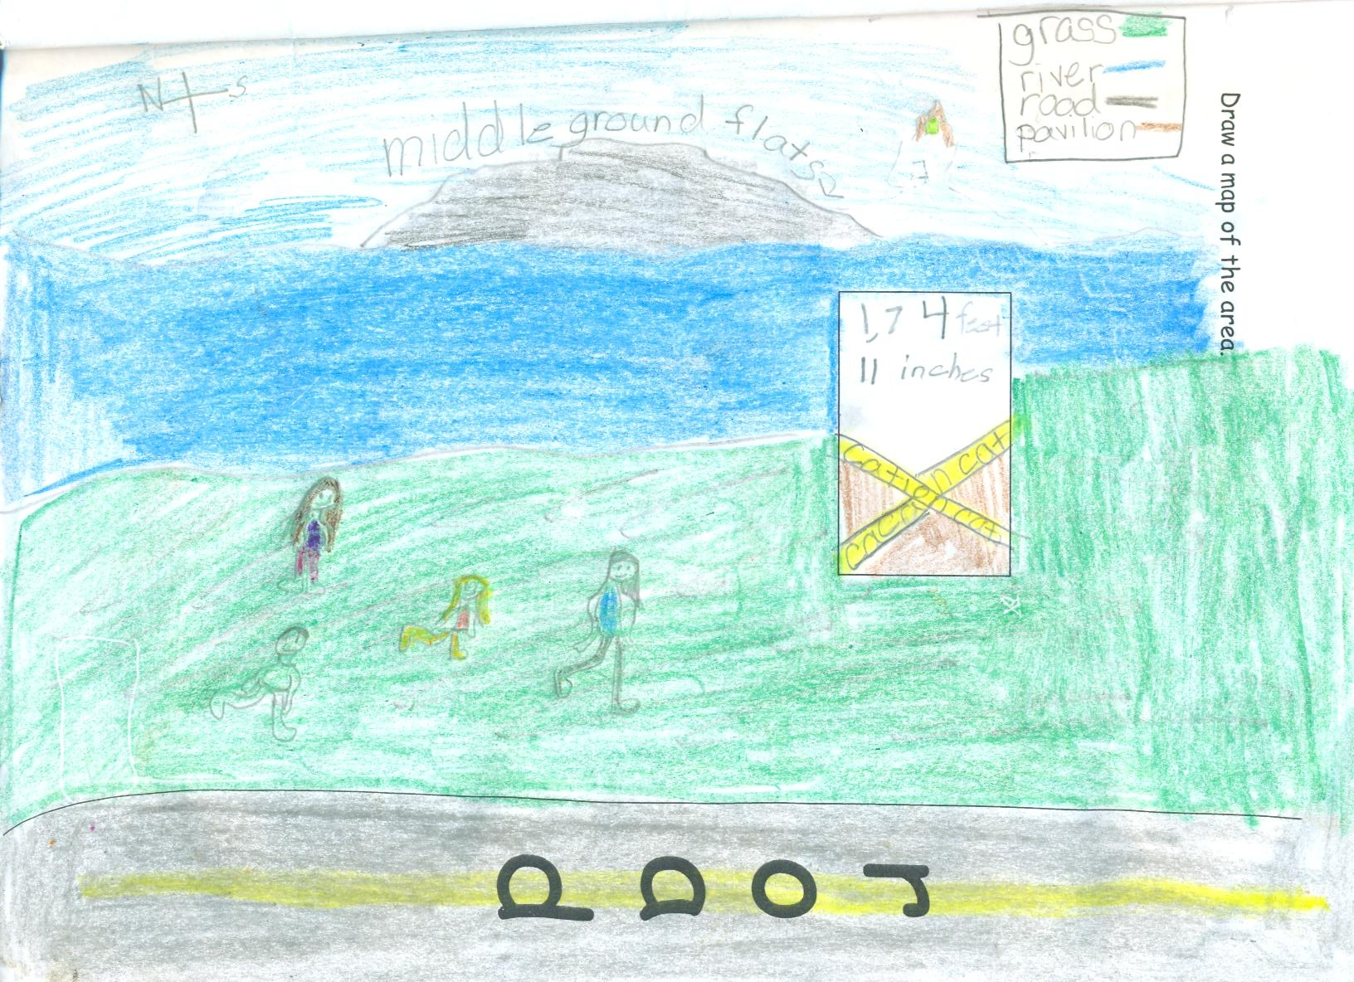 | 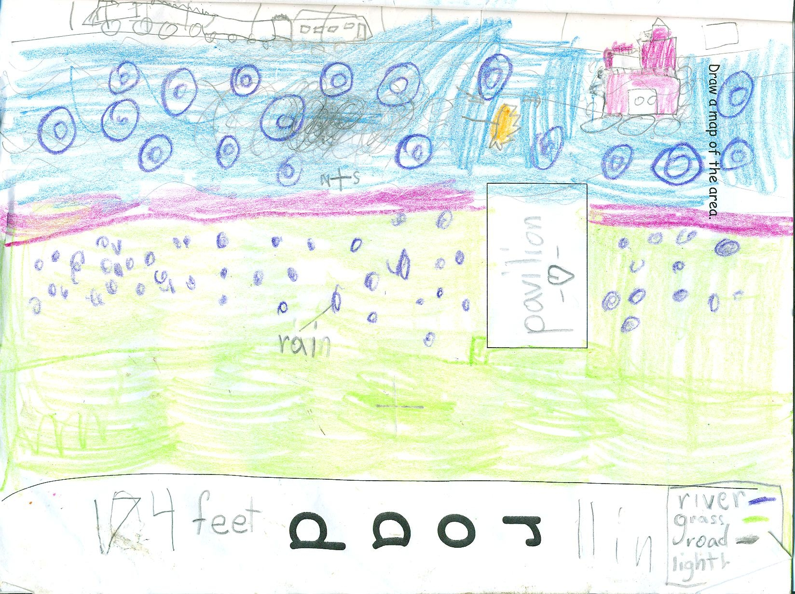
Samples of student site descriptions and sketches

Location: Waterfront of Athens, Greene County
Area: Grassy Park area with benches and lookout
Surrounding Land Use: 100% parkland with 75% vegetated coverage – grassy, parking lot, used for picnics, boating, fishing
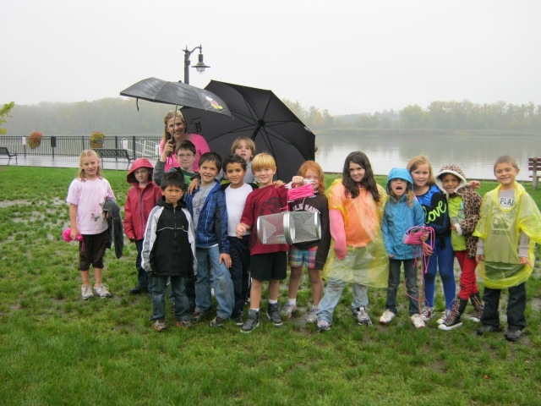
Ms. Futia’s second grade class took a trip to the Hudson where they collected data about the river on this wet, wonderful, rainy day.
- They drew a map of their travels and sketched the Athens riverfront like Thomas Cole the famous Hudson River School artist.
- They used a Beaufort chart to measure the wind
- The collected and compared air and water temperature
- They measured the water clarity with a secchi disk
- They wrote about what they saw, learned, liked and didn’t like
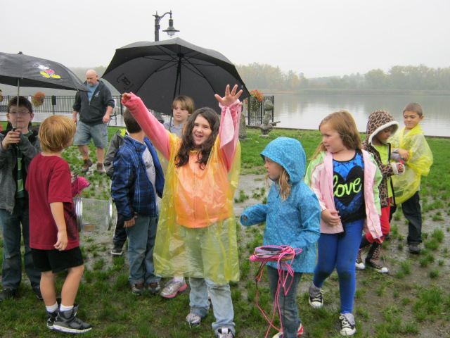
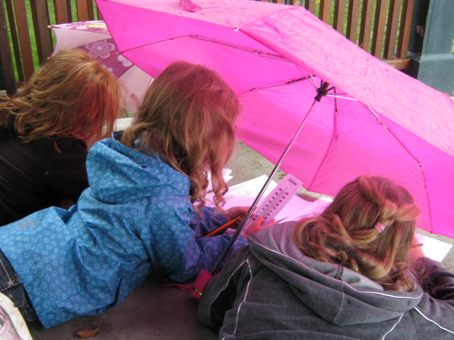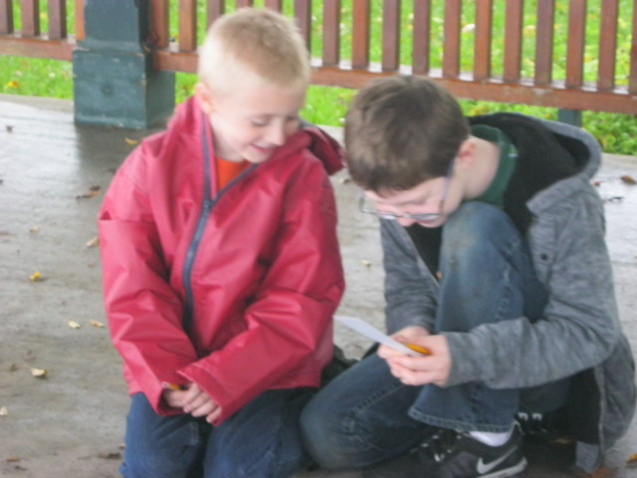


UNTIL NEXT YEAR!

