Day in the Life of the Hudson River 10/4/12 Data
RIVER MILE 127 – Stuyvesant Landing
Chelsea Benson, Leanne O’Grady - Columbia County Soil & Water Conservation District
Elizabeth Pagnani, The Alternative Learning Center (TALC) – 3-11 yrs. –
4 students & 5 adults
Latitude 47 N Longitude 73W (topo map)
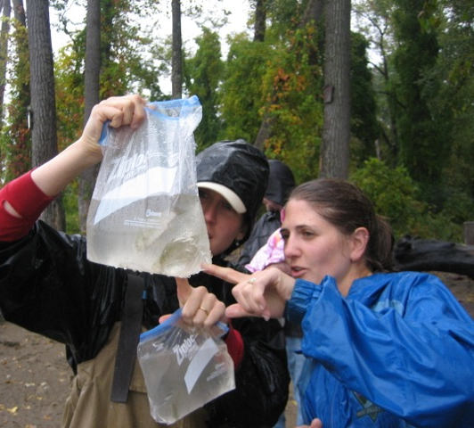 | 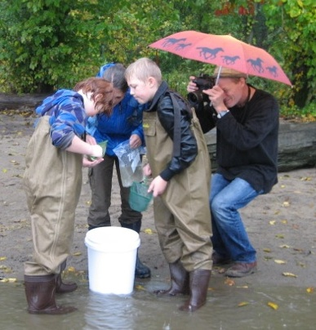 | 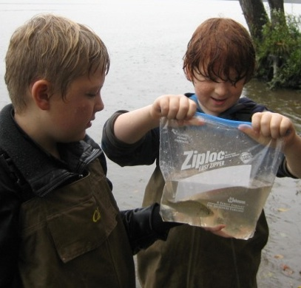

Location: Sandy point of Stuyvesant Landing, Columbia County. The sandy point is just south of the parking lot.
Area: forested area with narrow beach used for swimming, picnics & camping by permit. Park/Boat launch, sandy beach area on the point
Surrounding Land Use: 95% forested, 5% beach – used for picnics, swimming, campfires, sandy beach and dense woods behind
Sampling Site: Beach area
Plants in area: no plants in water
Water depth: waded in approx. 4 ft.
River Bottom –gradual slope, sandy

ITEM | Time | Reading 1 | Reading 2 | Comments
Physical
Air Temperature | 3:43PM | 68°F  20°C
Wind Speed | Beaufort 0-1 | 1.4-2.2 knots Anemometer | Coming from North
Cloud Cover | overcast
Weather today | Rain increasing during sampling. | Measuring in the moisture of our clothes = soaked! |  | About 5PM clouds blew off and a little sun came out
Weather last 3 days | Mild weather - mid 60°F during day – low 50°F night. Humid, rainy
Water | Calm
Water Temperature | 3:20 PM | 66.5°F  19.2°C
 | 3:30 PM | 65.4°F  18.5°C
Turbidity – short site tube | 3:40 PM | 60 JTU
Chlorophyll | 4:00 PM | 0.
Chemical
DO  Drop count | 4:00 PM | 6.0 mg/L | 19 ° C | 65%
pH  meter | 3:15 PM | 8.3
Nitrates | 3:30 PM | 0.27 ppm
Phosphates | 3:45 PM | 0.17 ppm
Alkalinity | 3:50PM | 60ppm
Salinity  Quantab Test strip | 3:45 PM | .006*  readings on wick stick | 34 ppm Chl⁻ | 61 ppm total salinity
Fish Catch –2 pulls - Seine 40 ft. X 3 ft.  Mesh 0.25 inch | Number Caught | Species | Size of largest | 3 seines –5 min. pulls- all caught in third seine
4:40 PM | 30 | Spottail shiner | 8 cm
 | 5 | Herring | 6 cm
 | 4 | Banded Killifish | 7 cm
 | 2 | Yellow Perch | 11 cm | Grand Total 41
Tides | 3:15 PM |  | 28 cm
 | 3:30 PM | Rising | 33 cm | .33 cm/min
 | 3:40 PM | Rising | 40 cm | .7 cm/min
 | 4:00 PM | Rising | 47 cm | .35 cm/min
Currents | 3:30 PM | 985.53 cm/60 secs | 16.42cm/sec | .32 knots
Our sampling beach is set back slightly from the direct current. We managed to get the orange out into the current. |  |  |  | North/Flood

