Day in the Life of the Hudson River 10/4/12 Data
RIVER MILE 145
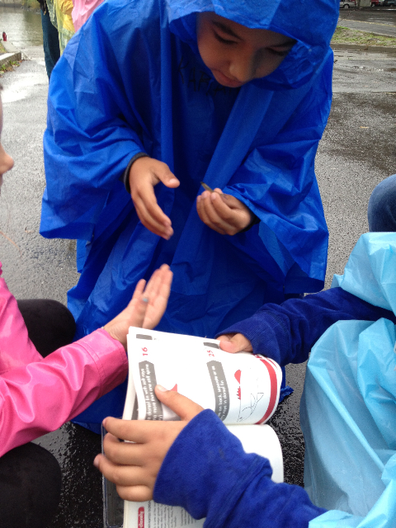 | 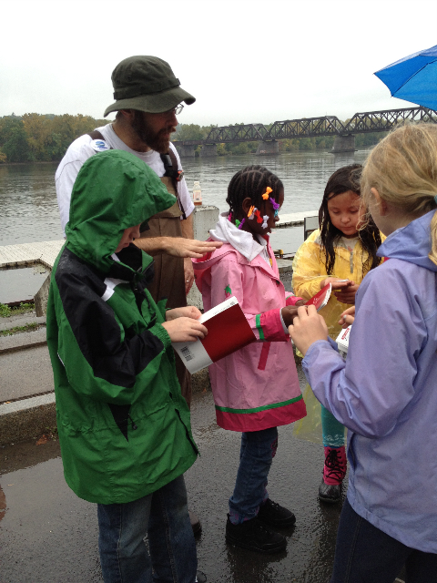
Karen Strong, Sean Madden NYDEC HREP, Corning Preserve, Albany Boat Basin, Albany
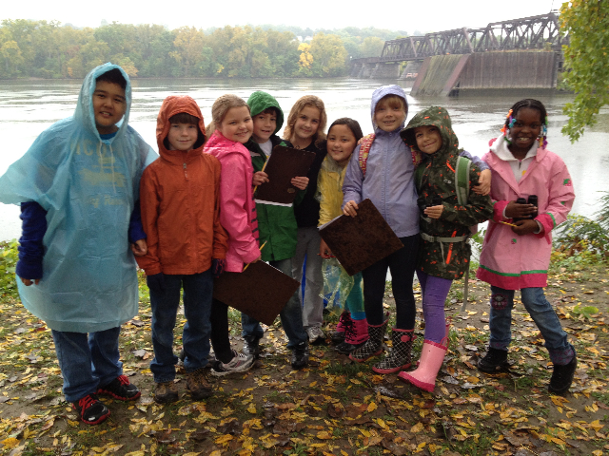
Natalie Aiello, Montessori Magnet School, 4th grade, 42 students
Latitude 43 Longitude 74
Location: Floating dock at riverfront park
Area: A path along the beach with rising forested hills, trees along both sides, plants along shore
Surrounding Land Use: Urban with sidewalks & amphitheater, picnic tables, train bridge, bike and walking path, parking lot but the Albany boat launch
Sampling Site: vegetation, banks altered, shoreline with raprap – floating dock
Plants: Trees: Ash and cottonwood; Tidal Marshes: Purple Loosestrife (invasive). Bittersweet (invasive), wild grape ivy (native, Water Chestnut (invasive)
River Bottom: Sandy and muddy

ITEM | Time |  | Reading 1 | Reading 2 | Comments
Physical
Air Temperature | 9:38 AM |  | 19° C  66° F | 12:43 PM | 20° C  68° F
Wind Speed | 9:38 AM |  | Beaufort #1 | Light air - | East
Cloud Cover | foggy
Weather today | Foggy and light rain
Weather recently | Yesterday 70s with light rain
Water calm | YES
Water Temperature | 9:55 PM | 15.5°C  60 ° F |  | 12:52 PM | 17.8°C  64 ° F
 | 11:10 AM | 14.5°C
Turbidity – long site tube | 10:52 AM | 102 cm  103 cm  89 cm |  |  | Average 98 cm
 | 12:30 PM | 90 cm  113 cm  110 cm |  |  | Avg. 104 cm
Chlorophyll | Time | Color Code
Chemical
DO  (drop count kit) | 10:15 AM | 10 mg/L |  | 16°C | 100%
 | 1:15 PM | 10 cm/L |  | 18°C | 105%
pH | 10 AM | 6.5 |  | 1:00 PM | 6.5
Salinity - quantab
Fish Catch  Seine 8 ft. X 3 ft i | Number Caught | Species |  | Length | Seine
10:40 AM | 1 | Herring |  | 3 inches | Diversity 2
12:30 AM | 44 | Herring |  | 1.5 inches | Total = 46
 | 1 | Banded Killifish
Tides | 9-1PM | Falling tide during sampling |  | LT was 8:20 AM
Currents – | TIme | # Cm in X sec |  | cm/sec | N/S -  Ebb/Flood/Still
 | 12:25 PM | 25 ft. in 42 secs |  | 1.68 cm/sec | South - Ebb
Shipping |  | Sailboats heading in both directions throughout the day

