A Day in the Life of the Hudson River 10/4/12 Data
RIVER MILE East River 1 East – Empire Fulton Ferry
Kara Gilmour & Isa Del Bello, Brooklyn Bridge Park Conservancy
Giannina Zlatar, The Brooklyn Waldorf School, 17 - 5th graders
40.7°N - 74°W
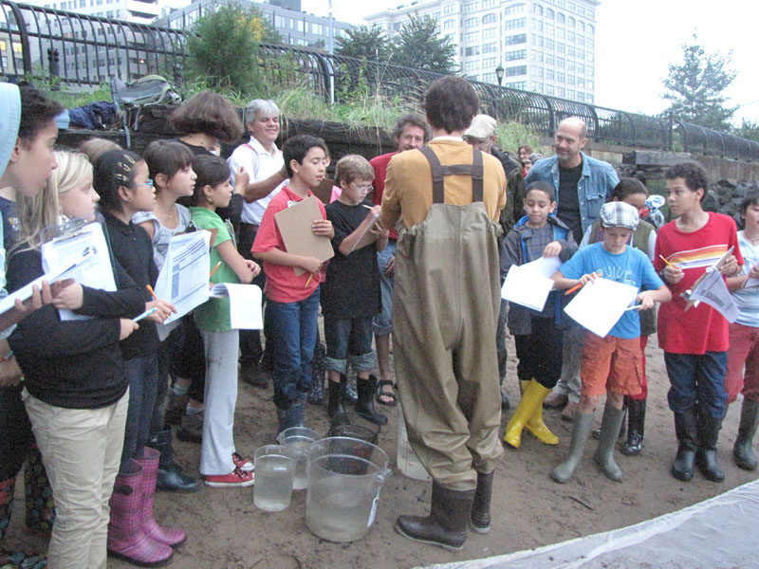
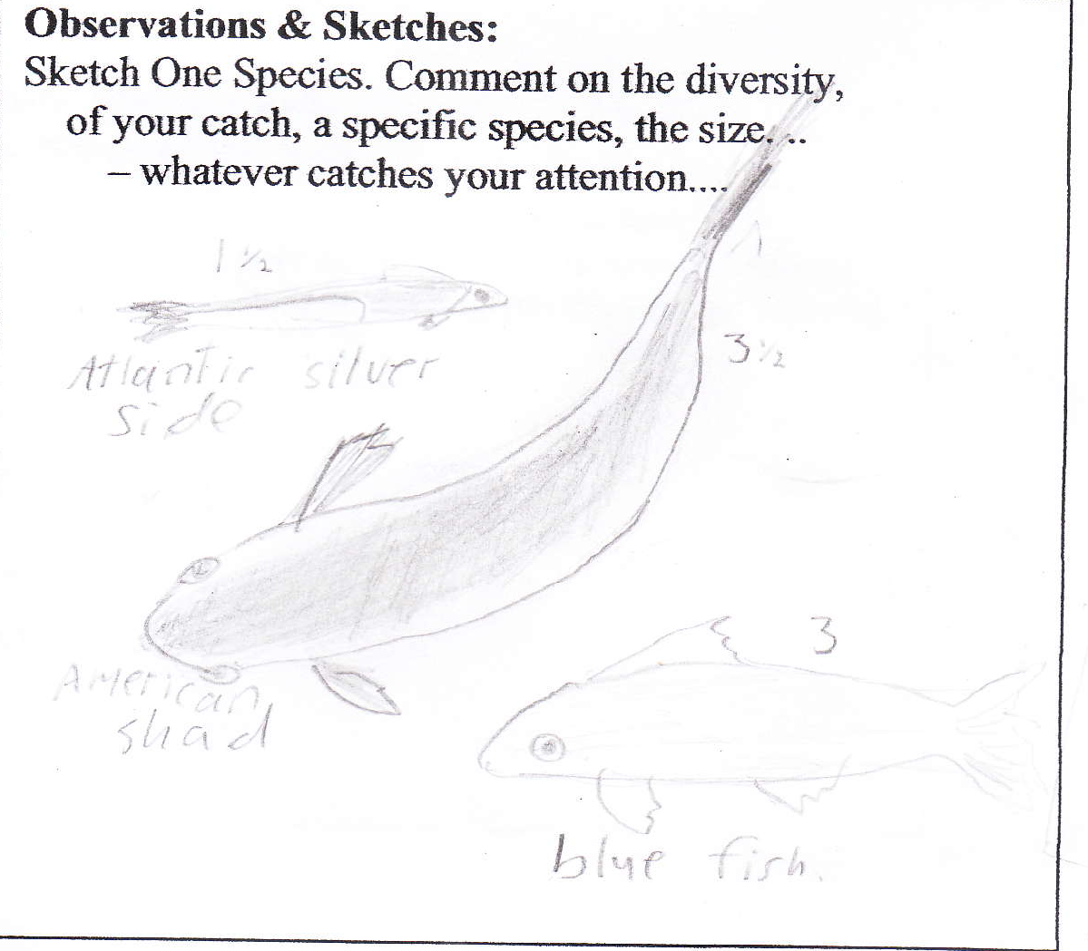

Location: South of the Manhattan Bridge @ Brooklyn Bridge Park
Area: 100% Urban/residential, 15% beach
Surrounding Land Use: Pier, bulkhead, riprap lots of commercial boats, fishing
Sampling Site: Rocky, sandy shoreline with rip rap, bulkhead, banks altered, piping entering river
Plants in area: no plants noted in water
Water depth: 10%
River Bottom –sandy, muddy, rocky
Times – 6:30-8:30 AM

ITEM | Time |  | Reading 1 | Reading 2 | Comments
Physical
Air Temperature | 8:05 AM |  | 20°C  64 °F
Wind Speed
Cloud Cover | Mostly cloudy
Weather today | Damp, humid
Weather last 3 days | Some rain, cloudy periods
Water Surface | Calm
Water Temp. |  | 22 °C
Turbidity - secchi | 7:45 AM | 40-46 cm
Chlorophyll | 7:55 AM | 2.0
Chemical
DO
pH
Salinity – hydrometer | 6:30-8:30 AM | 25.5 ppt |  | 22°C
Fish Catch – seine 20 ft. | 6:30 AM | Atlantic Silverside |  | 1 | 1.5 inch
 |  | Blue Fish |  | 1 | 3 inch
 |  | White Mullet |  | 1 | 3.5 inch
 |  | Periwinkle Snails |  |  | .25 inch
Tides | 6:30 AM | 0 cm
 | 8:00 AM | 36 cm |  | rising
Currents
Other Items
Core Description | Length | Abundant |  | Rare | No H2S smell
7:15 AM | 13 cm length | Sand and gravel |  | Pebbles, brick and coal | No oxidized top,
Commercial Shipping | 6:35 AM | Red boat |  | Southbound | Loaded
 | 6:50 AM | East River Ferry – white/black |  | Southbound | Light
 | 6:55 AM | Seastreak - white |  | Southbound | Light
 | 7:05 AM | East river ferry – blue roof |  | Southbound | Loaded
 | 7:10 AM | Policeboat – black/white |  | Southbound | Light
 | 7:15 AM | Seastreak again– blue |  | Northbound | Light
 | 7:15 AM | East river ferry again |  | Northbound
 | 7:20 AM | Pegasus – blue |  | Southbound | Loaded
Observations | No shells, saw buildings, parks, bridge, some crumbled pieces of brick.  Big wave – shoe gone in water!

