Day in the Life of the Hudson River 10/4/12 Data
RIVER MILE 2.5
Hudson River Park’s Pier #45
Shino Tanikawa- New York City Soil & Water Conservation District
PS 3 Manhattan K – 4th – 60 students
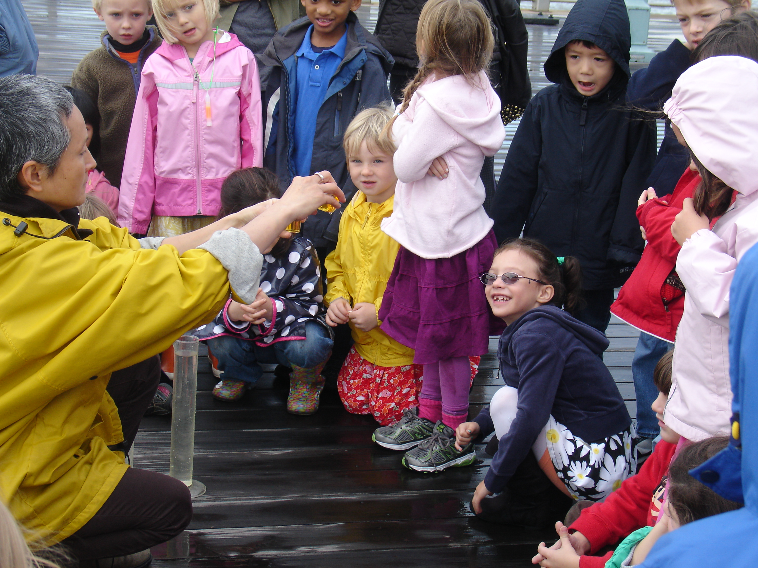

Location: Christopher Street Pier at the END of the pier where the “gazebo” is
Area: Pier, Banks altered – bulkhead – mainly metal and wooden pier
Surrounding Land Use: 100% Hudson River Park with walkway, some planted areas
Sampling Site: Recreational pier
Plants in area: None
ITEM | Time | Reading 1 | Reading 2 | Comments
Physical
Air Temperature | 11-11:30 AM | 21°C  22  23  22  24.5 |  | 22.5 average
Water Temperature | 11-11:30 AM | 20°C  20  21  20  21 |  | 20.4 average
Chemical
DO  (chemets ampules) | 11-11:30 AM | 5-6 mg/L
pH (ColorHast pH strip) | 11-11:30 AM | 7.5  6.5  7.0  7.5  7.0 |  | 7.1
Salinity (hydrometer) | Temp | Sp. Grav | salinity
 | 11-11:30 | 1.013 | 17.9 ppt | Average 18.6 ppt
 |  | 1.014 | 19.3
 |  | 1.014 | 19.6
 |  | 1.013 | 17.9
 |  | 1.103 | 18.3
Observations: It's raining now. It's so misty you can barely see the NJ skyline. The Statue of Liberty is almost out of view. -- Baird

It's a cloudy day out, but it's not raining. Fog hangs over the city, and I can't see the tops of some buildings. There's a light breeze. The water is kind of gray-green. A boat is coming. It's blue and white. There's also a water taxi coming. The water is bubbly. The water taxi makes big waves in the water. -- Kit

As you can tell, it rained a little then stopped, which is why the two students had different observations.

We saw a flock of geese (I think) flying in the typical V-formation, except barely a foot above water! There was heavy fog except for the narrow band right above the water, which provided a clear view path.

We also encountered a single Monarch butterfly on the pier.

