Day in the Life of the Hudson River 10/4/12 Data
RIVER MILE 23
Kinnally Cove & MacEachron Waterfront Park, Hastings-on-Hudson
Melissa Shandroff, Hastings High School APES 11th-12th grade, 48 students, 3 adults
Latitude 40°59’52”N, Longitude 73°53.03”W
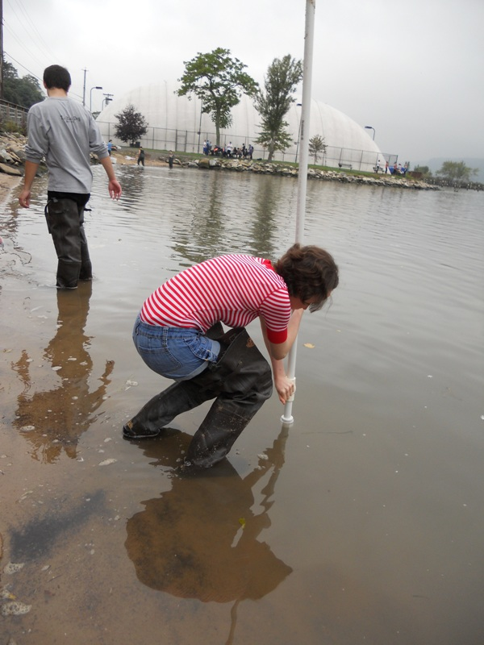
Location: Kinnally Cove, Hastings-on-Hudson, Westchester County
Area: Beach area with riprap shoreline, next to the park – used both spaces. Beach is totally covered during high tide.
Surrounding Land Use: 80% industrial/commercial (next to old Anaconda site), 5 % forested, 5% urban/residential, 10% beach
Sampling Site: beach, banks altered, riprap on shoreline, bulkhead
Plants in area: no water plants in area
Water depth: 4-6 ft.
River Bottom – sandy/muddy bottom

ITEM | Time |  | Reading 1 | Reading 2 | Comments
Physical
Air Temperature | 10:37 AM |  | 73.9 °F  °C | 10:54 AM | 74.4 °F  °C
 | 11:15 AM |  | 75.5 °F  °C | 11:34 AM | 76.0 °F  °C
 | 12:50 PM |  | 72.9 °F
Wind Speed | Beaufort 1 |  |  | SW
Cloud Cover | Overcast all day
Weather today | Overcast, small amount of rain during samplings <1cm (11:15-noon)
Weather recently | Rain, very humid
Water Surface | Calm
Turbididty – long site tube | 10:30 AM | 33.0 cm  45.0cm  40.0 cm |  |  | Average 39.3 cm
Chlorophyll | 10:45 AM | 1.0
Water temperature | 10:30 AM | 70.7 °F  69.8 °F |  | 21.5°C  21°C | Avg  70.25 °F  21.25°C
 | 11:00 AM | 68°F  69.8°F |  | 20°C  21°C | 68.9°F  20.5°C
 | 11:27 AM | 69.8°F  69.9°F |  | 21°C  21°C | 69.8°F  21°C
 | 12:30 PM | 69.8°F  73.4°FF |  | 21°C  23°C | 71.6°F  22°C
Chemistry
pH - pen | 10:44 PM | 7.6  7.5  7.0 |  |  | Average 7.4
DO | 10:44 AM | 8 ppm |  | 21.5°C | 90% saturation
 | 1:02 PM | 6 ppm |  | 21.0 | 65 %
Salinity *  Quantab high range | 11:00 AM | 1950 ppm Cl- |  | 3523 ppm salinity converted | *3.5 ppt  (seems low for other sites in the area)
Fish Catch  Seine 9 ft. (20 ft. pull) Dip net, minnow trap | Number Caught | Species |  | CPUE | Seine
Diversity – 4  Total Catch - 11 | 5 | Atlantic Silverside |  | Menidia menidia | 7.5 cm
 | 1 | Striped Bass |  |  | 7.5 cm
*reported as smallmouth bass - a freshwater fish | 1 | *White Perch or a Spot |  |  | 23 cm
 | 4 | Blue Crab |  |  | 1 large, 3 babies
Sediment Cores
Tide | 10:36 AM | Rising |  | 40 cm
 | 10:51AM | Rising |  | 58 cm | 1.2 cm/min
 | 11:05 AM | Rising |  | 65 cm | 0.5 cm/min
 | 11:25 AM | Rising |  | 68 cm | 0.15 cm/min
Currents
Time | CM/60 sec | Cm/sec |  | Knots | N/S Ebb/Flood Still
10:37 AM | 50cm | 0.83 cm/sec |  | 0.0162 kts | N - Flood
11:12 AM | 22 | 0.36 |  | 0.00071 | N - Flood
11:20 AM | 26 | 0.43 |  | 0.0084 | N - Flood
11:35 AM | 500 | 8.33 |  | 0.162 | N - Flood
12:25 PM | 0 | 0 |  |  | Still
Shipping | 11:13 AM | Cargo |  | White/Black | North - light
 | 11:13 AM | Motorboat |  | White | South
 | 11:38 AM | Motorboat |  | White | North
 | 11:38 AM | Motorboat |  | White | South
 | 1:17 PM | Cargo |  | Black/Green | North – light
 | 1:25 PM | Cargo |  | Black | North- light
Almanac Entry | Despite it being an overcast day, today was lovely! It was fun to identify fish and spend the day near the water. Everyone had a lot of fun and today was very productive. I think I can speak for everyone when I say I am glad I was a part of a Day in the Life! Emily Romano  Reflecting on our day at the Hudson River it was a really fun experience. From easy procedures such as chucking oranges into the river to harder procedures like determining dissolved oxygen in the river water, we did some pretty compelling experiments. We caught some fish, we tested with complex devices, and we truly had a great time. Miranda Mitchell

