Day in the Life of the Hudson River 10/04/12 Data
RIVER MILE 25E
Matthiessen Park, Irvington
Philip Levine and Joanna Morabito- Irvington Middle School Sixth Grade (144) and Irvington High School Marine Science Class 23 students, 11/12th graders
Latitude 41 ͦ 2’ 30” N Longitude 73 ͦ 52’ 32” W
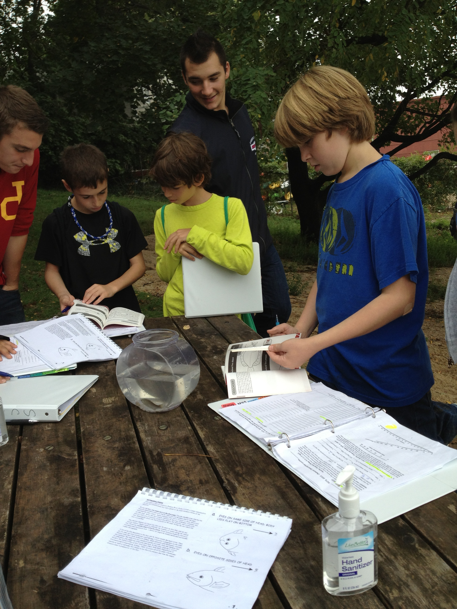

Area: Matthiessen Park, Village of Irvington, Westchester County
Surrounding Land Use: 40% grass, 10% beach, 5 % forested, 45% river
Sampling Site: Matthiessen Park
Plants:
Water Depth: 4 feet
River Bottom: Mud, Sand, Rocks. The further you went out the muddier it got.
Weather Conditions: Humid, Warm, Foggy.

ITEM | Time |  | Reading 1 | Reading 2 |  | Comments
Physical
Air Temperature | 9:15 am  10:23 am |  | 22°C | 21°C
Wind Speed | 9:30 am |  | No wind | No wind
Cloud Cover | 9:30 am  11:30 am |  | 100% | 100%
Weather today | Overcast, humid, foggy, muggy, warm.
Weather recently | Rainy, humid.
Water Surface
Water Temperature – | 10:30 am  8:30 am | 20°CC |  |  | 18°C
Turbidity –water chemistry test kit | 9:55 am  11:35 am | 20JTU |  |  | 40JTU
Chlorophyll | 11:30 AM | 0.5
Chemical
DO  (drop kits) | 8:30 am  8:51 am | 4 ppm  42% saturation |  |  | 4 ppm  42% saturation
pH | 8:30 am  9:35 am | 8 |  |  | 7
Salinity -  meter | 8:48 am  8:30 am | Readings ranged from 6 to 10 ppt collected from 9:30 to 11 a.m. |  |  | 7
Fish Catch- 12:00 PM to 1:25 PM | Number Caught  30  2  4  1  1 | Species  Atlantic Silverside  Striped Bass  Blue Crabs  White Perch  Oyster |  |  | Average Length  3 inches  3 inches  2 inches  2 inches  4 inches | Seine
*Lots of water celery in nets
Tides  R= right tide stick  L = Left tide stick | TIME (am)  8:29 R  9:25 R  9:33 L  9:33 R  9:51 L  9:51 R  10:04 R  10:04 L  10:15 L  10:15 R | Water height (cm)  12.5  30.5 (boat wave)  16  24  24  33  39  31  34.5  44 |  |  | Rise/Fall  RISE
Currents | Time  10:30 am  11:45 am  9:08 am | Cm/60 sec  11.6  22.5 |  |  | Cm/sec  1.9  .375 | Direction  First flowing north  Second flowing south
Core – 8 cm long | TIME  9:45 am | Rare  Coal |  |  | Common  Pebbles and mud | Abundant  Sand and gravel
Traffic | 9:30 am | Boat passed, Columbian Sky
Other Items | Students’ Hypotheses: For water chemistry majority of the students found results to be close to their predictions.

