A Day in the Life of the Hudson River 10/4/12 Data
RIVER MILE 28
South Nyack, Piermont Ave.
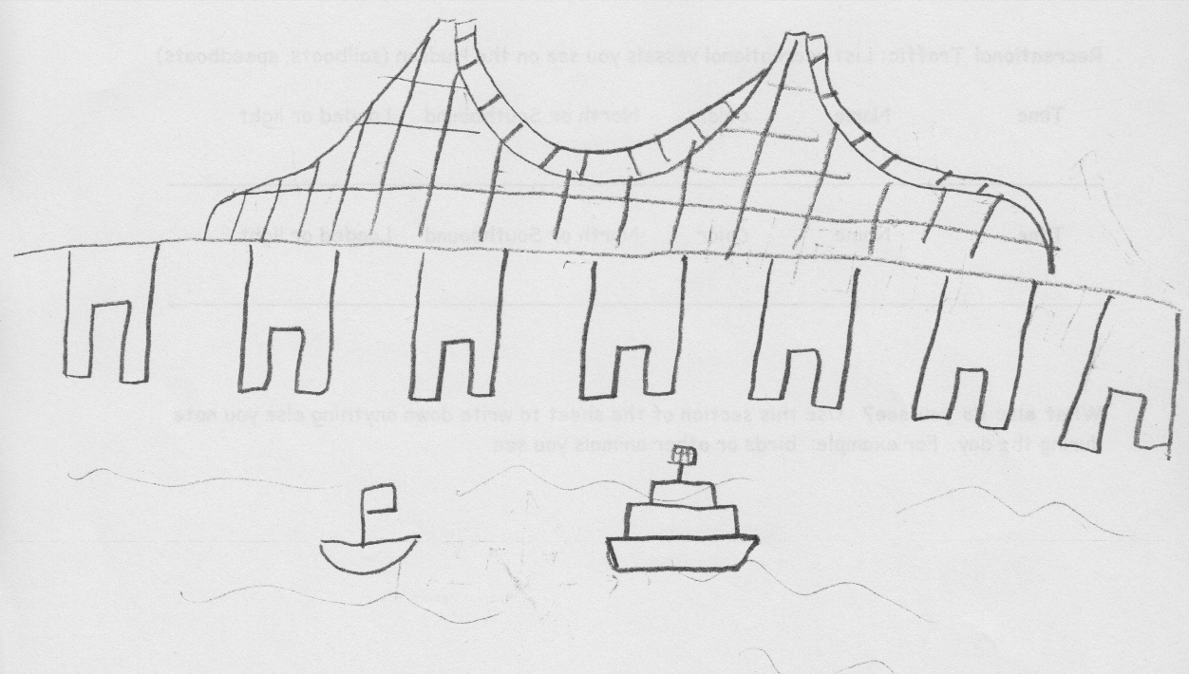
Diana Cutt, U. S. EPA
Dr. Brand, Ms. Maloney, Ms. Holmes and Mr. Pregiato
Upper Nyack Elementary School, 73 students 3rd and 3rd/4th mix grade
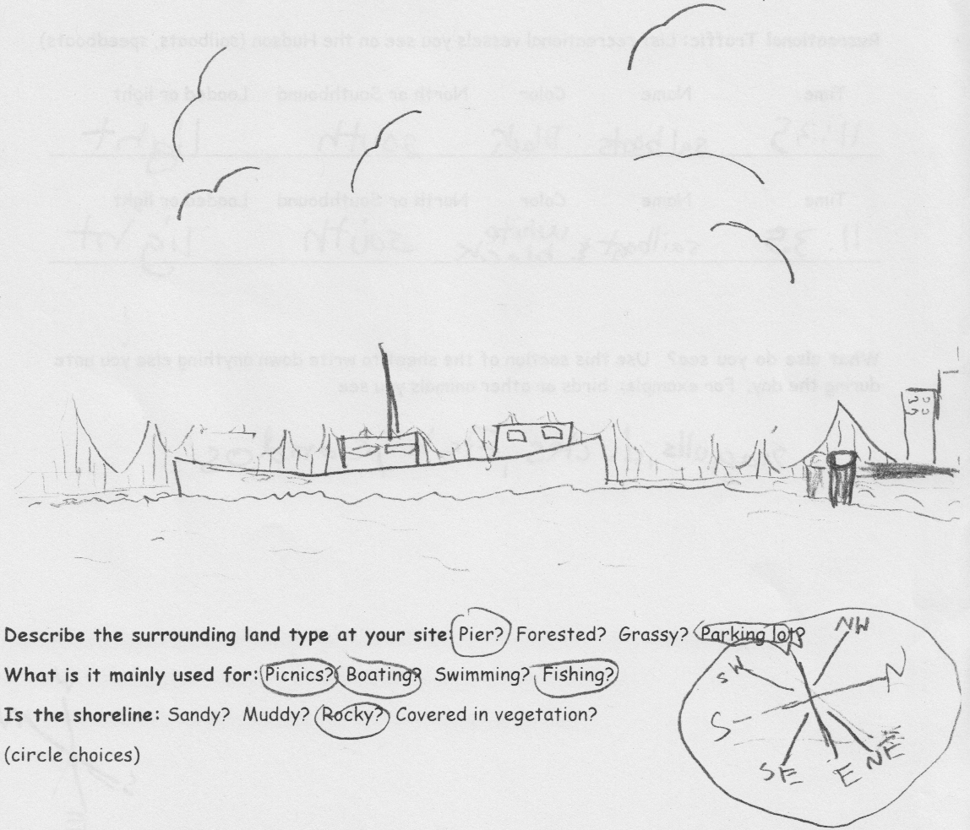 | 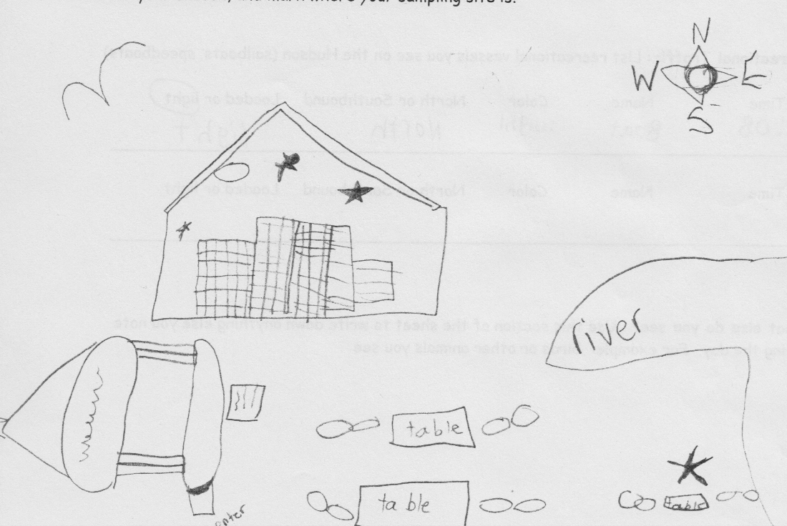

Location: Nyack Memorial Park, Nyack NY
Area: Park with a sandy and slightly rocky beach and pier area
Surrounding Land Use: Park with homes behind
Sampling Site:
Plants in area:
Water depth:
River Bottom
ITEM | Time |  | Reading 1 | Reading 2 | Comments
Physical
Air Temperature | 9:58 AM  10:07  10:17  10:36  11:05  11:23  11:46 AM |  | 23°C  27  24  29  25  26  30 |  | Each reading average of 6
Wind Speed & Direction | TIME  10:05-11:54 AM |  | Beaufort chart 1 |  | Read 6 times and stayed the same
Cloud Cover | 10:23 AM |  | clear | 11:11AM  11:52 AM | Mostly Cloudy
Weather today | Clear and sunny all day
last 3 days | Rain yesterday and some rain days prior
Water | Very calm
Water Temperature | 10:10 AM  10:55 AM | 21°C  21.66 |  | 70 °F  71 | Read in F and converted to C
Turbidity  Long site tube | 10:06 AM  10:24 AM  10:41 AM  11:18 AM  11:30 AM  11:59 AM | 35 cm  60 cm  74 cm  46 cm  50 cm  43 cm
Chemical
DO  Drop count | Not read
pH  test strips | 10:10 AM  11:15 AM | 7.5  7 |  | Each was an average of 20 readings
Salinity  hydrometer | 11:30 AM | 0 ppt  4 ppt  6 ppt |  |  | Average 3.33 ppt
Fish Catch | The high school team seined and we looked at their catch
Tides | 10:00am  10:35am  11:10am  11:25am  11:51am | Rising  Rising  Rising  Rising  Rising |  | *Measured by marking the waterline along shore in the old boat ramp with water filled buckets.
Currents | Time
Other Observations | Direct sun today, light breeze and water very still

