Day in the Life of the Hudson River 10/4/12 Data
RIVER MILE 2
Chris Anderson - The River Project
Bob Wallace - NYU
Karen Johnson, Dora Kong, Kim Esther, Jane O’Donnell
3rd grade Trevor Day School – 58 students + 13 adults
Latitude N 40°43’71 N Longitude 74°00’89 W
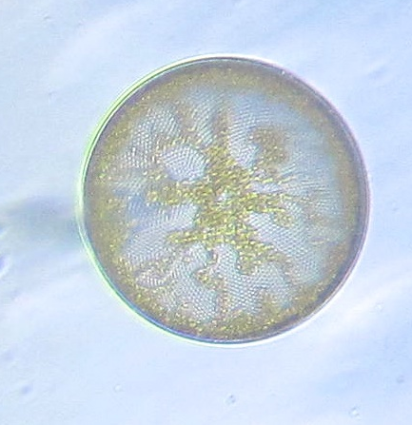 | 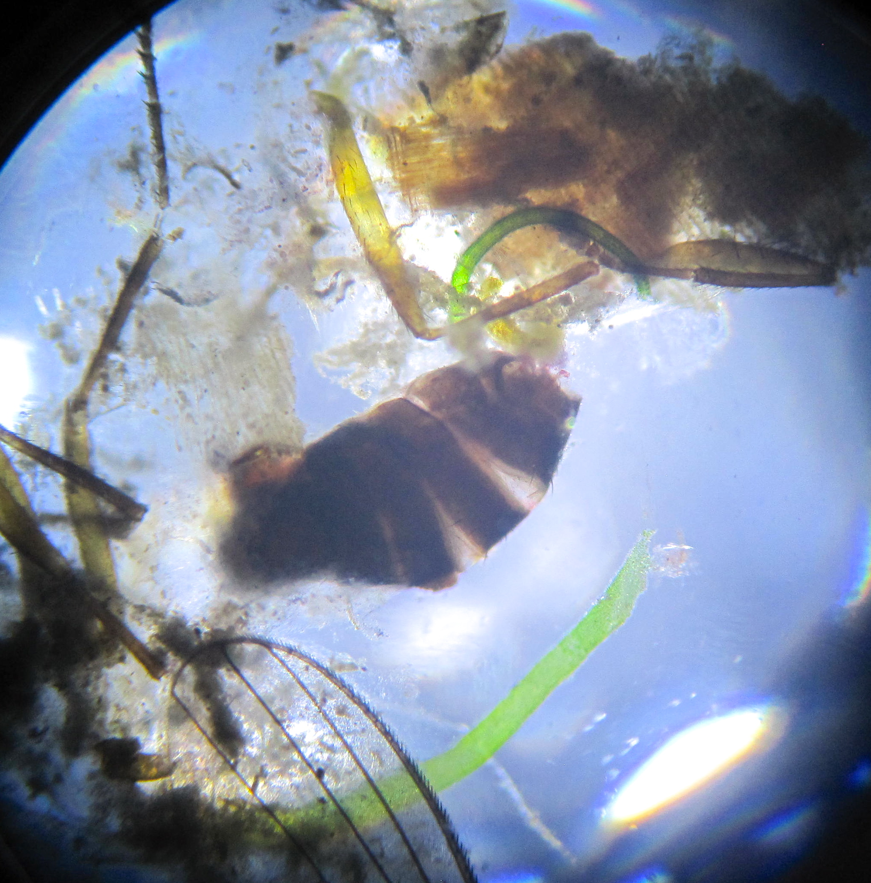 | 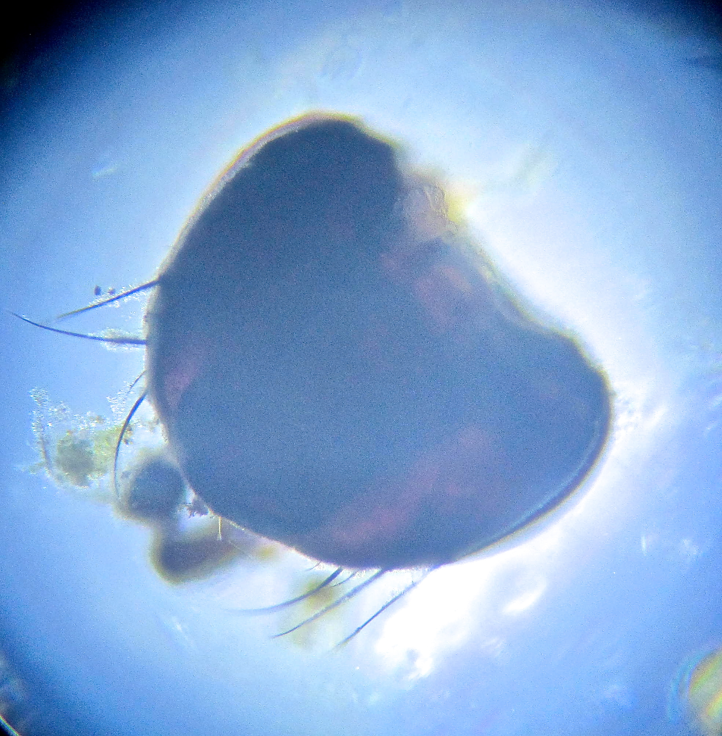
Plankton Samples Pulled From the Hudson River

Location: Pier 40 Hudson River (also called North River)
Area: Large pier with many facilities: athletic fields, kayaking and boathouse, seasonal moorings available, parking, fishing on the pier, benches & picnic tables for the public Surrounding Land Use: parking lot – area used for picnics, boating, fishing
Sampling Site: Banks altered; concrete & wood pilings, pier extends into river/cement bulkhead
Plants in area: None visible
Water depth:
River Bottom – muddy
NOTE:
This highly urban site is just west of the busy Westside Highway – it is the largest pier in Hudson River Park (with a 14 acre footprint); Pier 40 is used for recreation; school groups use the athletic fields; there are 3 public boathouses; there are many people by on the river’s edge: jogging, bike riding, walking; River Project’s temporary home is on Pier 40.

ITEM | Time |  | Reading F | Reading C | Comments
Physical
Air Temperature | 11:15 AM  11:37 AM |  | 75.2 °F  79.1 | 24 °C  26.1 | Average – 77 °F  25 °C
Wind Speed | Time |  | Beaufort Chart | Kestral Meter
 | 11:15 AM |  | #1.5
Cloud Cover | Mostly cloudy
Weather today | Clouds and humid, threat of rain
Weather recently | Rain and humid
Water | Fairly calm, minimally choppy
Water Temperature - | 11:07 AM  11:28 AM  11:51 AM  12:03 PM | 68 °F  68 °F  68 °F  68 °F |  | 20°C  20°C  20°C  20°C | Average – 68 °F  20 °C
Turbidity (long site tube | 11:01AM | 91 cm  60  61 |  |  | 70.6 cm
Chlorophyll
Chemical | TIME | TEMP. |  | PPM | % SAT.
DO  (drop count kit) | 11:07 AM | 20°C |  | 7 PPM | 75%
pH – color match LaMotte kit | 10:59 AM | 8.5  8.5  7 |  |  | Average 8
Salinity – hydrometer - | 10:59 AM | 16.0 ppt  16.0  16.0 |  |  | 16 ppt
Vertebrate Catch | Number Caught | Species |  | Size | Minnow traps
Unable to do fish
Tides
Currents | AM | 39.6 cm/sec |  |  | Flooding North
Boat Traffic | 12:02 PM | Barge |  |  | Southbound
 | 12:04 M | NY Waterway Ferry |  |  | Southbound
 | 12:07 PM | Speadboat |  | Beast | Southbound

