Day in the Life of the Hudson River 10/4/12 Data
RIVER MILE 300
Upper Works Trailhead (Adk High Peaks Wilderness), Tahawus Rd.
Adirondac (abandoned mining village), Newcomb NY
GPS Latitude 44°05.370’ N Longitude 74°03.358’ W
Elevation 1,820 ft/550 meters
Doug Reed, Hudson Basin River Watch
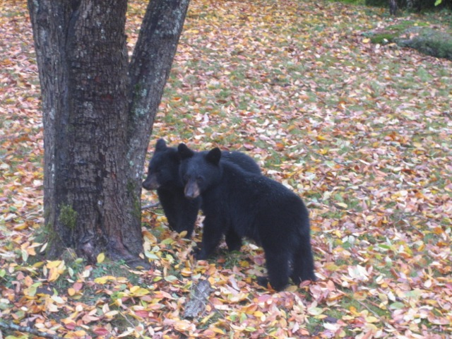

Location: Adirondack (abandoned mining village), Newcomb NY, where the Hudson takes its name
Area: a rushing river
Surrounding Land Use: 100% forested
Sampling Site:
Plants in area:
Water depth:
River Bottom : cobbles
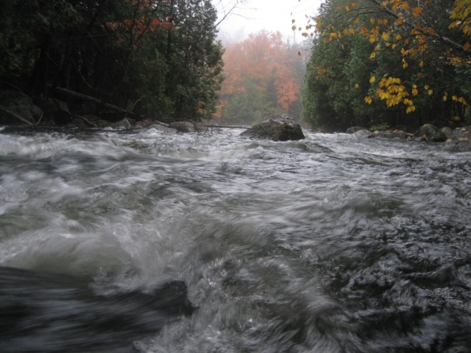  Calamity River | 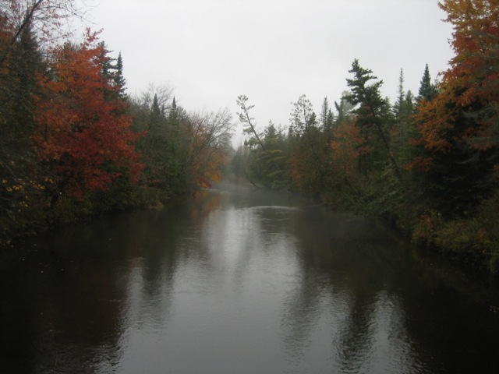  Opalescent River

ALMANAC ENTRY : 5-7AM at the headwaters of the Hudson River, Arbutus Pond, Henderson Lake outlet, and Opalescent River. After a night with a family of three black bears in the Arbutus area, one lone loon warbles out on the dark pond. Quiet and still. Crickets softly purr. Mist barely drifts the air is so still on Arbutus Pond. Water temperature 58°F. At the uppermost reach, where the Hudson first takes its name, between Henderson Lake, Calamity Brook, and Opalescent River, the river is roaring from recent rains. Water temperature 54°F. I'm looking around Tahawus and the old ironworks for the highest source water which ultimately comes from Mt. Marcy and Lake Tear of the Clouds, down Feldspar Brook and Opalescent River to the Hudson, caught a glimpse from the Opalescent River Club bridge, then ran downriver to collect and relay samples from Schuylerville, Albany, and Stuyvesant groups - 350 beautiful miles of Day in the Life of the Hudson River running!

Water Temperature | 6:00 AM | 54°F  12°C
Water calm | Rushing

