Day in the Life of the Hudson River 10/4/12 Data
RIVER MILE 31 – Hook Mountain State Park
Laurie Seeman & Joanne Dickey– Strawtown Art & Garden Studio
Lorraine Marden, Jennifer Armoceda -Blue Rock School –
5^{th,} - 8th – 41 students, total 9 adults
40°7’9”N Latitude - 73°54’49” W Longitude
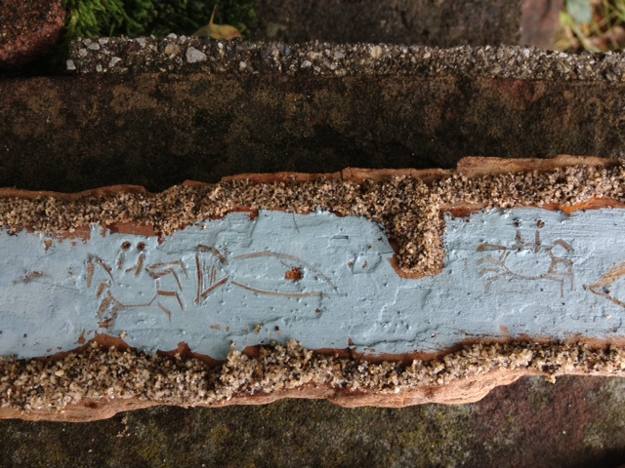
Location: Nyack Beach near Hook Mountain Sandy Beach right side of riverfront area
Area: Park/Boat launch, sandy beach area on the point with riprap
Surrounding Land Use: 20% urban/residential; 60% forested; 20% beach
Sampling Site: Sandy beach – with a lot of trees, picnic tables, sandy and rocky at edges, covered with vegetation beyond the beach, stone wall, riprap shore, collected wood debris, charcoal, and slag –not many houses.
Piping coming into river south of sampling site
Plants in water: no plants in area
Plants in area: none
Water depth: 32 cm
River Bottom –sandy, rocky, muddy – a bit of clay

ITEM | Time |  | Reading 1 | Reading 2 | Comments
Physical
Air Temperature | 10:10 AM |  | 18.2°C  65°F
 | 12:55 PM |  | 22°C  72°F
Wind Speed | Beaufort 1-2 |  | Not enough wind for anenometer | SE
Cloud Cover | Mostly cloudy
Weather today | Cloudy AM then light rain until noon (1/4 inch) and some wind- overcast –
Weather last 3 days | Rainy, mid 70s, wet, very cloudy, foggy
Water | Began calm and then turned to choppy
Water Temperature | 10:46 AM | 70°F  74 |  | 21.12°C  23.35 | Avg –  72°F  22°C
 | 11:45 AM | 72°F  71  73 |  | 22°C  21  22.79 | Avg –  72°F  22°C
 | 1:30 PM | 78°F  76  78 |  | 25.56°C  24.46  25.56 | Avg –  77.5°F  25°C
Turbidity | 11:00 AM | 0 JTU  40  70 |  |  | Avg – 37 JTU
Chlorophyll | 1:15 PM | 0.7
Chemical
DO  Drop count | 11:06 AM | 5 mg/L |  | 22 ° C | 55%
pH  Indicator solution | 10:28 AM | 7.5  6.75  7 |  |  | 7.08
Salinity  Test strip | 10:58 AM | 1926 ppm CL-  2791  2475 |  | 2397 ppm avg. chl- | 4330 Total Slainity
Fish Catch |  | Number Caught |  | Species | Length of largest
Seine 25 ft. X 4ft.  Mesh 0.25 inch |  | 4 |  | Striped Bass | 2.5 inch
Total 228 fish in 12 pulls |  | 60 |  | Atlantic Silversides | 3 inch
 |  | 4 |  | Blue Crabs | 1.5 inch
 |  | 150 |  | Moon Jellies | 0.25 inch
 |  | Totals 228 |  | Diversity 4
Tides | Time | Height |  | Rate of Change | Rising/Falling
 | 10:24AM | 32 cm |  | Set stick | rising
 | 10:59 AM | 47 |  | 15 cm/32 mins | rising
 | 11:00 AM | 50.6 |  | 3.6cm/1 min | rising
 | 12:42 PM | 74 |  | 23.4cm/1:42 min | rising
*HT -12:18 PM | 1:21 PM | 80* |  | n/a
Currents* | CM/60 secs | Cm/Sec |  | North/South Ebb/Flood/Still | Knots
10:37 AM | 76.2 | 1.27 cm/sec |  | Ebb | 0.0247 kts
11:30 AM | 132 | 2.2 cm/sec |  | Ebb | 0.0428 kts
12:45 PM | 60 | 1 cm/sec |  | Ebb | 0.0411 kts
1:32 PM | 127 | 2.11 cm/sec |  | Ebb | 0.0194 kts
Shipping Traffic | 1:30 PM | Cargo Ship |  |  | Southbound
Other Observations

