Snapshot Day 10/4/12 Data
RIVER MILE 35
Croton Point Park, Croton on Hudson
Debborah Ashley, New Visions Environmental Science and Sustainability, BOCES, 8 students, 12th grade, 2 adults
Latitude 41degrees 11.174’N Longitude 73 degrees 53.913’W
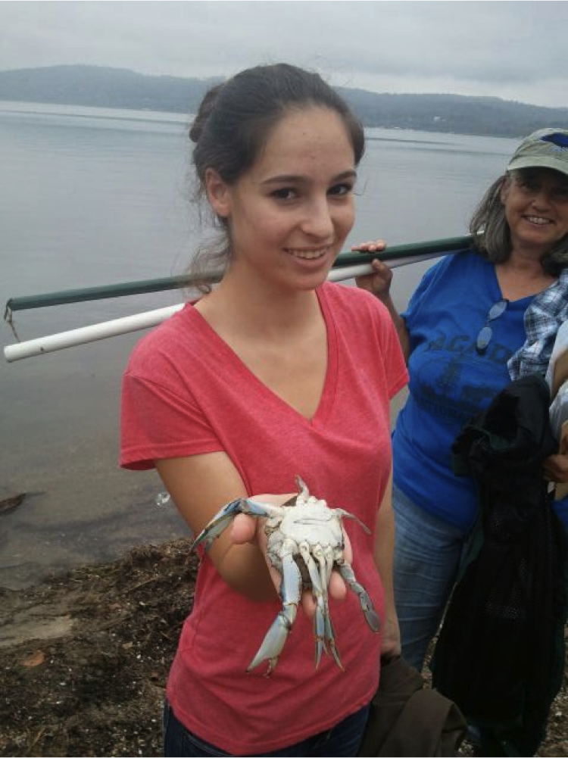
Student with Male Blue Crab
Location: Mother’s Lap, Croton Park NY
Area: Rocky beach surrounded by rising forested land and some pier but mostly grass,
Surrounding Land Use: Boating, recreation and picnics - beach 40%
Sampling Site: shoreline is sandy beach,
Plants in area: none
Water depth: 1 ft. at sample collection site
River Bottom – sandy, with muddy and rocky parts
Observations - On the ground, there are shells, devil’s heads, seaweed (water celery), and sticks.

ITEM | Time |  | Reading 1 |  |  | Comments
Physical
Air Temperature
Wind Speed | Time |  | Beaufort #
Cloud Cover | overcast
Weather today | Cloudy and rainy
Weather recently | Rainy last few days
Water Temperature | 1:00 PM | 22°C |  |  | Depth 1 ft. | 3 readings
Turbidity –  meter | 1:05 PM | 46.3 NTU - sample |  |  | 116.1 NTU standard
Fecal Coliform | PM | positive
Chlorophyll | 12:55 PM | 0.3 |  |  | Color chart
Chemical – | TIME | Reading |  |  | Temp | Saturated
DO - ampule | 1:01 PM | 8  8  8. |  |  | 22°C | 98 %
pH –  (litmus paper, & meter) | 1:16 PM | 6.5  6.5 |  |  |  | Average 6.5
Salinity - *instrument listed as refractometer but treated as quantab reading | 1:16 PM | 1420 mg/L* Cl- |  |  | 2565 Total salinity
Conductivity |  | 284.2 |  |  | Siemens Per Meter | in Sodium Chloride
 |  | 304.5 |  |  | Siemens Per Meter | in Water
Tides | 11:09 AM | 14 cm height
rising | 12:17 PM | 22.5 cm |  |  | 8.5 cm/68 mins | 0.125 cm/min
rising | 12:58 PM | 28.1 cm |  |  | 5. 6 cm/41 mins | 0.137 cm/min

Fish | Type | Number | Largest
 | Shiner | 2
 | Striped Bass | 1
 | Atlantic Silverside | 21 | 2.5 in
 | Shrimp | 1 |  | crustacean
 | Blue crab | 2 | (1 Male) | Crustacean
Traffic-
Recreational | 12:15 PM | Sailboat | white
 | 12:15 PM | Sailboat | White/Blue
Organisms Seen | Crow | King Fishers (2) | Mallards (2) | Cormorant
 | Seagull | Monarch Butterfly

