Day in the Life of the Hudson River 10/4/12 Data
RIVER MILE 35W – Bowline Park, Haverstraw Waterfront
Ryan Coulter, DEC helped with seining
Chuck Barone, Nanuet High School – 12th grade – 20 students
41.° 12’11” N 73.° 57’ 48” W
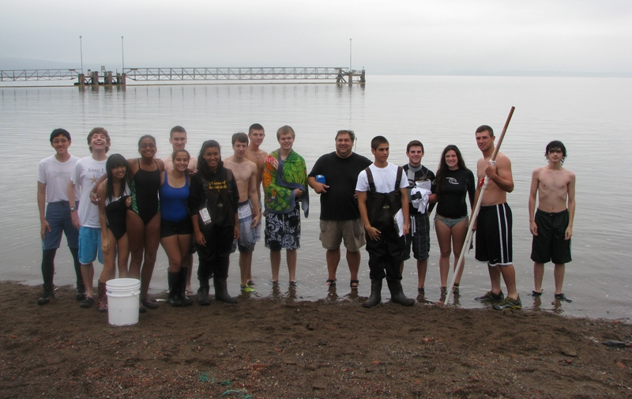 | 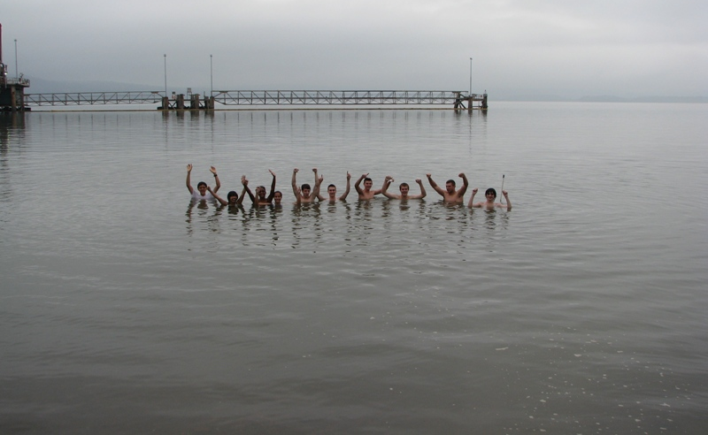

Location: Bowline Park, Haverstraw waterfront, Rockland County NY
Area: Parking lot, recreation, fishing
Surrounding Land Use: 25% beach, 5% Industrial/commercial, 68% recreational, 2% forested
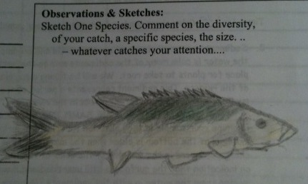
Sampling Site: shoreline is sandy, muddy, rocky, small beach, bank altered, large rip rap, bulkhead, industrial tress spans the water to the north and east, bricks in the sand
Piping coming into river
Plants in area:
Water depth:
River Bottom –sandy, muddy, rocky

ITEM | Time | Reading 1 | Reading 2 | Comments
Physical
Air Temperature | 9:30 am | 69°F  20.5°C
Wind Speed
Cloud Cover | cloudy | foggy
Weather today | overcast
Weather last 3 days | Very rainy last few days
Water | calm
Water Temp. – 2 ft. depth | 9:30 AM | 22.5°C  23.0 | 74°F  74 | Cloudy – in the shade
 | 12:13 PM | 22.0°C | 72°F
Turbidity – Long site tube | 9:50 AM | 48.2 cm  40. cm |  | Average 44.2 cm
Chlorophyll | 12:20AM | 0.3
Chemical
DO  Drop count | 10:45 AM | 23 C | 6.4 PPM | 80 % sat
 | 12:00 PM | 22.5 C | 7.2 PPM | 85 % sat
pH  pH pen | 10:57 AM | *6 |  | *seems too low – calibration?
 | 12:00 PM | *5
Salinity  Hydrometer (?) | 10:45 AM | 1.002 | Temp 22.5 | 4.1 ppt
 | 10:50 AM | 1.002 | Temp 23 | 4.2 ppt
 | 12:00 PM | 1.002 ppm | Temp 22.5 | 4.1
 | 12:00 PM | 1.001 ppm | Temp 22.5 | 2.7
Fish Catch | Time | Number Caught | Species | Length of largest
Seine 50 ft. X 6ft.  Mesh 0.25 inch | 10:30AM | 11 | Bay Anchovy | 3 inch
 | Diversity-3  Totals 24 | 10 | White perch | 7 inch
 |  | 3 | Blue crab | 5 inch
Tides | 9:30 AM | 120 cm
 | 12:45 PM | 190 cm | rising | 70cm/195 min  0.36 cm/min
Currents | CM/60 secs | Cm/Sec | North/South Ebb/Flood/Still | Knots
9:50 AM | 0 | 0 | Still | 0
12:15 PM | 250 cm/60 s | 4.2 cm/sec | Flood
Core – | Length | Rare | Common | Abundant
Shipping | 9:00 AM | Haverstraw Ferry | White/blue | North bound
Observations | An oil transfer platform just north of the sampling site.  Broken bricks were along the beach showing how there were old brick factories in the area. Large rocks sticking out of the ground. There is construction happening in the parking lot so whenever it rains the runoff comes on the beach and into the river.

