Day in the Life of the Hudson River 10/4/12 Data
RIVER MILE 41
Steamboat Dock Park, Verplanck, Westchester
Bob Connick, Sott Rizzo, Mahopac High School; Teatown Lake Reservation
Environmental Research and Field Biology 9th - 12th graders –33students
Latitude N 41°14.962 Longitude W 73°57.888
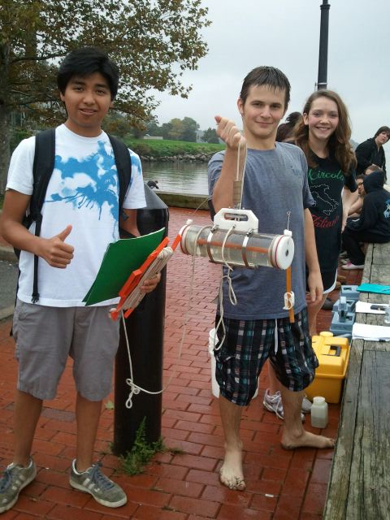 | 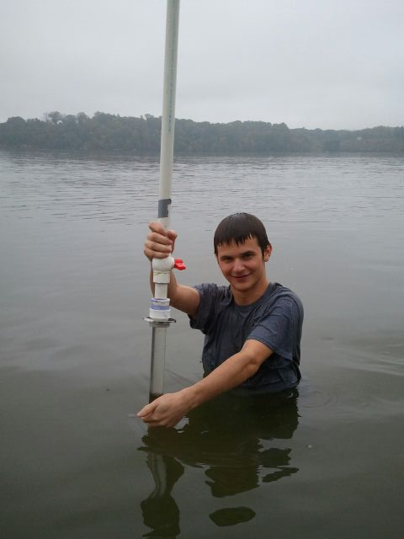

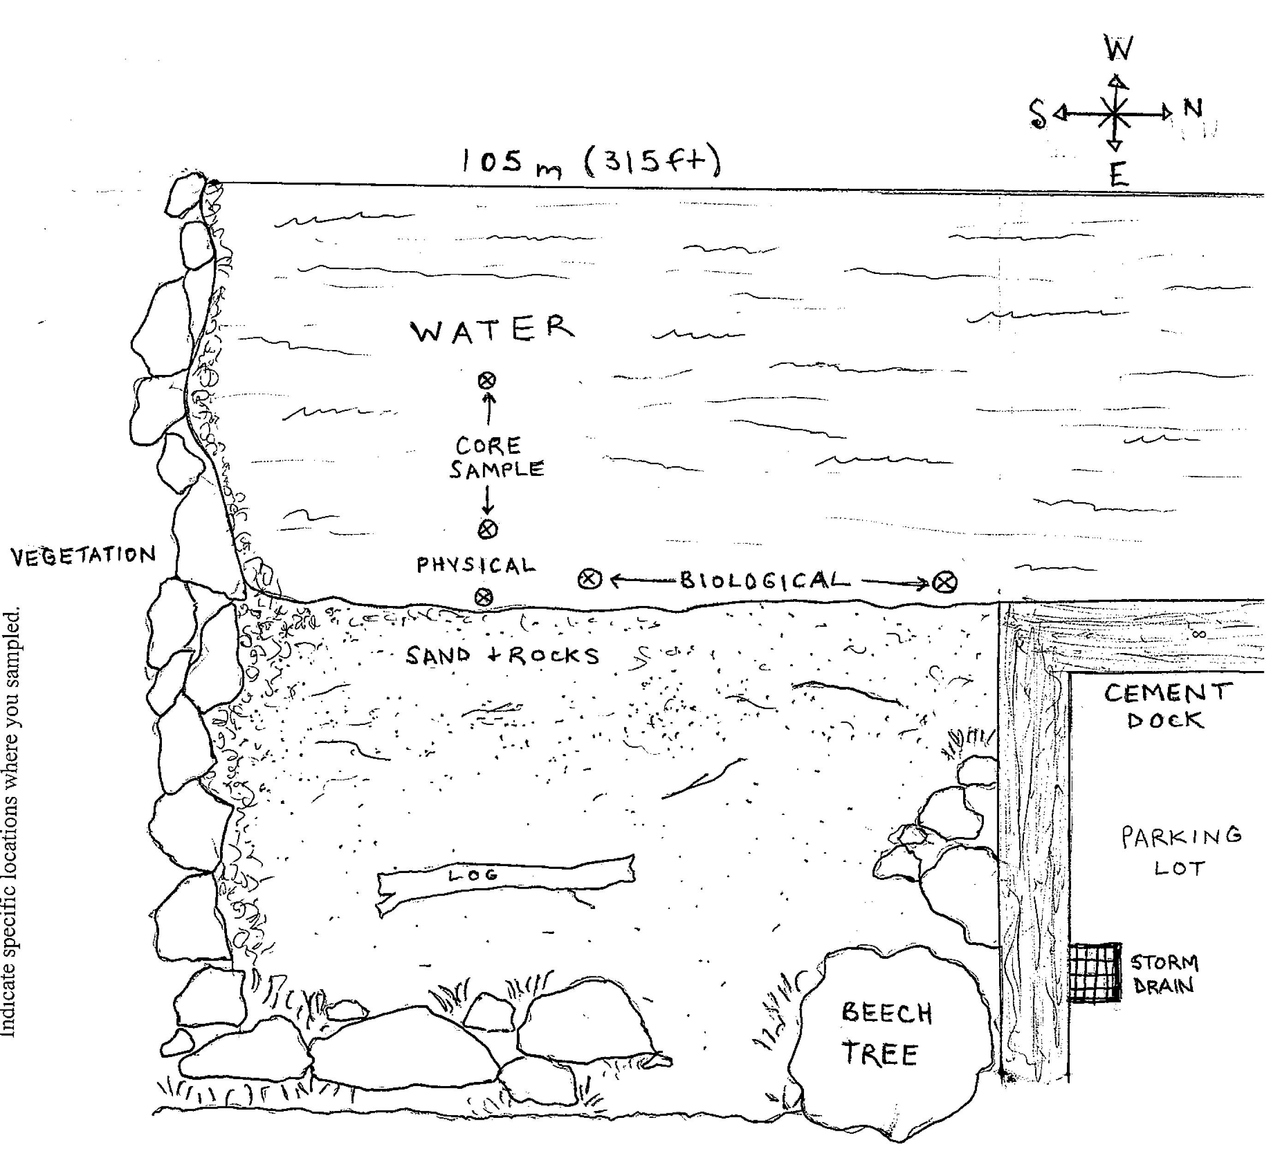
Location: Steamboat Dock Park beach, City of Verplanck in Westchester County
Area: located in a small cove between a point and a bulkhead – sampled approximately 30 ft. from south end of dock/parking lot
Surrounding Land Use: Industrial/Commercial 25% , beach 70%, Forested 5%. Some buildings with large parking lots in front to the north. Beach, a street with houses with some trees to the south
Sampling Site: beach, riprap, banks altered, dock, bulkhead, pipe south of the sampling site 10-15 meters.
Plants in area:
Water depth:
River Bottom – sandy
Observations- 2% bur-reed in area
.
ITEM | Time |  | Reading 1 | Reading 2 |  |  | Comments
Physical
Air Temperature | 10:45 AM |  | 23ºC
Wind Speed | Beaufort Chart: 2 |  | Light breeze
Cloud Cover | Morning fog |  | 90% cloud cover | Overcast
Weather today | Cold, light rain, drizzle, humid
Weather recently | Heavy showers, warm air temperature
Water Surface | Calm
Water Temperature – | 22.6ºC  22.5ºC
Turbidity – | 11:04 AM | 75 cm  Transparency tube |  |  | 78cm  Trans. tube
Chlorophyll | 11:40 am | 0.5
Chemical
DO  (drop kits) | 10:45 AM  11:30 AM  12 AM | 8 ppm  7 ppm  9 ppm |  |  |  |  |  | 95%  Saturation  105%
pH  Indicator solution | 10.40AM  11:13 AM | 7.4  7.7 |  |  | 7.8  7.5
 | 12 PM | 7.6
Salinity  YSI SCT meter | 10:30 AM  11:28 AM  12:00 PM | 2.4 ppt  2.3 ppt  2.6 ppt
Conductivity  YSI SCT meter | 10:25 AM  10:30 AM  11:30 AM | 4483 microsiemen/cm  4507 microsiemen/cm  4166 microsiemen/cm |  |  |  |  |  | ppm is = 0.64 conductivity
Alkalinity  (Hach kit: drops) | 10:55 AM  11:00 AM  11:30 AM | 80 mg/L  100 mg/L  160 ppm
Nitrates  (colorimeter) | 10:30 AM  10:49 AM | - ppm  - 0.6 ppm
Phosphate  (colorimeter) | 10:30 AM  10:40 AM  11:13 AM | 0.55 ppm  0.25 ppm  0.00 ppm |  |  | Used color |  |  | wheel
Fish Catch- 10:30 AM | Number Caught | Species |  |  | CPUE |  |  | Seine
50 ft net X 4ft– 50 ft. pull
Run 1 | 1 | Striped Bass
 | 0 | Shiners
 | 82 | Silversides
 |  |  |  |  | X=83
Run 2 | 4 | Silversides
 | 2 | Yellow perch
 | 1 | White perch |  |  | X=7
Run 3 | 77 | Silversides |  |  | X=77
Total Catch 167 fish |  | Total Diversity 4 species
Invertebrates | 1 large blue crab | 4 small dead blue crab
Birds | 1 song sparrow, 2 Cormorant, 1 Ring Bill Gull, 1 Osprey, 40 Bluejay (migrating) , 3 Canadian geese, 2 Mallards
Trees | Tree of Heaven, London planetree, willow, Red maple,  Golden rod, Turtle grass, eel grass, honey suckle, Asiatic day flower, vines, Albizzia
Tides | TIME | Water height |  | Rise/Fall
 | 10:30AM | 0 inches |  | Rise |  | Put at waterline
 | 11:30AM | 6 inches |  | Rise
 | 11:36 AM | 7 inches |  | Rise
Currents | Time
Core – | TIME | Rare |  | Common |  | Abundant
Traffic | 10:22 AM  11:30 AM  11:32 AM  12:05 PM | Commander  Coast Guard  Cape Wendy  Captain’s Choice |  | Northbound  Southbound  Southbound  Southbound |  | Light  Light  Loaded  Light
Other Items

