Day in the Life of the Hudson River 10/4/12 Data
RIVER MILE 43
Riverfront Green, Peekskill, Westchester
Michael Billy, Walter Panas High School - 17 students, 12th graders
(younger student group shadowed the HS students)
Rebecca Schultz, Constitution Marsh Audubon Center & Sanctuary
Latitude N 41°17’13” Longitude W 73°55’.53.53"
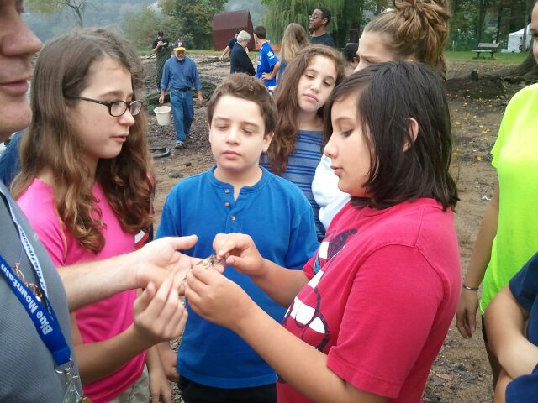

Location: Riverfront Green, Peekskill, Westchester County
Area: Grassy park area with beachfront, pier, sandy beachfront, used for picnics, boating and fishing
Surrounding Land Use: Recreational use 40%, beach 25%, Industrial/Commercial 25%, forested 5%, Urban/residential 5%
Sampling Site: beach with sandy shoreline
Plants in area:
Water depth:
River Bottom – sandy, muddy, rocky.
Site Observations: brick, crab shells, glass, plastic, water chestnut pods, H20 bottles
ITEM | Time |  | Reading 1 | Reading 2 | Comments
Physical
Air Temperature | 9:10 AM |  | 70°F  22°C | 9:30 AM | 72°F  23°C
Wind Speed | 0 Beaufort |  | km/hr >1, | knots/hr>1 | North
Cloud Cover | cloudy
Weather today | cloudy
Weather recently | Lots of rain
Water Surface | Calm
Water Temperature – | 9:20 AM | 21°C |  |  | Water 3 ft. deep
Turbidity – long-site tube | AM | 21 cm  12 cm  13 cm |  |  | Average 17.3cm
Chlorophyll |  | 1.0
Chemical
DO  (drop kits) | 9:20 AM  9:22 AM | 11.1 mg/l  11.1 mg/l |  | 21°C  21°C | 126 % satur.  126% satur.
pH | 9:18 AM | 7.5
Salinity -  meter | 9:18 AM | 1.96 ppt
Fish Catch- Noon | Number Caught | Species |  | Length | Diversity/ Totals
20 ft net X 4ft– | 1 | White Perch |  | 4 inch | DIV = 3
9:30 AM | 1 | Pumpkinseed Sunfish |  | 4 inch | Totals = 4
 | 5 | Redbreast Sunfish |  | 5 inch
Tides | 9:00 AM | Set stick
 | 10:00 AM | 23 cm |  | rising
Currents | Time | Cm/60 sec |  | Cm/sec | Direction
 | 9:10 AM | 0 |  | 0 | still
 | 9:18 AM |  |  |  | still
 | 9:25 AM |  |  |  | still
Core – | Length | Rare |  | Common | Abundant
Noted H2S smell and oxidized top (but no measurements) | Not given | Gravel, freshwater mussel, macroinvert., |  | Pebbles, wood, shells | Mud, sand
Commercial Traffic | 8:51 AM | Barge |  | Red & Black | North/loaded
Recreational Traffic | 9:58 AM | Small boat |  | White | North
Other Items | Killdeer, geese, fishcrows, seagulls, blue crab, mallard ducks, monarch butterfly

