Day in the Life of the Hudson River 10/4/12 Data
RIVER MILE 57
Donahue Memorial Park, Cornwall Landing, Village of Cornwall-On-Hudson, Town of Cornwall, Orange County, NY
Christopher O’Sullivan, NYSOPRHP Trailside Museums & Zoo
Deborah Gilson & 9 adults, Willow Ave. Elementary - 4th grade – 75 - students
GPS Latitude 41°26’36”N Longitude 74°0’1”W
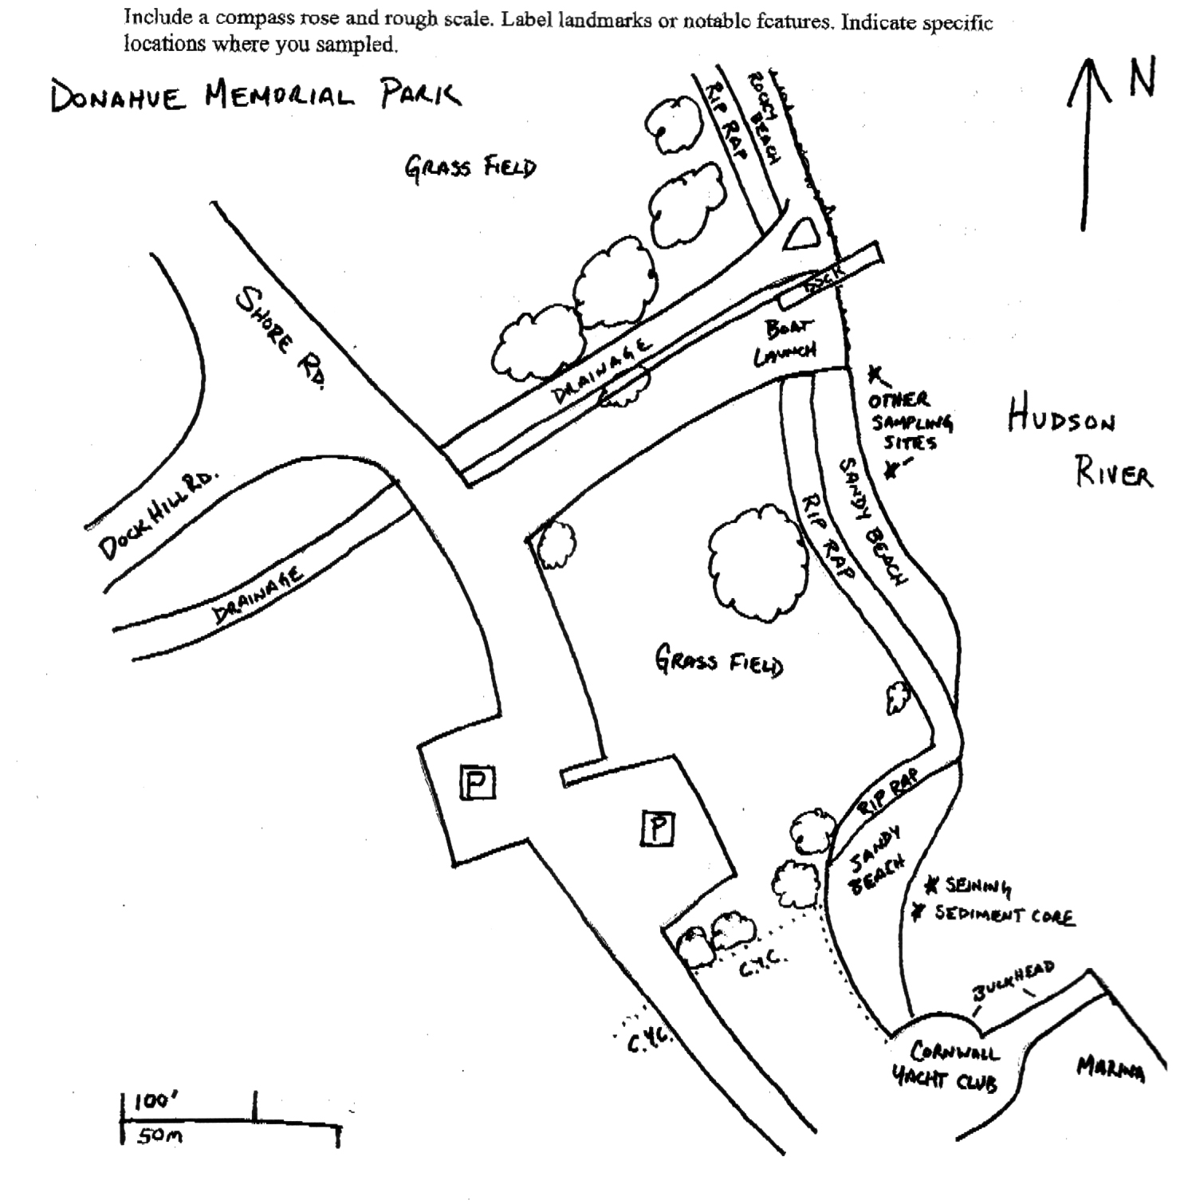

Location: Donahue Memorial Park
Area: Sandy beach used for seining & sediment core, 2nd beach are for other sampling.
Surrounding Land Use: Forested 15%, beach 5%, 80% open and grassy
Sampling Site: pier, sandy beach, altered banks, shoreline riprap, bulkhead, collected wood & debris in area,
Plants in area:
Water depth:
River Bottom – muddy, rocky

ITEM | Time |  | Reading 1 | Reading 2 | Comments
Physical
Air Temperature | 10:10 AM (students) |  | 71°F | 10:45 AM (Tom Lake) | 18°C  64°F
Wind Speed
Cloud Cover | cloudy
Weather today | Drizzly and wet
Weather recently | Rainy and humid
Water Temperature | 11:25 AM (students) | 23°C  73 °F |  | 12:00 PM (Tom Lake) |  |  | 21.6 °C  71°F
Water Calm
Turbidity  Long sight tube | 11:10 AM | 44 cm  52  60 |  |  |  | 52 cm
Chlorophyll
Chemical
DO
Drop count kit
pH (indicator sol.) | 11:20 AM | 7.0
Salinity -  meter | 11:00 AM | Salinity 1.2 ppt
Fish Catch  80 ft. seine X 4 ft. with bag – ¼ inch mesh - | Number Caught | Species |  | Size |  | Comment
10:00AM | 2 | American Eel |  |  |  | ‘Shoestring’
Diversity=9 | 12 | Spottail Shiner
Totals = 42 | 5 | Eastern banded killifish
 | 9 | White Perch
 | 7 | Striped Bass |  | 58-65 mm
 | 2 | Smallmouth Bass |  | 115-117 mm
 | 4 | Largemouth Bass |  | 109-145 mm
 | 2 | Tessellated Darter
 | 6 | Blue Crab
Tides | TIME | RISING/  FALLING |  | HEIGHT IN CM |  | RATE OF CHANGE
 | 9:45 am |  |  | 0 cm
 | 10:40 am | Rising |  | 20 cm
Currents | 9:45 AM |  |  |  |  | Flood
 | 10:45 AM |  |  |  |  | Ebb - waves
Boat | 9:41 AM | Barge |  | Red/Black |  | North - light

