Day in the Life of the Hudson River 10/4/12 Data
RIVER MILE 58
Plum Point, New Windsor, Orange County, NY
Jennifer Merriam, Orange County Community College
undergraduate– 13 students, 1 adult
GPS Latitude 41°27’47.67”N Longitude 74°0'42.88"W
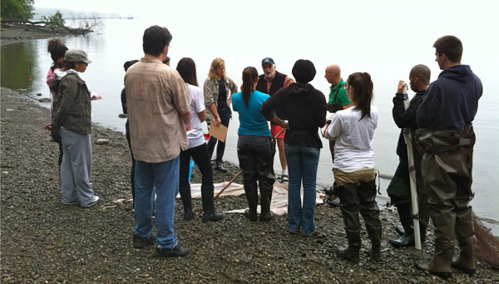
Location: Northern Sandy beach at Plum Point, New Windsor, Orange County, Public Shore, Picnic Area
Area: Sandy beach bordered by forested area and parking lot. Used for picnic, fishing, kayaking
Surrounding Land Use: Forested 10%, beach 90%,
Sampling Site: sandy beach (cove), rip rap in area of sampling site, debris in the area such as broken concrete, docking
Plants in area: no submerged aquatic vegetation
Other trees in area – mostly wooded – oak, tulip, poplar and maple.
Water depth: 70 cm - shallow (students can wade out in chest waders about 10 meters)
River Bottom – consolidated bottom, cobble-gravel, sandy
ITEM | Time |  | Reading 1 | Reading 2 | Comments
Physical
Air Temperature | 8:10 AM |  | 19.5°C  67.1°F | 9:40 AM | 21.5°C  70.7°F
Wind Speed | Beaufort 0 |  | MPH 0
Cloud Cover | overcast |  | Light drizzle 10:10 AM
Weather today | No rain from 0800-1010, absolutely still (no wind, water like glass, overcast, foggy)
Weather recently | Raining
Water Surface | calm
Water Temperature | 9:40 AM | 21.5 °C  21.0  21.5 |  |  |  | 21.3°C  70.34°F
Water Calm | yes
Turbidity  Short sight tube | 9:55 AM | 14.13 NTU  15.31  12.45 |  |  |  | 13.96 NTU avg.
Chlorophyll | 2:00PM | 0.3 color chart
Chemical
DO  (drop kit) | TIME | Temp |  | DO |  | % Sat
DO – drop count test kits | 9:45 AM | 21 °C |  | 8 |  | 90
pH - meter | 9:55 AM | 6.5  7.0  7.0 |  |  |  | 6.8 average
Salinity – test strips | TIME | ppt |  | Cl- |  | Total Salinity
 | 2:05 PM |  |  | 96 mg/L |  | 173 mg/L
Nitrates | 10:05 AM | 4.4 ppm  4.44 ppm  4.4 ppm |  |  |  | 4.44 ppm
Phosphates | 10:07 AM | 0 ppm
Fish Catch  12 ‘ X 3 ‘ with ¼ inch mesh | Species | Count |  | Size of largest |  | Totals
96 foot pull | American Eel | 2 |  | 14
 | Bay Anchovy | 3
 | Spottail Shiner | 4
 | Banded Killifish | 1
 | Striped Bass | 10
 | Smallmouth Bass | 2
 | Tessellated Darter | 1
 | Blue Crab | 4
CPUE |  | 23 total catch |  | 96ft=105m_ computed |  | 0.22 fish/meters
Tides | Time | Height in cm |  | Rate of change |  | Rising/falling
 | 8:10 -8:55 AM | 4.5 cm |  | Falling |  | 0.1 cm/min
 | 9:40-10:10 AM | 9.5 cm |  | Rising |  | 0.32 cm/min
Currents | 9:40 AM | 1.7 cm/sec |  | North |  | ebb

