Day in the Life of the Hudson River 10/4/12 Data
RIVER MILE 60
Dennings Point Park, Beacon, Dutchess County
Latitude 42°N, Longitude 73°56’W
Michael Hintzman & Staff - Beacon Institute for Rivers and Estuaries
Lia Harris, Cary Institute of Ecosystem Studies
Michele Ryan, Tracy Misch, Gayhead Elementary School 23 - 4th graders &
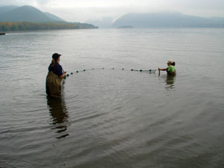 | 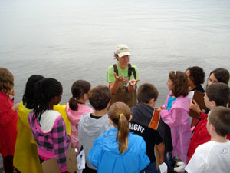

Location: Dennings Point, Beacon, Dutchess County
Area: Beach with large piping entering river. Believe area mostly used for sightseeing and fishing. Found a homemade crab trap on the beach!
Surrounding Land Use: Nature preserve with few buildings, 60% forested; 30% beach; 10% buildings
Sampling Site: Beach, covered with vegetation, rocky & sandy
Water depth:
River Bottom :
Plants:
Sample Times – 10 AM-1PM

ITEM | Time |  | Reading 1 | Reading 2 | Comments
Physical
Air Temperature
Wind Speed | Beaufort < #1
Cloud Cover | Clouds & Fog
Weather today | Drizzly and wet
Weather recently | Some rain, some sun
Water Temperature
Water Surface
Turbidity - | Turbidity tube | 34 cm
Chlorophyll |  | 1.0
Chemical
DO –

Salinity – Quantab strips | Stick measure  3.6 | Total Chloide  129 ppm Cl |  | Total salinity  233 ppm
Fish Catch | Species | Number |  | Length of largest | Comment
 | Shiners | 4
 | Striped Bass | 1 |  | Very small
 | Blue Crab | 1 |  | 3-4 inch! | Very exciting
Tides | Flood entire sampling period
Currents | Flood - Observed driftwood in main channel as orange was stuck in the cove current
Traffic | 11:00 AM | White Boat
 | 12:40 PM | Yellow Kayak |  |  | North
Other Items | Lots of waterchestnut pods, beach glass, and bits of brick on the beach
Core | Description |  |  |  | Water depth
14 cm long | The core sample was very dark, hard-packed mud with bits of rock, sticks and a small pinecone. |  |  | Muddy smell...a trace sulphuric smell | 2 ft

