Day in the Life of the Hudson River 10/4/12 Data
RIVER MILE 76
Waryas Park, Poughkeepsie, Dutchess County
Brian Reed, Lynn Fordin, Sue Parise, Poughkeepsie Day School, 38 students, 2nd-3rd gr.
N 41°7’ – W 73°9’
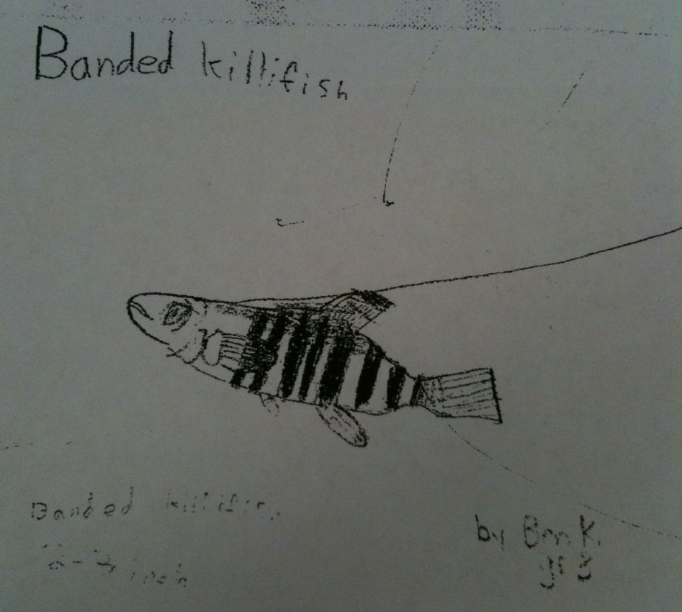
Location: Waryas Park, Poughkeepsie, New York.
Area: public park, pier, grassy, parking lot. Park used for fishing, small boat launch, another pier for small boat launching
Surrounding Land Use: 40 % urban/residential; 20% Industrial/commercial; 40% park area with grass and waterfront docks
Sampling Site: shoreline is riprap, vegetation, banks altered, pier
Plants in area: Yes – small percentage
Tidal Shallows:
Water depth: 3 meters
River Bottom –muddy
Sample Times 9:30-11:30 AM
ITEM | Time |  | Reading 1 | Reading 2 | Comments
Physical
Air Temperature | 1
Wind Speed | 10:30 AM |  | #0-1 | Didn’t register on meter
Cloud Cover | overcast |  | 10:30-11:30 | Steady drizzle
Water | Calm
Observations | Steady drizzle, foggy weather from 9:30-11:15. Overcast whole time, no breeze
Water Temp. |  |  |  |  |  | .
Turbidity – long site tube | 10:00 AM- noon | 56 cm  62 cm  47 cm |  | *turbidity increased after rain |  | Average 55 cm
Chlorophyll | 10:00 AM | 0.2 |  | Noon |  | 1.5
Chemical
DO
pH –
Salinity -
Fish Catch – 10feet net | Number Caught | Species |  | Largest
9:30-11:30 AM | 47 | Banded Killifish |  | 8 cm |  | Diversity 8
 | 3 | Tessellated Darter |  | 7 cm |  | Totals 75
 | 18 | Spottail Shiner |  | 10 cm
 | 1 | Striped Bass |  | 9 cm
 | 2 | Pumpkinseed Sunfish |  | 6 cm
 | 1 | Smallmouth Bass |  | 11 cm
 | 1 | Eel |  | 18 cm
 | 2 | Blue Crab |  | ~1.75 cm
Tides | Tide stick fell victim to a huge wake from a passing ship
Currents | 9:30 AM | 810 cm/60sec |  | 13.5cm/sec |  | Flood
 | 10:45 AM |  |  |  |  | Still
 | 11:30AM | 1200 cm/60sec |  | 20cm/sec |  | flood
Core | Length of Core | Rare |  | Common |  | Abundant
 | 10 inches  4 inch top  6 inch bottom | Clay, pebbles, leaves, wood, brick, slag |  | Mud, gravel, shells (tiny pieces) |  | sand
 | 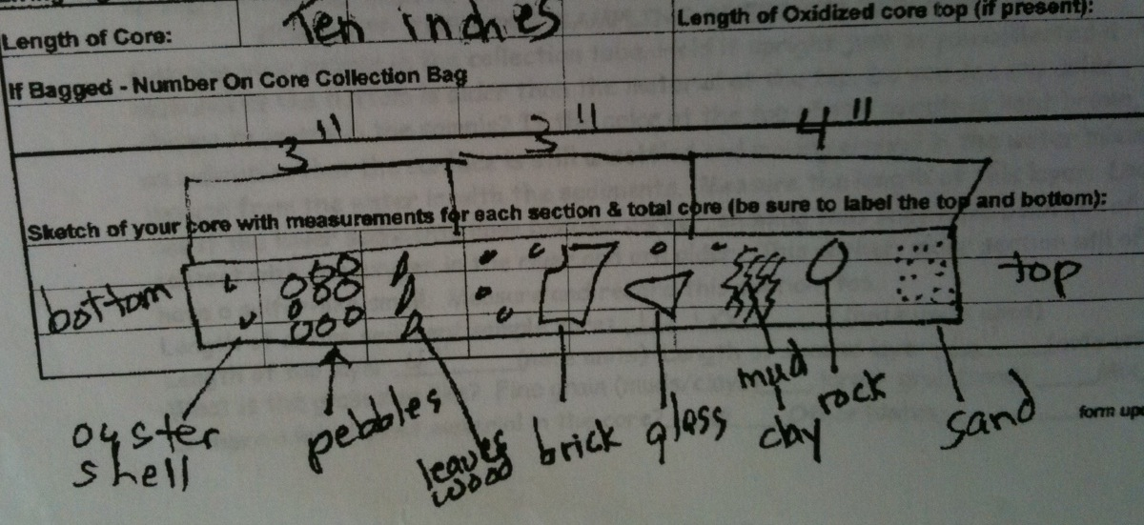
Observations | Boat Station: Lots of river traffic - crew rowers; tug and oil barges. Pleasure motor yachts; ocean going ships - The cruise ship was loading for an The cruise ship was loading for an excursion, singing, and then heading out with a horn blast that the kids loved (woke them right up!).
 | Seine Station: We were 3 classes of second-third graders. Each class did three or more sweeps of the net totaling 9-10 seines. First group had an abundance of spottail shiners, most managed to survive! The most exciting was coming up with the juvenile blue-claw crab – less than 2 cm across – and the eel. Interestingly, almost everything we caught was 7 cm. The larger lengths recorded here are the one exception for the most part.

