Day in the Life of the Hudson 10/4/12 Data
RIVER MILE 79
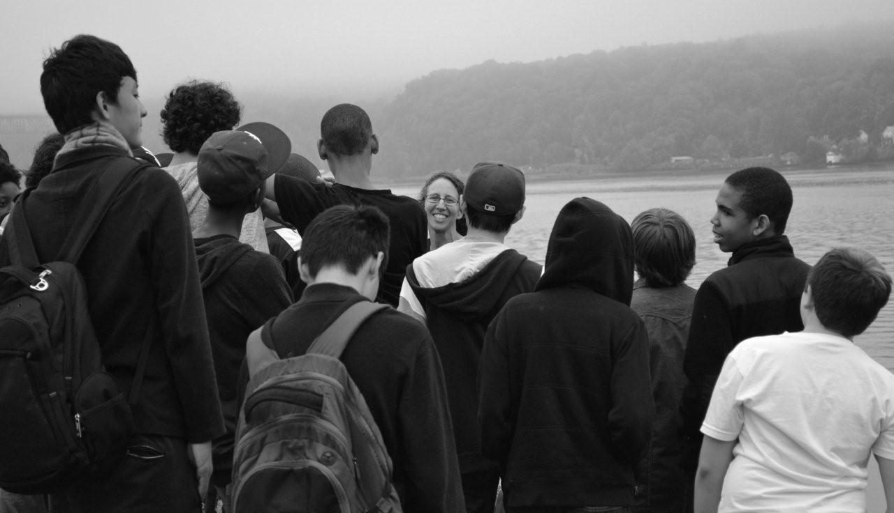
Miriam Straus, Oakwood Friends School, 6th-8th grade, 18 students, 5 adults
Marist College Waterfront
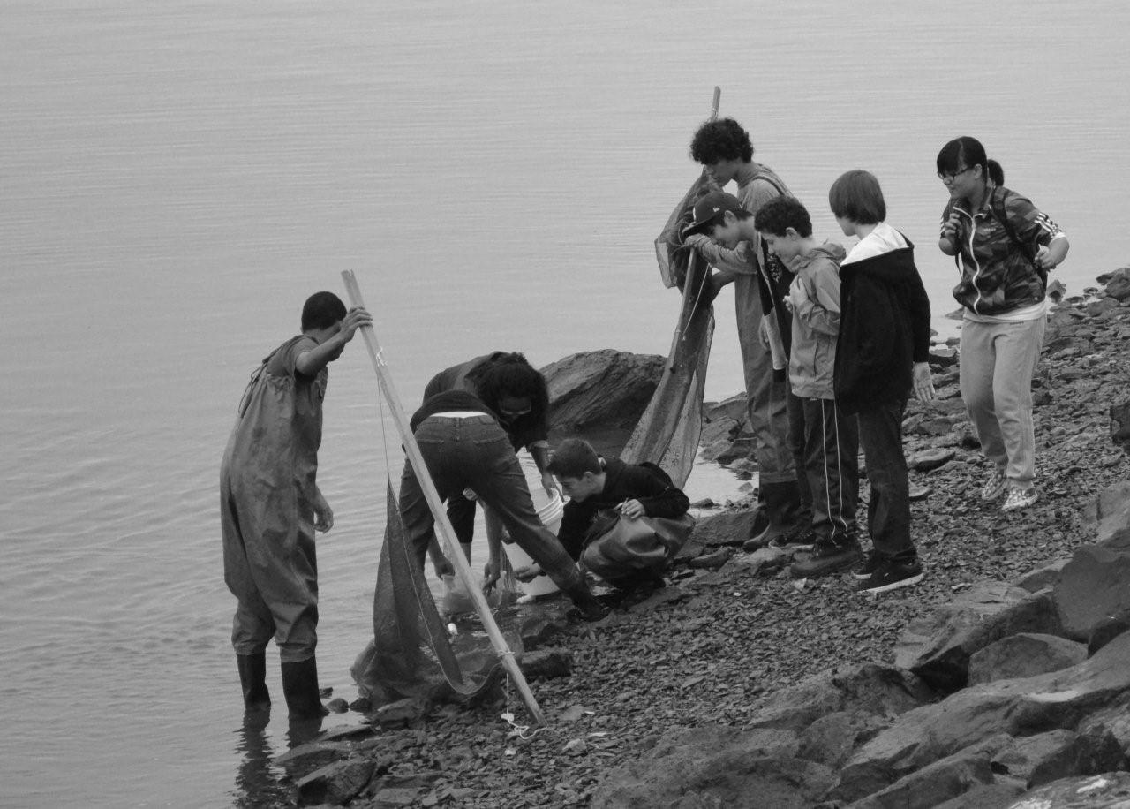
Location: Marist College riverfront park
Area: Lawn down to the waters edge with rip rack edges
Surrounding Land Use: Urban with, college campus
Sampling Site: vegetation, banks altered, shoreline with raprap – floating dock
Testing: 9:30-10:30

ITEM | Time |  | Reading 1 | Reading 2 | Comments
Physical
Air Temperature
Wind Speed | 12:55 PM |  | Beaufort #3
Cloud Cover
Weather today
Weather recently
Water Temperature | 9:30-10:30 AM | 21.78 °C  22.04  22.55  22.67  22.78 |  |  | Avg. 22.36 °C
 | 11:10 AM | 14.5°C
Water calm
Turbidity – long site tube | 9:30-10:30 AM | 55 cm  56  50 |  |  | Average 53.7
Chlorophyll | Time | Color Code
Chemical
DO  (drop count kit) | 9:30-10:30 AM | 8 mg/L  8 mg/L  7 mg/L |  | 22°C | 93%
pH | 9:30-10:30 AM | 7.5  8  7.5 |  |  | Average 7.75
Salinity - quantab
Fish Catch | Number Caught | Species |  | Length | Seine
 | 1 | White Perch
 | 1 | Bluegill
 | 1 | Silverside
 | 4 | Shiner

Total catch | 72 or > | Diversity | 6 species
Currents - | Time | Velocity | m/sec | cm/s
 | 9:30-10:30 | 10m/75 sec | 0.13 m/sec | 0.0013 cm/s
 |  | 8.52m/52 sec | 0.16 | 0.0016 cm/s
 |  | 72 m/241 sec | 0.30 | 0.0030 cm/s

