Day in the Life of the Hudson River 10/4/12 Data
RIVER MILE 97
Sojourner Truth/Ulster Landing State Park, Town of Ulster, Ulster Co.
Latitude 42°N, Longitude 73°56’W
NYSDEC SCA member
Stephen Hart, Mill Road Elementary School 3rd graders – 50 students, 10 adults
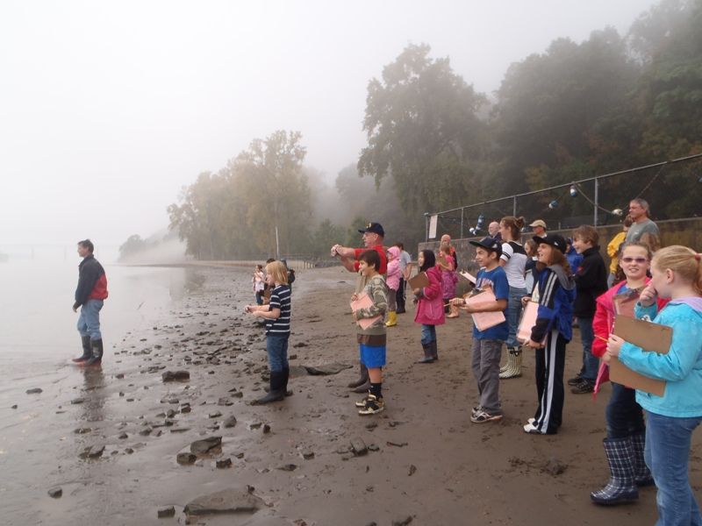
Location: Swimming beach, Sojourner Truth/Ulster Landing Park, Town of Ulster, Ulster County
Area: fishing, swimming beach, has a building with restrooms
Surrounding Land Use: Beach 5%; Forested area 90%; parkland with grass and picnic area 5%
Sampling Site: beach, altered bank with concrete bulkhead, wood debris driftwood, slag and brick in the area, drainage from bulkhead north of site immediately
Plants in area:
Water depth: 3 ft.
River Bottom: sandy at the edge then very muddy
Plants: no plants

Site Sample Times 9:30-12:30 PM
ITEM | Time |  | Reading 1 | Reading 2 | Comments
Physical
Air Temperature | AM |  | 21°C  70 °F
Wind Speed | 0 Beaufort
Cloud Cover | mostly cloudy
Weather today | drizzle to light rain
Weather recently | Overcast and rainy, a little cooler
Water Temperature | AM | 18.3°C  65°F
Water Surface | calm
Fish Catch - seine | Species -  None caught! | Number |  | Length of largest | Seine #
Tides- | Time | Depth |  | Falling/Rising
Measured for 2 hr. period | start | 0 |  | Set
Measured for 2 hr. period | stop | 6 inches |  | Rising | 3 inches an hour
Currents | AM | Faster in the main channel |  |  | Flood
Core | 6 inch length | Dark grey color |  | Mainly sand | Few bits of organic matter

