Day in the Life of the Hudson River 10/4/12 Data
RIVER MILE East River 1 West
Dan Tainow, Lower East Side Ecology Center
Michael Paoli, Ella Baker School
7th-8th grade, 23 students, 3 adults
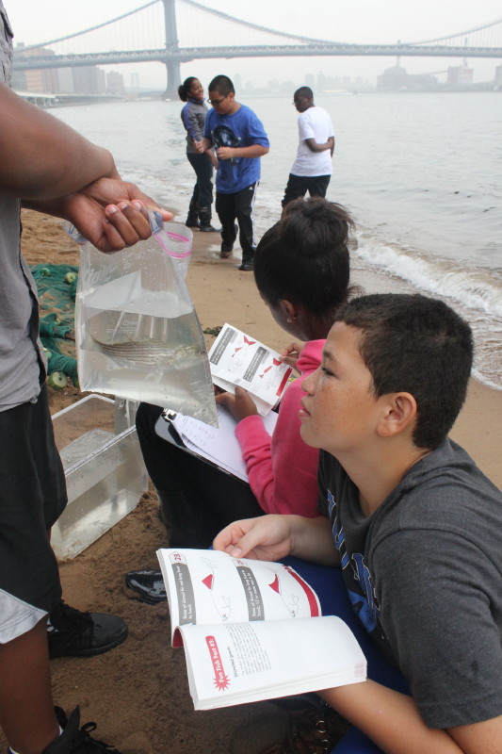 | 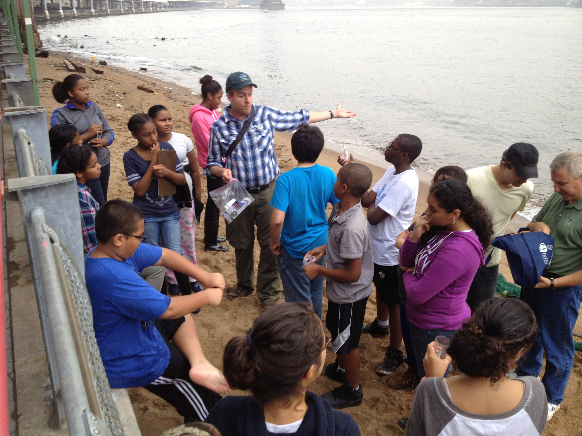
Location: Beach under the Brooklyn Bridge, 125 ft. North of Dover St., Manhattan side
Area: Pier and path for recreational walking, jogging, bike riding and fishing. The surrounding land is sandy with water – beach like. Water best used for fishing & boating. Lots of rocks and sand. Beach is opened to the public but no swimming. Also near a parking lot.
Approaching the site:
Surrounding Land Use: Urban/residential 20%; Forested 15%; Industrial/Commercial 10%; Beach 20%; other 35%
Sampling Site: Sandy, Beach, covered in vegetation, banks altered, bulkhead with timbers, RipRap. Piping entering river
Plants in area:
Water depth:
River Bottom –
Plants:

ITEM | Time |  | Reading 1 | Reading 2 | Comments
Physical
Air Temperature | 9:40 AM |  | 78°F  26°C
Wind Speed
Cloud Cover | overcast |  | drizzle
Weather last 3 days | Some rain, fall like weather with sun also
Water surface
Water Temperature - | 10:00 AM | 68°F  20°C
Turbidity  Long site tube | 10:10 AM | 49 cm
Chlorophyll | 11:00 AM | 0.1 color chart
Chemical
DO - tablets | 10:00 AM | 8 ppm |  | 20°C | 85% saturation
pH – color match kit | 10:15 AM | 7.6
Salinity  (Hydrometer) | 10:30 AM | 23 ppt |  | 1.017 specific gravity
Fish Data | Time | Fish Catch |  | Totals
 |  | Juvenile Striped Bass |  | 1
 |  | Atlantic Silverside |  | 3
 |  | Comb Jellies |  | 5
Tides | 9 -11 AM | Flood
Currents
Shipping | 9:35 AM | Water taxi |  | Yellow | Southbound
 | 9:40 AM | East River Ferry |  | White | Southbound

