Day in the Life of the Hudson River 10/4/12 Data
RM -2 , Valentino Pier
Kerstin Kalchmayr, NY/NJ Baykeeper
Mira Rubens, PS 230 (NYC Dept. of Ed) 5th graders – 30 students, 7 adults
GPS Latitude N : 40°40’42. 10” - W-74°01’06.07

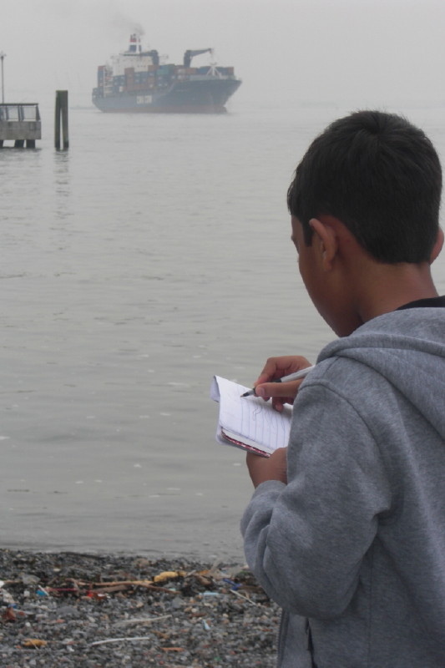
Location: Valentino Pier, Redhook, Brooklyn, NY

Area: beach area along the bay

Surrounding Land Use: Beach – 5%; Urban/residential 25%; Industrial/Commercial 60%; park 10%

Sampling Site: beach

Shoreline: beach area, Pier, riprap

Plants in area: No plants in water

Water depth: 10 feet

River Bottom : rocky near the little beach area

ITEM | Time |  | Reading 1 | Reading 2 |  | Comments
Physical
Air Temperature
Wind Speed | Beaufort Force |  | 1
Cloud Cover | clear
Weather today | drizzly
Weather recently | Relatively warm weather the previous days, some precipitation
Water Temperature | 11:08AM | 20°C  68°F
Water calm | yes
Turbidity – secchi disk | 10:45 AM | 122 cm
Chlorophyll
Chemical
DO  (YSI handmeter) | 11:08AM | 3.45mg/L |  |  | 20°C | 30%
pH –YSI | 11:00 AM | 7.6
Salinity – hydrometer | 10:45 AM | 22 ppt  22 ppt  22 ppt |  |  |  | 22 ppt
Fish Catch  30 ft. seine net with bag in middle | Number Caught | Species |  |  | Length of largest | Macro Species
 | 10 | Atlantic Silversides |  |  | 10 cm
Tides
Currents
Traffic
Other Items
Core

