Day in the Life of the Hudson River 10/10/13
(Salt Front RM 69.3)
HARLEM RIVER MILE 13
Swindler’s Cove Park on the Harlem River
Mya Jenkins and the New York Restoration Project Staff (4)
Fatima Wilson -5th grade Bronx Charter School of Excellence (47 students), 4adults
GPS Latitude 40° 51’36”N – Longitude 73°55’12”W
(40° 86 N -73° 92 W)
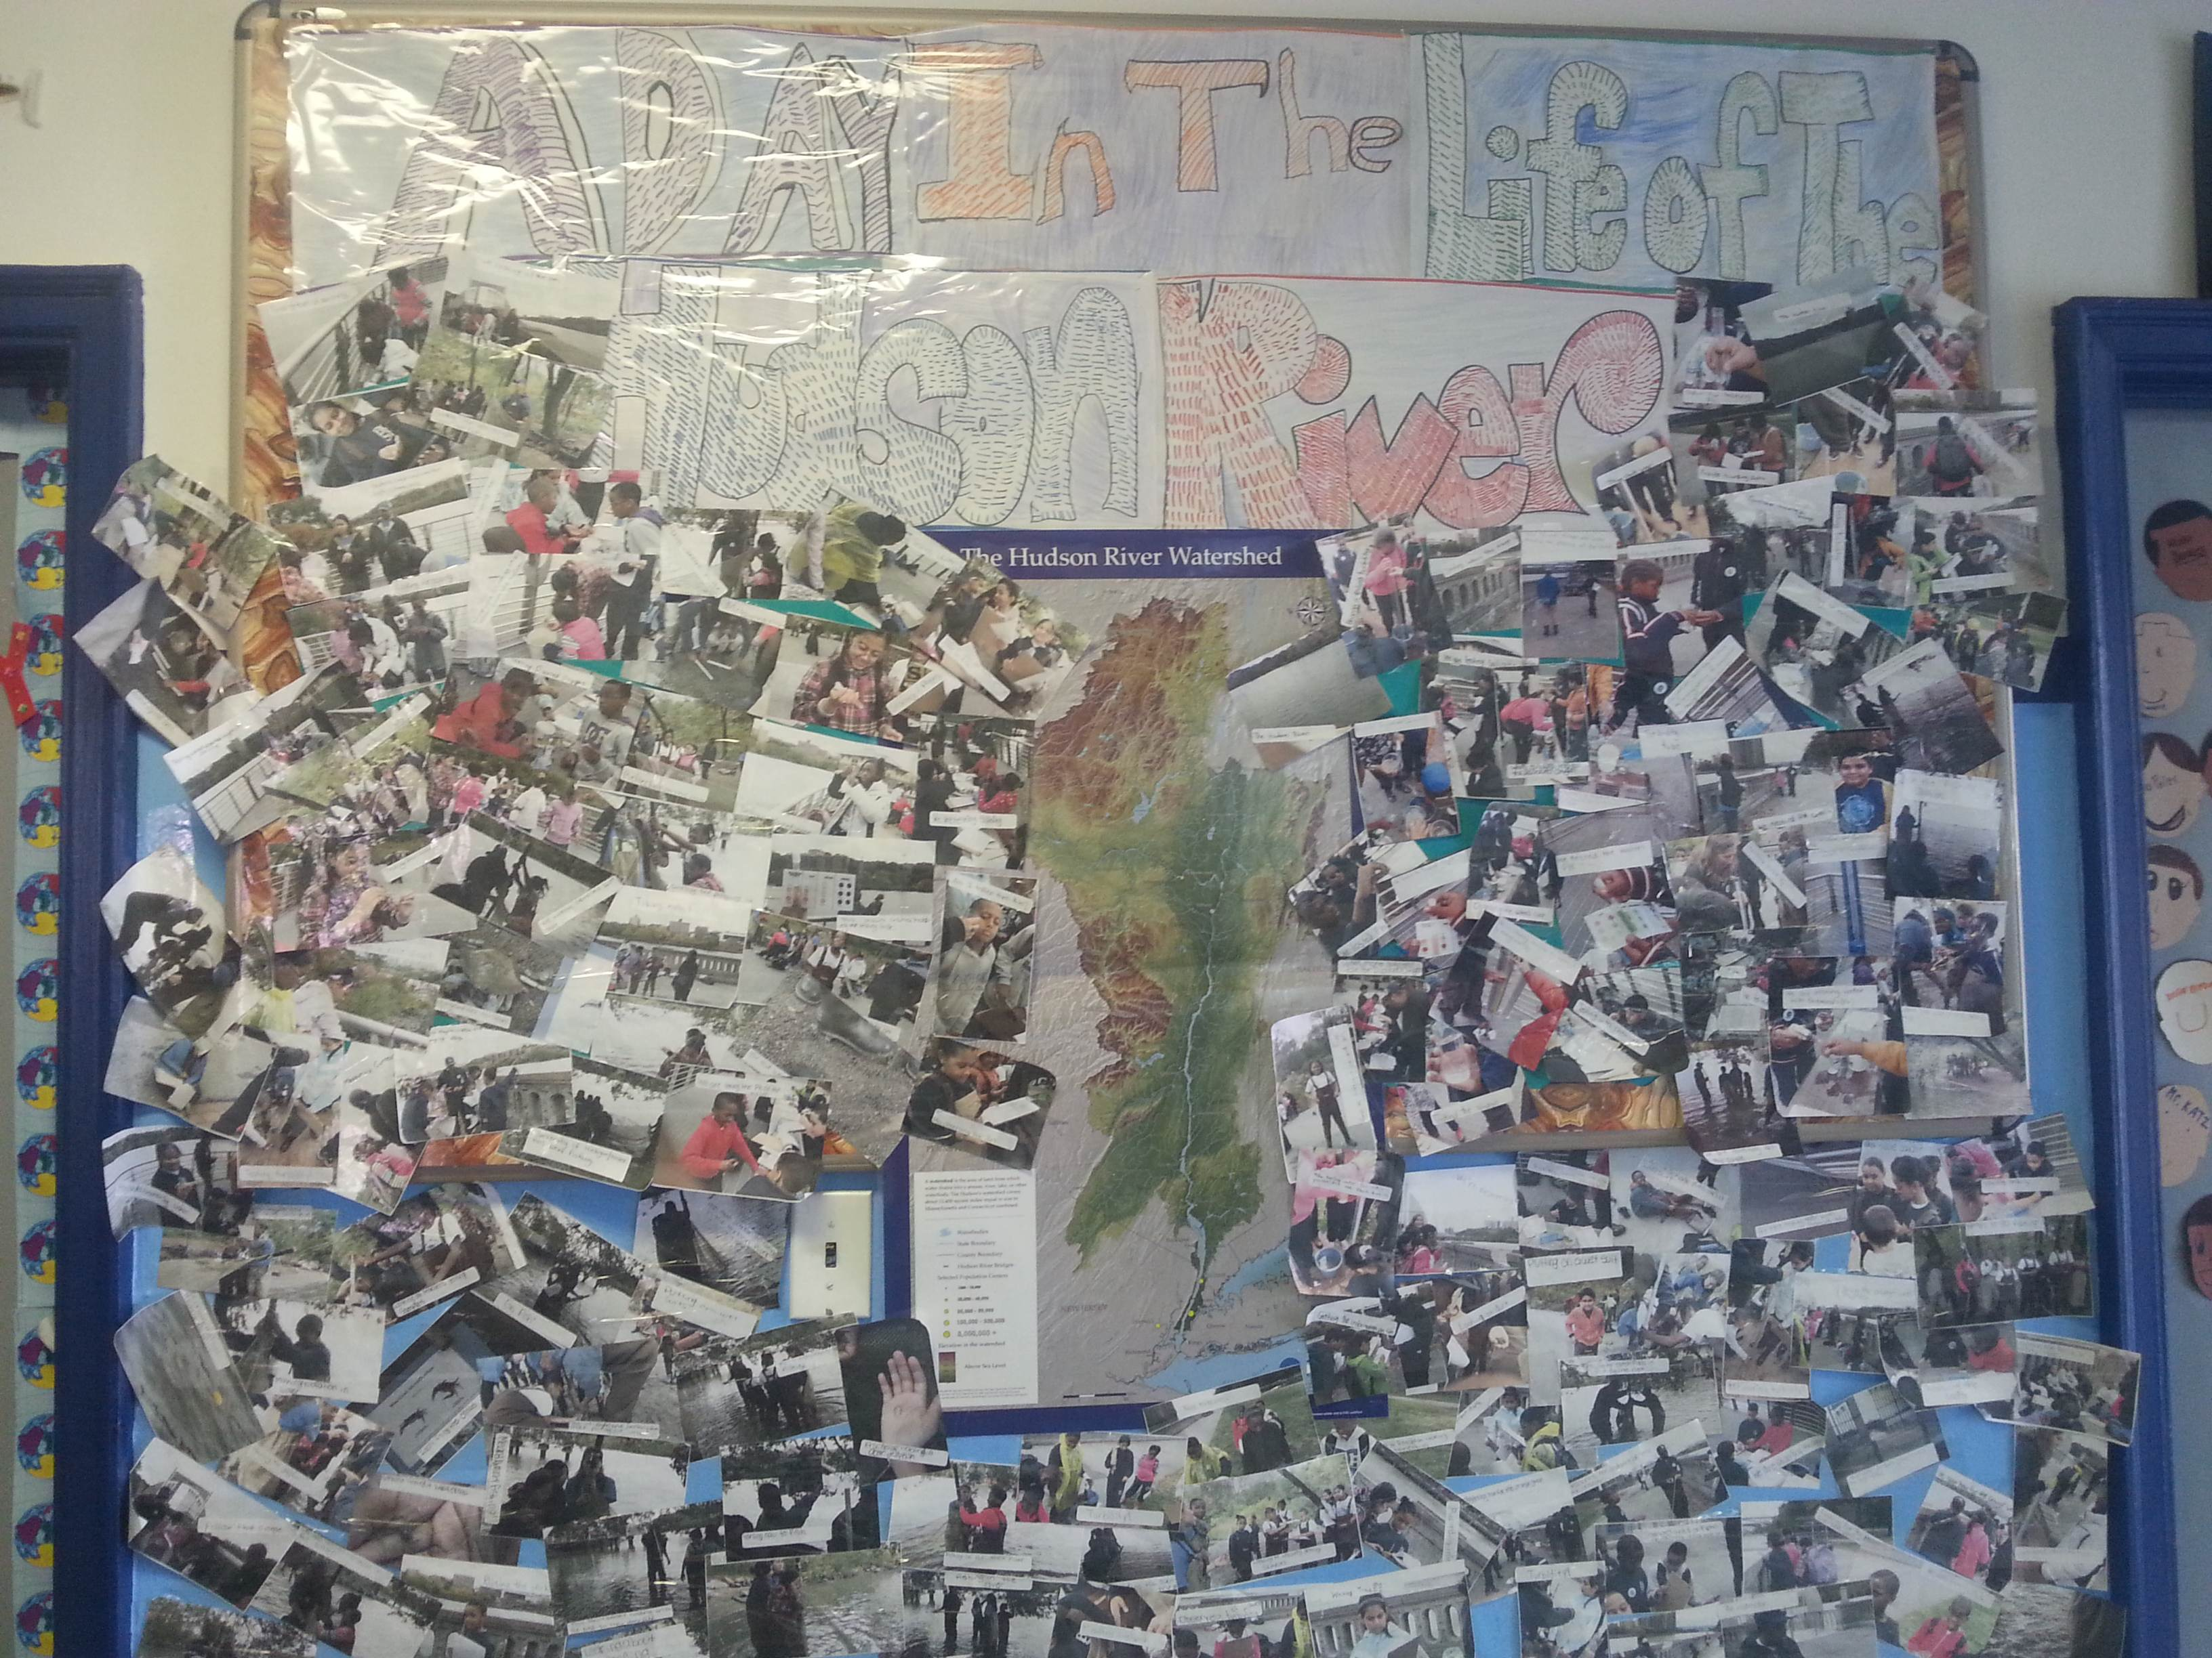
Back in School the students create an event wall!
Location: Beach at Swindler Cove Park, next to the north end of Harlem River Drive, Manhattan
Area: There is a pier, beach, floating boathouse with a dock. Area used for boating, rowing, biking, walking, school groups- forested and grassy area
Surrounding Land Use: 50% beach, 50% Industrial/Commercial
Sampling Site: Sandy, muddy beach area, covered with vegetation, riprap banks
Plants in area: grass, sycamore trees
Water depth:
River Bottom: muddy
ITEM | Time | Reading 1 | Reading 2 | Comments
Physical | Sampling occurred between 10:00 AM to 2:00 PM
Air Temperature
Wind Speed
Cloud Cover | Mostly cloudy | Overcast
Weather today | drizzly
Weather recently | Drizzly and cool
Water | choppy
Water Temperature | 11:26 AM | 17°C | 62.6°F
Turbidity – long site tube
Chlorophyll
Chemical | TIME | DO | Temp
DO | 11:26 AM | 4 ppm | 15°C | 35% saturation
 | 12:05 PM | 4 ppm | 15°C | 35 % saturation
 | 12:48 PM | 4 ppm | 16°C | 40% saturation
pH – | 11:05 AM | 7.5
 | 11:31 AM | 8
 | 11:49 AM | 7
 | 12:31 PM | 8
Salinity – chloride tablets | 11:22 AM | 14 ppt
 | 12:00 PM | 14 ppt
 | 12:45 PM | 14 ppt
Fish Catch – | Number caught | Species |  | Diversity & Total catch
 | 2 | Atlantic Silverside | DIVERSITY – 1  TOTAL CATCH–2
Macros | 4 | Blue Crab
 | 6 | Moon Jellies
Tides
Currents –  15 sec intervals | 1020 cm/15 sec | 68 cm/sec | 1-3 kts | Flood
 | 990 cm/15 sec | 56 cm/sec | 1-2 kts | Flood
 | 930 cm/15 sec | 62 cm/sec | 102 kts | Flood
 | 930 cm/15 sec | 62 cm/sec | 102 kts | Flood
Core Sample Sediments | Length | Common | Present | Description
Traffic – recreational (

