Day in the Life of the Hudson River 10/10/13 Data
(Salt Front RM 69.3)
RIVER MILE -10
South Beach Wolf Park, Staten Island
N 40°44.375’ W-74°0.1820’
Steve Stanne, HREP, NYSDEC
Mary Lee, St. Clare’s School, 70 Seventh graders and 15 adults
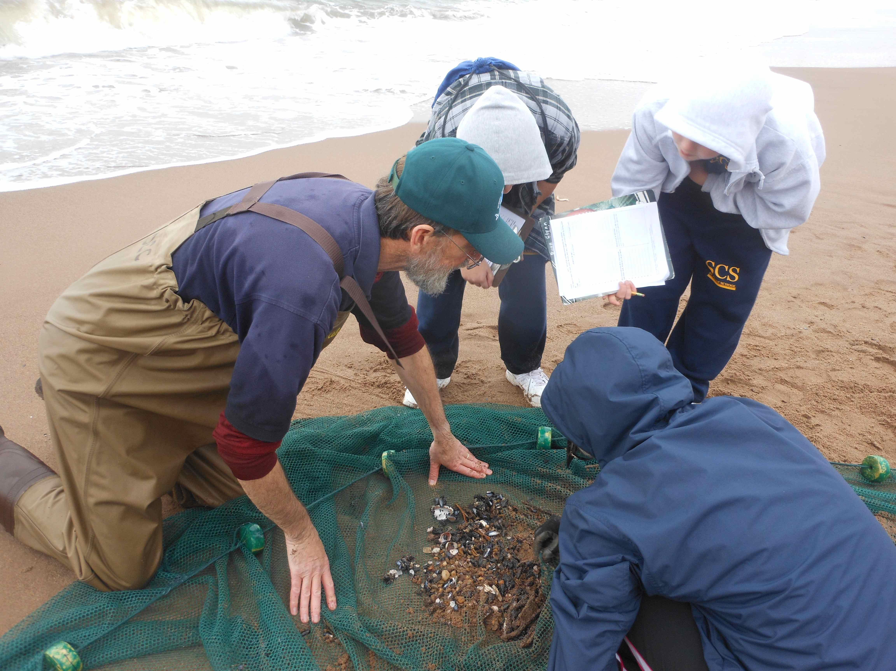 | 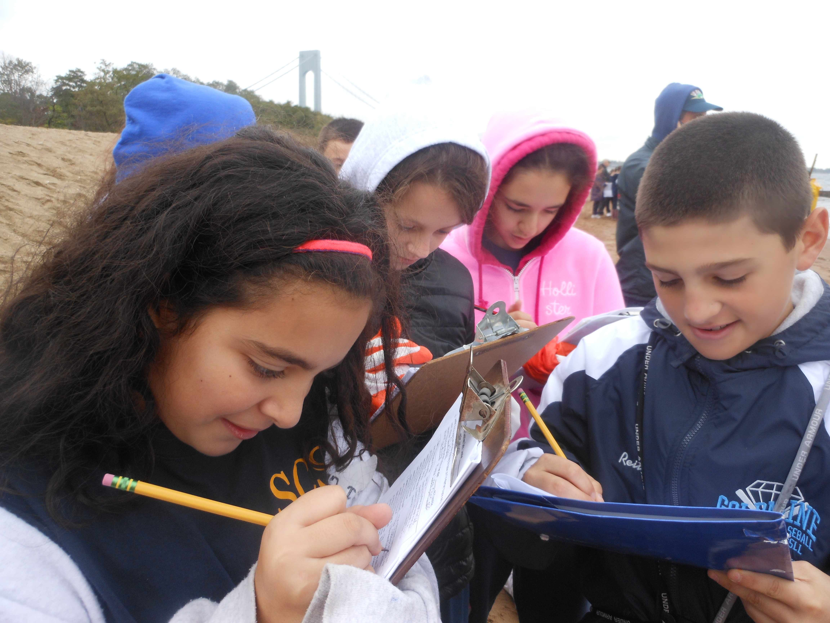
Location: South Beach of Wolf Park, Staten Island
Area: Beachfront – see student sketches (attached)
Surrounding Land Use: 90% beach,10% Boardwalk/Park
Sampling Site: Beach area with bulkhead, concrete broken in area
River Bottom: Sandy
Plants in area: No plants

ITEM | Time |  | Readings
Physical
Air Temperature | 10:00 AM  10:52 AM |  | 18.3°C  15°C | 65°F  59.3°F
Wind Speed | Beaufort #4 |  | 3.6 mph | East
Cloud Cover | 12:15 PM  12:46 PM  1:03 PM  1:33 PM |  | 100%  100%  100%  100%
Weather today | Cold & damp, overcast |  | Became colder as day progressed | Water surface |  | Very choppy – high waves
Weather recently | Windy, cool, some rain
Water Temperature | 10:03 AM  10:08 AM  10:13 AM | 20°C  19°C  18°C |  | 68°F  64°F  60°F | Weather grew colder during day
Turbidity  Turbidity tube | 10:45 AM | 20.0 cm  27.1  22.5 |  | 23 cm avg
Chemical | Time | ppm |  | Temp | % Sat
DO  Estuary wide monitoring Kit – | 10:10 AM  10:19 AM  10:36 AM  10:58 AM  11:13 AM  11:30 AM | 8 ppm  7  7  8  10  8 |  | 15° C  15°C  15°C  16°C  17°C  17°C | 80%  70%  70%  80%  100%  90%
pH  Litmus Paper | 10:00 AM  10:25 AM  10:45 AM  11:03 AM  11:19 AM  11:35 AM | 6  6  6.5  5.5  6.5  6 |  | 6 average
Salinity - hydrometer | 10:07 AM  10:27 AM  10:46 AM  11:05 AM  11:21 AM  11:40 AM | 32 ppt  30 ppt  28 ppt  27.75 ppt  29 ppt  28 ppt |  | 29 ppt | Specific gravity 1.028
Fish Catch – seine 50ft. net – 20-30 ft. pull | Time | Species |  | Number
 | 10:00-11:30 AM | Hermit Crab  Mole Crab  Mussels  Spider Crab  Comb Jellies |  | 1  16  15  3  8 | No fish but macro-invertebrates also netted 1 blue crab claw
Tides (from pier to water) | Time | Distance to water |  | Rate of change | Flood or Ebb
 | 10:02 AM  10:15 AM  10:30 AM  10:45 AM  11:00 AM  11:15 AM  *stick float away | 50 cm  60 cm  70 cm  80 cm  90 cm  90cm |  | Start point  6.6cm/min  6.6cm/min  6.6cm/min  6.6cm/min  0 cm/min | Baseline  Flooding  Flooding  Flooding  Flooding  Unchanged
Currents - Time | Cm/30sec | Cm/sec |  | Knots | N/S Ebb/Flood
10:05 AM | 258 | 8.6 |  | 0.2 | N - F
10:24 AM | 540 | 18 |  | 0.4 | N- F
10:46 AM | 600 | 20 |  | 0.4 | N-F
11:03 AM | 0 | 0 |  | 0 | 0
11;16 AM | 62 | 2.1 |  | 0.04 | N-F
11:30 AM | 0 | 0 |  | 0 | 0
Core Sample | Length | Abundant |  | Common
 |  | Sandy |  | Gravel  pebbles
Shipping – Time | Type | Name |  | Color | Direction/ light or loaded
10:02 AM | Cargo | Zim |  | R/W/B | N loaded
10:24 AM | Cruise | Seastruck |  | B/W | S loaded
10:30 AM | Cargo |  |  |  | S
10:33 AM | Speedboat |  |  |  | S
10:38 AM | Cruiseship | AIDA |  |  | N loaded
10:38 AM | Cargo |  |  | R/B | N loaded
11:20 AM | Tanker |  |  | R | N loaded
11:32 AM | Sailboat |  |  | W | W
11:34 AM | Cargo | Harbor Fashion |  | R/B | N loaded

