A Day in the Life of the Hudson River 10/4/13 Data
RIVER MILE 108
Lasher Memorial Park, Germantown, Columbia County
Tom Crowell, Columbia Land Conservancy
Jim McDarby, Hudson High School, 12th graders – 30 students
GPS Latitude 42°09.50’ N Longitude 73°53.21’W
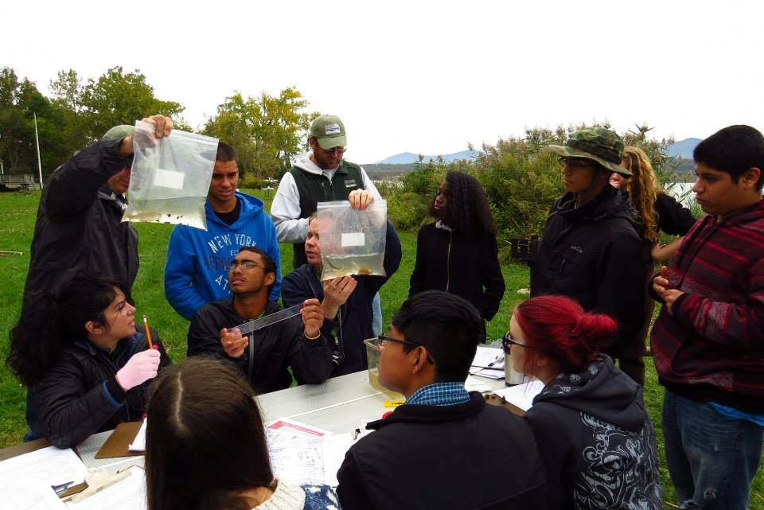 | 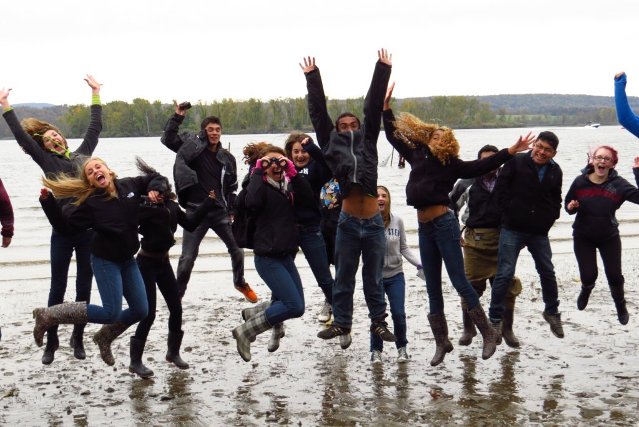

Location: Lasher Memorial Park, Boat Launch, North Germantown Landing
Area: Grassy area, used for picnics and boating
Surrounding Land Use: Beach – 82%; Urban/residential 10%; Other 8%
Sampling Site: Park with mowed lawn, rip rap in are
Water depth: 3
River Bottom : sandy,
Plants: Goldenrod, common reed, maple, cottonwood

ITEM | Time |  | Reading 1 | Reading 2 |  | Comments
Physical
Air Temperature | 10:10 AM |  | 48°F  10.2°C
 | 12:29 PM |  | 60°F  16°C
Wind Speed | Beaufort #3  Gentle Breeze |  | SW | 12:29 PM  Beaufort 2 |  | SW
Cloud Cover | Mostly Cloudy
Weather today | Cloudy and rainy all day
Weather recently | Monday heavy rains, Tues. cold no rain, Wed. winds no rain
Water Temperature | 10:12 AM | 18°C |  |  |  | 2 ft. depth water
Water calm | Choppy
Turbidity – sight tube | 12:30 PM | 9 cm |  |  |  | Averages
Chlorophyll | 12:38 PM | 1.5
Chemical
DO – cloud cover | 9:45 AM  10:30 AM | 13°C  5 °C |  |  | 16 ppm  15 ppm
Nitrates | 9:46 AM  10:20 AM | 5 ppm  5 ppm
Phosphates | 9:42 AM  10:15 AM | 2 ppm  1 ppm
pH –color match kit | 9:48 AM  10:05 AM | 7.5  7.5
Salinity – Quantabs | 9:52 AM  10:20 AM | 34 ppm Chloride  34 ppm Chloride |  |  | 0.006 | 61 ppm total salinity
Fish Catch  40 ft. seine net X 3/8 inch mesh | Number Caught | Species |  |  | Length of largest | Macro Species
 | 1 | American Eel |  |  | 4.2 cm | Damselfly larva
 | 7 | Banded Killifish |  |  | 10.5 cm
 | 1 | Striped Bass |  |  | 4 cm
 | 1 | American Shad |  |  | 10 cm
 | 1 | Emerald Shiner |  |  | 13 cm
 | 1 | White Perch |  |  | 10 cm
 | 1 | Shiner |  |  | 3.25 cm
 | 1 | Pumpkinseed |  |  | 2.5 cm
 | 14 total | 8 Diversity
Tides | 9:30 AM | Unable to read
Photo shows exposed mudflats | 9:54 AM | 26.65 cm
 | 12:30 PM | 5 cm
Currents | 9:35 AM | ebb
 | 12:20 PM | ebb
Traffic | 9:35 | Two Pleasure boats |  |  | Southbound
 | 10:25 | Red Black Barge |  |  | North | Empty
 | 11:00 AM | Barge |  |  | Northbound
 | 12:30 PM | Barge |  |  | Sourhbound
Other Items | Floating Styrofoam | Detergent Bottle |  |  | Glass
Core | No

