Day in the Life of the Hudson River 10/10/13 Data
(Salt Front RM 69.3)
RIVER MILE 127 – Stuyvesant Landing
Chelsea Benson, Leanne O’Grady - Columbia County Soil & Water Conservation District
Elizabeth Pagnani, The Alternative Learning Center (TALC) – 3-11 yrs. –
13 students & 5 adults
Latitude 47 N Longitude 73W (topo map)
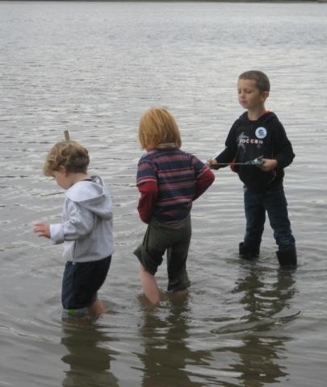 | 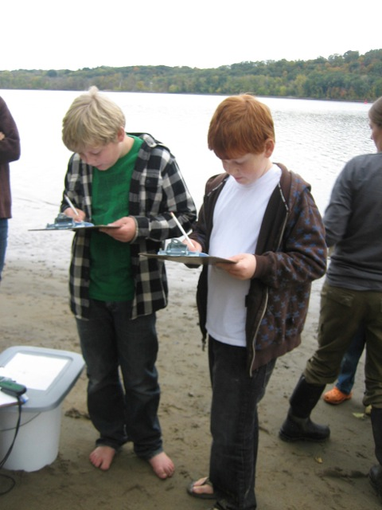 | 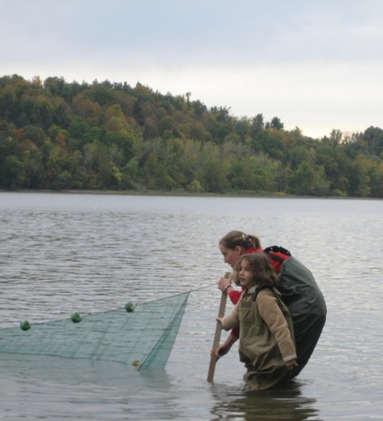

Location: Sandy point of Stuyvesant Landing, Columbia County. The sandy point is just south of the parking lot.
Area: forested area with narrow beach used for swimming, picnics & camping by permit. Park/Boat launch, sandy beach area on the point
Surrounding Land Use: 95% forested, 5% beach – used for picnics, swimming, campfires, sandy beach and dense woods behind
Sampling Site: Beach area
Plants in area: no plants in water
Water depth: waded in approx. 4 ft.
River Bottom –gradual slope, sandy

ITEM |  | Time |  | Reading 1 |  | Reading 2 |  | Comments
Physical
Air Temperature |  | 3:47 PM |  | 60 °F  16°C |  | 4:37 PM |  | 59 °F  16°C
Wind Speed |  | Beaufort 0 |  | 0 knots Anemometer |  | Small amt.. from North
Cloud Cover |  | overcast
Weather today |  | Cloudy and overcast
Weather last 3 days |  | Mild weather - mid 60°F during day – low 40°F night.
Water |  | Calm
Water Temperatur |  | 4:05 PM |  | 61°F  16 °C
 |  | 5:00 PM |  | 61°F  15°C
Turbidity – short site tube |  | 4:10 PM |  | 60 JTU
Chlorophyll |  | 3:15 PM |  | 2
Chemical
DO  Drop count |  | 3:45 PM |  | 9.0 mg/L |  | 17 ° C |  | 90%
pH  pen |  | 3:38 PM |  | 8.8  8.5
Nitrates |  | 4:05 PM |  | trace
Phosphates |  | 4:02 pM |  | 2.0ppm
Alkalinity |  | 3:45 PM |  | 70 ppm  66 ppm |  |  |  | Average 68 ppm
Salinity  Quantab Test strip |  | 3:45 PM |  | .005*  readings on wick stick |  | 28 ppm Chl⁻ |  | 51 ppm total salinity
Fish Catch –2 pulls - Seine 40 ft. X 3 ft.  Mesh 0.25 inch |  | Number Caught |  | Species |  | Size of largest |  | 2 seines –5 min. pulls-
2nd seine |  | 5 |  | Spottail shiner |  | 10 cm
2nd seine |  | 5 |  | y-o-y striped bass |  | 12 cm |  | Diversity 4
1st seine |  | 1 |  | Banded Killifish |  | 5 cm
2nd seine |  | 1 |  | Bluegill sunfish |  | 7 cm |  | Grand Total 12
Tides |  | 3:40 PM |  | Rising |  | 19 cm
 |  | 3:45 PM |  | Rising |  | 26 cm |  | 1.4 cm/min
4:40 PM |  | 4:00 PM |  | Rising |  | 35 cm |  | 0.6 cm/min
 |  | 4:20 PM |  | Rising |  | 46 cm |  | 0.55 cm/min
Currents  North/Flood |  | 3:55 PM |  | 409 cm/60 secs |  | 6.8 cm/sec |  | 0.13 knots
North/Flood |  | 4:35 PM |  | 711 cm/60 sec |  | 11.9 cm/sec |  | 0.22 knots
Our sampling beach is set back slightly from the direct current. We managed to get the orange out into the current.
Ships | Time |  | Type |  | North/Southbound |  | Light/Loaded
 | 3:10 PM |  | Party boat |  | Southbound |  | 3 stories tall!
 | 3:30 PM |  | Tug with barge |  | Southbound |  | light
 | 4:30 PM |  | Sailboat |  | Southbound
 | 4:30 PM |  | Sailboat |  | Northbound

